Why You Shouldn’t Fear New Highs
- Stocks made more new highs last week, as the bull market continues
- Many investors are fearful of new highs, but history says you shouldn’t be
- Inflation is showing up in the areas you’d expect given tariffs, but there are some positives on the inflation front
- All of this only adds to the tight spot the Federal Reserve Bank is in regarding cutting rates

Do you have a fear of heights? This is known as acrophobia, which is something many, many investors have. Studies show the fear of failure hits much harder than the feeling of success. This is why we always remember our favorite sports team’s tough losses much more vividly years later than the big wins.
If you’ve done this long enough then you recall there indeed was one final new high in 2000, right before stocks were cut in half. Or there was one final new high in 2007, right before another 50% haircut. Not to mention both of those times took years and years to even get back to even.
Think about this, since 1950 (when the S&P 500 became 500 stocks) it has made 1,250 new highs. Incredibly, that comes out to a new high 7.2% of all trading days, or a new high every 14 trading days, approximately. That is a new higher every three weeks! In other words, new highs happen a lot and being scared of new highs isn’t going to benefit your portfolio.
With stocks hitting new highs and the surprise summer rally alive and well, we wanted to discuss new highs more in depth this week. Let’s be clear, there are always worries and concerns, but a fear of heights shouldn’t be one of them.
New Highs Happen in Clusters
The S&P 500 broke out to new all-time highs in 2013 and it has been a major secular bull market ever sense. Yes, there have been bear markets and scary moments along the way, but the overall path has been higher prices. Or as Thomas Monson said, “We cannot direct the wind, but we can adjust the sails.” The wind has been at our backs for a long time and it remains there, putting a smile on many investors.
You see, new highs happen in clusters that can last a decade plus, but the flipside is many years can also occur without any new highs, like when we saw a total of 13 new all-time highs in the 12 calendar years from 2000 through 2012. We call this a secular bear market and they are the unfortunate part of longer-term investing.
Here’s a nice chart that shows new highs happen in clusters that can last a very long time, and we remain optimistic that many more new highs are still left in this secular bull market.
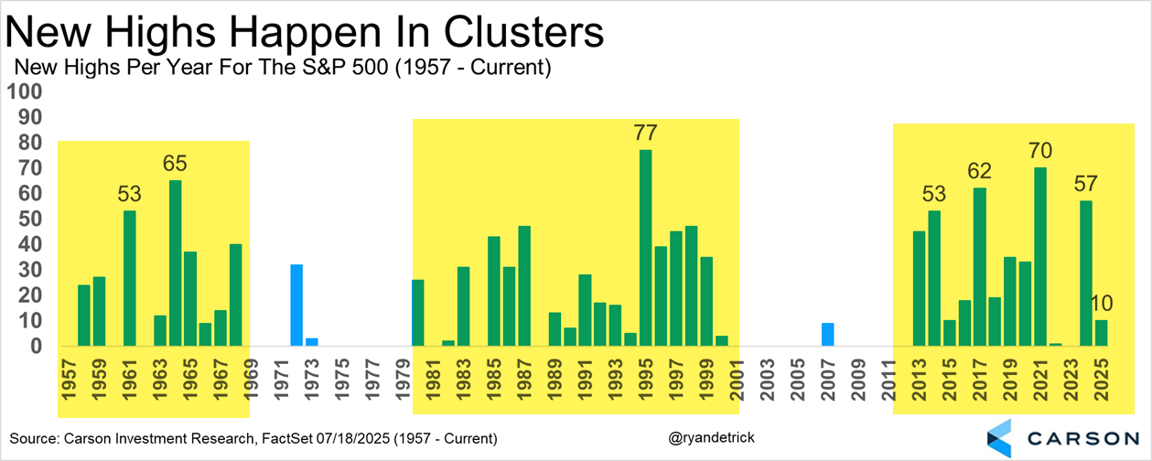
Don’t Be Scared
Lastly, should you buy at an all-time high? This is always a hard question. You didn’t have to think about this three months ago, and we were writing at the time that it was the time to potentially scope up some great deals. Now with stocks up more than 25% it is harder, but the bottom line is new highs tend to lead to more new highs.
Since 1990, the S&P 500 was higher a year after an all-time high 82.4% of the time and up a median return of a very impressive 13.5%. For every peak in 2000 or 2007, there are literally hundreds of other new highs that weren’t a major peak. And the good news? We don’t think the most recent new high is the peak just yet!
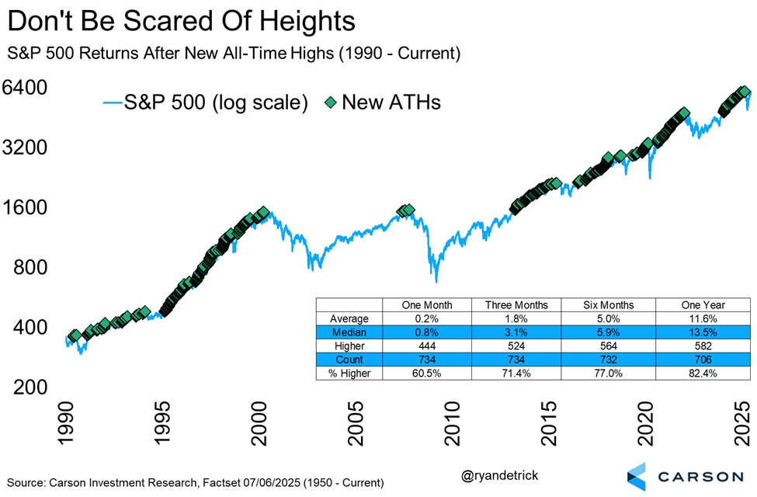
Let’s Talk About Inflation
One big question on everyone’s mind has been how tariffs would impact inflation. This is especially pertinent for the Federal Reserve (Fed), as it’s going to determine their next course of action—whether they continue to wait or cut rates sooner rather than later.
April and May were too early for any tariff impact to show up. Keep in mind that we got big whipsaws in tariff policy, including massive tariffs on Chinese goods pulled back in May. Still, the average effective tariff rate is about 10%-points higher than it was at the beginning of the year, and the proof is in the pudding that is federal government finances—we have in fact seen a big jump in import duties collected by the federal government. So, who’s paying this? As I’ve noted in the past, import prices haven’t fallen and that indicates that foreign exporters are not the ones paying these tariffs. It’s US businesses, via a hit to margins, or consumers, via higher prices. The question is when it would show up in the data. The short answer is that it’s started showing up in June inflation data, but at the same time, there have also been some disinflationary forces countering the inflationary impact of tariffs.
The headline Consumer Price Index (CPI) rose 0.3% in June and is up 2.4% annualized over the last three months. Core inflation, excluding food and energy prices, rose just 0.2% in June and is also up just 2.4% annualized over the last 3 months. These aren’t particularly concerning inflation numbers, at least as far as the Fed is concerned. But there’s a lot going on under the hood.
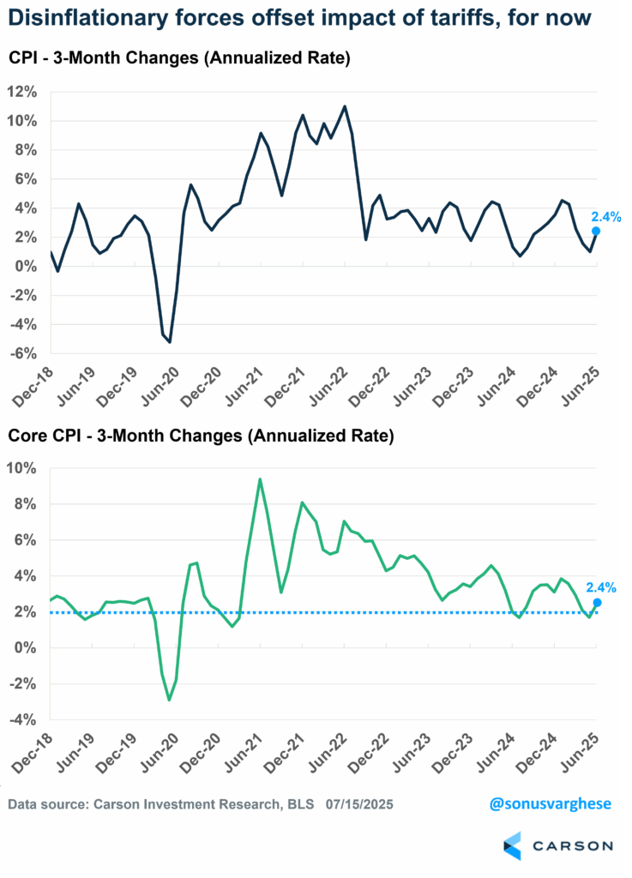
Tariff Impact Shows Up
If you want to look for the impact of tariffs, core goods (outside of food and energy) would be the place. And prices are rising there. Some areas where we saw a notable pickup in prices in June:
- Household furnishings and supplies (including appliances): +1.0% (12.4% annualized); last three months: +6.3% (annualized)
- Recreation commodities: +0.8% (9.8% annualized); last three months: +6.6% (annualized)
You can see the sharp upswing in prices for both these categories in the chart below. The June increase was the fastest monthly pace since the peak of pandemic-driven inflation in 2022.
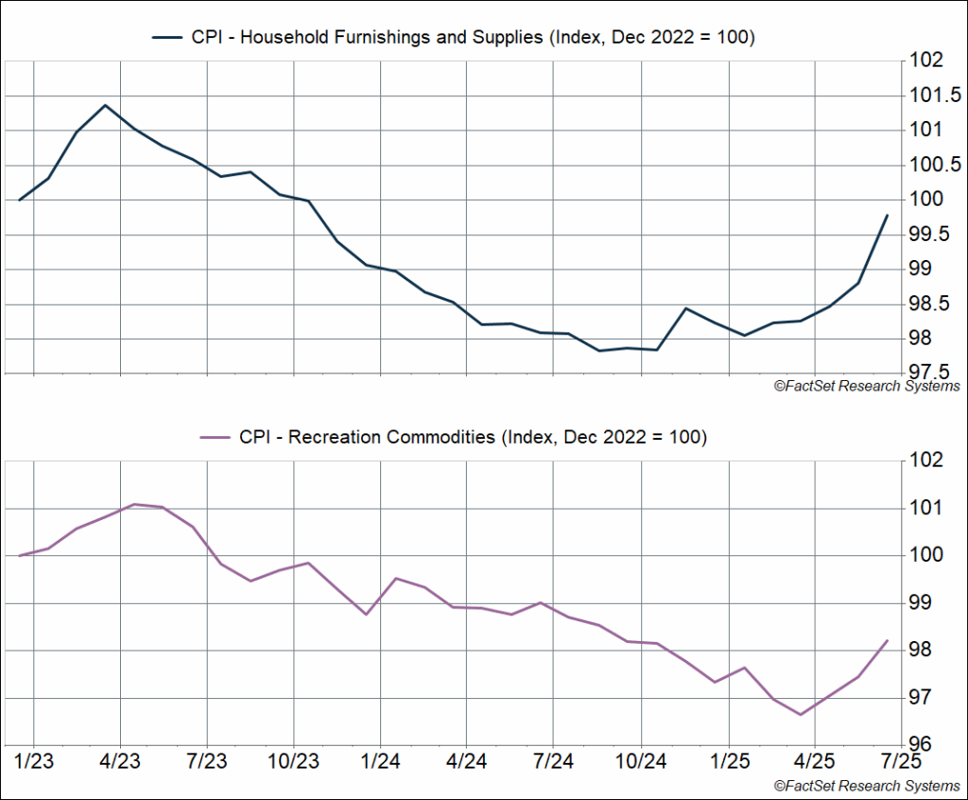
Another area that is not being discussed is the tariff impact on food prices. Higher food prices hit households even harder than gas prices (we all have to eat, whether at home or outside). The bad news is that food prices are rising more than normal, for a variety of reasons, including tariffs.
Grocery prices rose 0.3% for the second straight month in June. This was despite meat/poultry/fish/egg prices falling 0.1% in June (egg prices fell 7.4%). On the other hand, coffee prices rose 2.2% in June and are up 13% over the past year.
I like to keep an eye on CPI of “full services meals and snacks,” i.e. seated restaurants, to gauge underlying inflationary pressure. That’s because it combines several drivers of inflation including:
- Worker wages
- Food inflation, and even energy prices (including transportation)
- Rent of restaurant premises
Prices for restaurant meals jumped 0.5% in June (that’s about 6% annualized). Prices are running at a 5.8% annualized pace over the past three months and are up 4.1% from last year. That’s well above pre-pandemic levels and levels that would be consistent with “normal” 2% inflation.

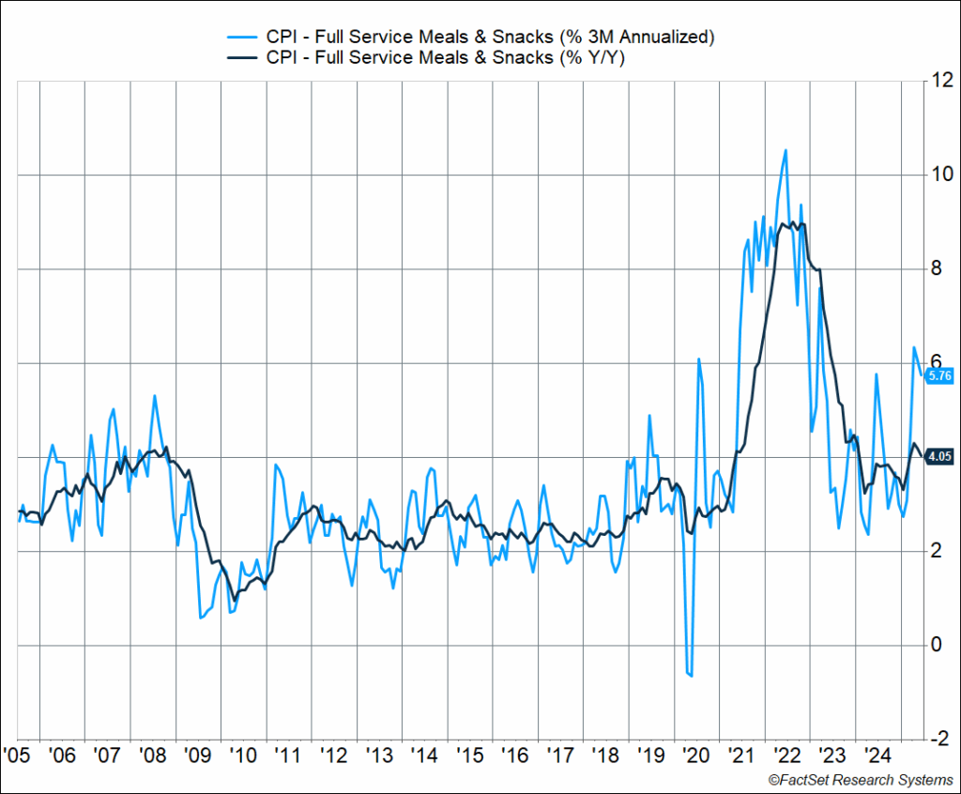
Normally, I’d say this is a symptom of underlying inflationary pressures, driven by strong labor income. But we know worker wages are easing, and it’s unlikely higher rents are a problem, which means the source of inflation is underlying food prices, and probably energy and transportation costs.
In fact, nationwide average diesel prices, which are more tied to food price inflation, are at their highest levels in almost a year, hitting $3.72/gallon.
Big Disinflationary Forces Are Also in Play
The biggest disinflationary force that is countering the inflationary impact of tariffs, and even higher food prices, is shelter (housing). Shelter makes up about 35% of the CPI basket and 44% of core CPI, and so it matters a lot. As a reminder, shelter inflation is made up of two major components:
- Rents of primary residences: 8% of CPI and 10% of core CPI
- Owners’ equivalent rent (OER): 27% of CPI and 34% of core CPI
We saw a big slowdown in May and June, especially for rents of primary residences. Over the last three months rents are up 3.2% annualized and OER is up 3.8%. As you can see below, on a monthly basis, shelter inflation has more or less normalized, at least relative to what we saw in 2018–2019.
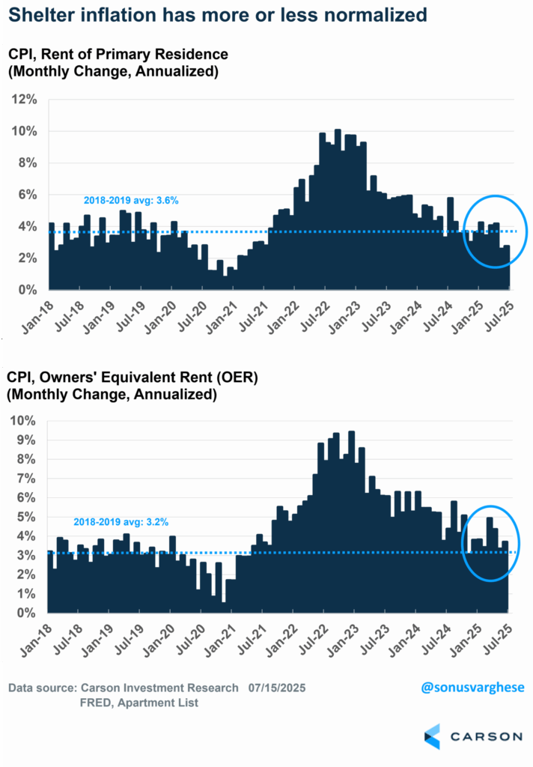
The good news is that if you look at the private market data, there may be more shelter disinflation to come. Private rental inflation data form Apartment Lists still shows nationwide rents declining 0.6% year over year, the 25th straight month of declines, which means rents should continue to ease.
We’re also seeing disinflation in key cyclical areas, notably travel:
- Airfares fell 0.1% m/m in June, the fifth straight month of declines. Last three months: -21% annualized
- Lodging including hotels/motels fell 3.6% in June, the fourth straight month of declines. Last three months: -15% annualized

This is not exactly good news as it tells me that travel demand is soft. And that’s likely because aggregate income is slowing even as monetary policy remains too tight (with higher rates). Aggregate income is the product of:
- Job growth, which is slowing
- Wage growth, also slowing
- Hours worked, which is running soft
Aggregate income growth rose just 3% annualized over the past three months. Think of that as the pace of nominal GDP, and if you shave off about 2% for inflation, that means real GDP growth is clocking in around 1%. That’s not recessionary but it is really soft, and well below the near 3% pace we saw in 2023-2024. Meanwhile, Fed policy rates are around 4.4%.
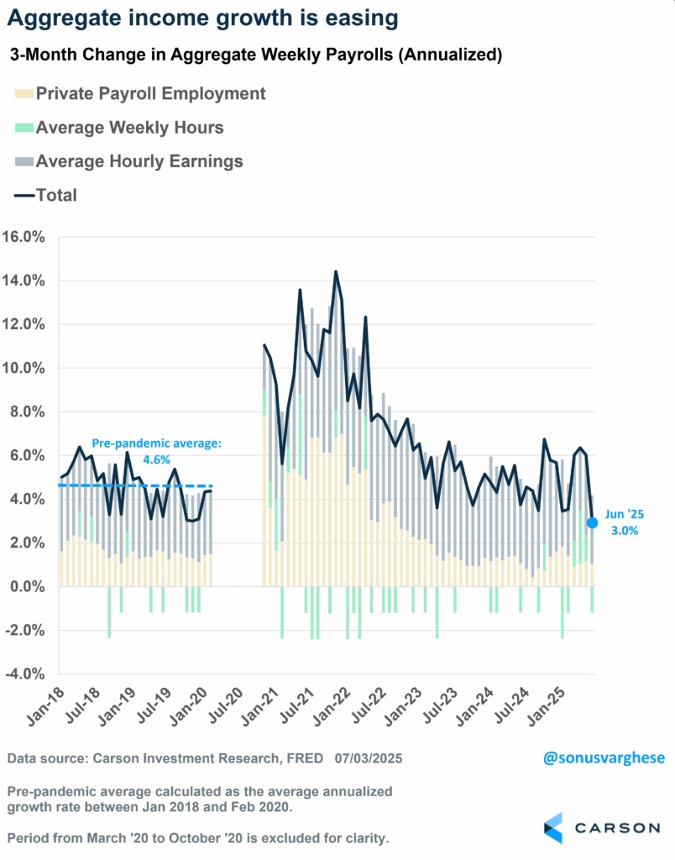
The Fed Is in a Bind of Its Own Making
Here’s the Fed’s conundrum right now: tariff-related inflation is clearly showing up. But there’s weakness in the economy, especially income growth.
- If they don’t cut rates, that weakness gets even worse, because policy is too tight.
- If they do cut rates that could make the inflation problem worse, with demand rising once again, boosting cyclical activity (and prices), adding to inflationary pressure from tariffs.
The Fed is in a bind. If they signal a cut, they could look very foolish if July, August, and September inflation data turn out to be hot, on the back of tariffs. And they likely don’t want to look foolish again, given what happened in 2021. From that perspective, they’re right to wait at this point.
This predicament could’ve been avoided if they’d cut rates back in January and March, for a total of 0.5%-points. Policy rates would’ve been in the 3.75–4.0% range, which would still be on the tighter side, but not extremely so (the Fed’s own estimate of “neutral” is 3%). And if tariff inflation showed up, they could’ve waited on more cuts even as the economy didn’t feel the weight of really tight monetary policy. In that scenario, we could’ve ended 2025 with rates below 4% instead of above, which may be likely now.
It may be December before a rate cut actually materializes, if at all. That means policy is going to remain extremely tight for another six months or so and will likely get even tighter if wage growth continues to ease.
Of course, that’s going to put even more pressure on Powell personally from the White House. President Trump was apparently close to firing him, even showing off a letter stating that to House Republicans. But he pulled back, for now. The pressure will only increase when the Fed skips cutting rates in July, and perhaps in September as well.

This newsletter was written and produced by CWM, LLC. Content in this material is for general information only and not intended to provide specific advice or recommendations for any individual. All performance referenced is historical and is no guarantee of future results. All indices are unmanaged and may not be invested into directly. The views stated in this letter are not necessarily the opinion of any other named entity and should not be construed directly or indirectly as an offer to buy or sell any securities mentioned herein. Due to volatility within the markets mentioned, opinions are subject to change without notice. Information is based on sources believed to be reliable; however, their accuracy or completeness cannot be guaranteed. Past performance does not guarantee future results.

S&P 500 – A capitalization-weighted index of 500 stocks designed to measure performance of the broad domestic economy through changes in the aggregate market value of 500 stocks representing all major industries.

The NASDAQ 100 Index is a stock index of the 100 largest companies by market capitalization traded on NASDAQ Stock Market. The NASDAQ 100 Index includes publicly-traded companies from most sectors in the global economy, the major exception being financial services.

The views stated in this letter are not necessarily the opinion of Cetera Advisor Networks LLC and should not be construed directly or indirectly as an offer to buy or sell any securities mentioned herein. Investors cannot invest directly in indexes. The performance of any index is not indicative of the performance of any investment and does not take into account the effects of inflation and the fees and expenses associated with investing.

A diversified portfolio does not assure a profit or protect against loss in a declining market.

Compliance Case # 8190582.1_072125_C

