More New Highs and a Jobs Surprise
- The S&P 500 had another big week last week and made more new highs along the way.
- After a negative Q1, stocks gained double digits in Q2, which historically has been a sign of more strength to come.
- The S&P 500 gained more than 5% in the first half of the year (better than average) and historically a gain of 5–10% at the midpoint has suggested more gains the rest of the year.
- June payrolls surprised strongly to the upside, but the dependence on growth in non-cyclical areas of the economy is somewhat concerning.
- Aggregate income growth has been easing, not at all to a recessionary level, but to a pace that may give us something like 1–2% GDP growth.
What a first half it was, as the S&P 500 was down close to 20% at the April lows and incredibly have come back to new highs already, one of the fastest recoveries ever.
We’ve discussed why this market may be like a slingshot and here’s another way to show why the shakeout and recovery in the first half could be a good sign for the bulls for the rest of 2025.
We found five other times that stocks were lower in the first quarter, then up more than 10% in the second quarter. The third and fourth quarters were higher every single time, with the rest of the year up nearly 16% on average. No, we don’t think stocks will do quite that well the final six months, but this does little to change our opinion the bulls should continue to do well the rest of this year.
The Sweet Spot
The S&P 500 gains an average of 4.3% the first half of the year, which makes the 5.5% gain in the first half of 2025 better than an average year. We found that years that were up 5–10% at the midpoint of the year actually tended to do quite well the rest of the year, higher a very impressive 13 out of 15 times and up 6.4% on average, better than the average final six months of 4.8%.
This very well could be the sweet spot for stronger performance and likely higher prices the rest of this year.
June Payrolls Beat Expectations, but Still Problems Beneath the Surface
June payrolls came in above expectations, with headline payrolls rising 147,000 versus expectations for a 106,000 increase. Moreover the unemployment rate eased a bit to 4.1%, versus expectations for an increase from 4.2% to 4.3%. On the face of it, this was a big positive because the "whisper numbers" were definitely more pessimistic. Fueling the pessimism, President Trump once again called for Federal Reserve Chair Powell's resignation on Wednesday evening, right around the time the President typically gets the payroll data. (No conspiracy here, as the President always gets the data ahead of the rest of us on the evening before the release.)
On to the details. As noted above, the headline payroll increase was very positive at +147,000, and we saw a net upward revision of +16,000 jobs for April and May too, taking the 3-month average to 150,000. The upward revisions are not really significant but it was welcome after a recent string of big downward revisions.
But outside of this (and these numbers aren’t trivial), the rest of the data was just about meh. To be clear, the labor market hasn't broken, but it's not really all that strong either. There are any number of issues under the hood. For one thing, job growth has really slowed. The economy has created 782,000 jobs over the first six months of the year, versus 985,000 over the first six months of 2024 and 1.5 million over the first six months of 2023. The pace of job growth has eased to 1.1% year over year, down from 1.3% in December 2024. Back in 2018–2019, payrolls grew at an annualized pace of 1.4%.
One difference is that immigration has really slowed this year and so the economy needs fewer jobs to keep up with population growth. This does help keep the unemployment rate lower, but it’s accomplished with slower job growth.
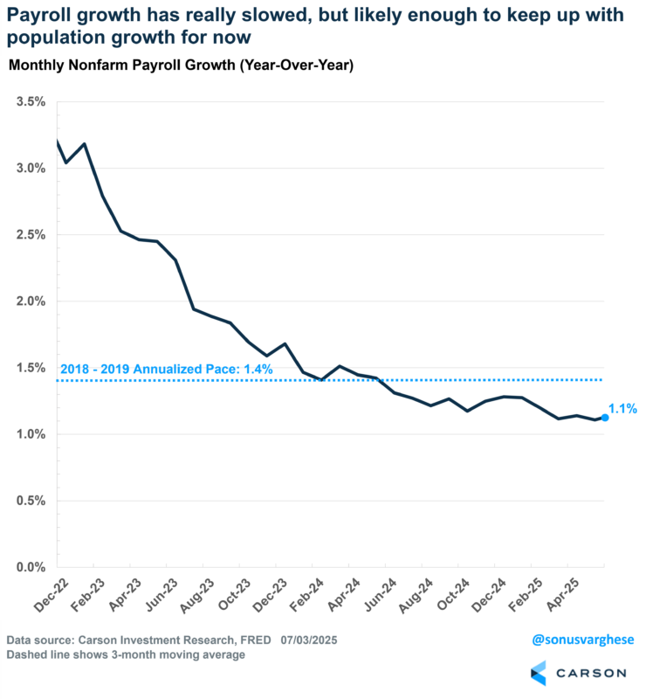
Immigration has slowed to an annualized pace of around 600,000, about a third lower than where it was in Q4 2024. And we'd already started seeing a slowdown after mid-2024, on the back of a big drop in unauthorized immigration, which has gone into reverse this year (with deportations). Analysis from Goldman Sachs suggests net immigration may slow even further to around 500,000 by year-end. It was running over two million between 2022 and 2024—there's a reason why payroll growth averaged about 254,000 a month during those three years. The economy basically had to create that many jobs to keep up with population growth. Of course, this also drove aggregate income growth well above the pre-pandemic trend, which in turn drove real GDP growth close to 3% annualized in 2023–2024.
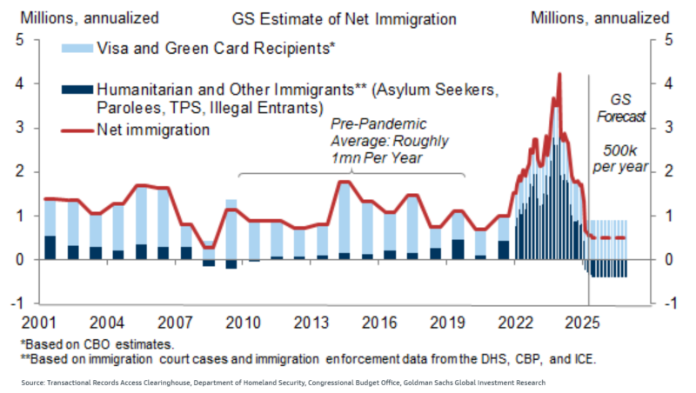
All said and done, if net immigration pulls back to 500,000, which would be much lower than the 2017–2019 pace (averaging about a million per year then), the economy likely has to create just 60,000–80,000 to keep up with population growth. And if the economy is doing that, and then some, we're unlikely to see the unemployment rate increase either.
The unemployment rate pulled back from 4.2% to 4.1% (actually, 4.24% to 4.12%), which was a big positive, along with the fact that the prime age (25-54) employment-population ratio rose to 80.7%, not far below the peak level of 80.9% we saw this cycle (last summer). Looking at the unemployment rate, the problem is that 130,000 people left the labor force, making the numbers look better. Employment within the household survey, which is where we get the unemployment rate from, rose just 93,000 in June, but keep in mind that this survey is significantly noisier than the establishment survey that gives us the headline jobs number. The household survey has a 95% confidence interval of +/- 600,000 versus +/- 150,000 for the establishment survey.
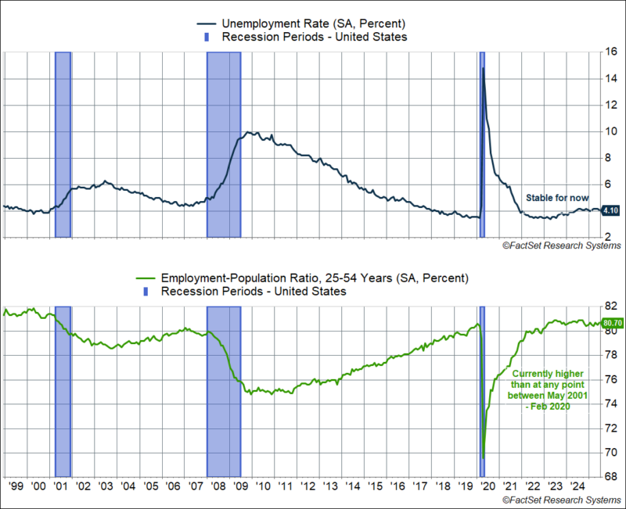
We do want to caution that none of this implies the labor market is breaking down. In fact, the ranks of multiple job holders is growing, which is positive, as this would happen only if the economy was creating more jobs, and workers can actually find more than one job. Multiple jobholders are now 5.4% of those employed, which is higher than it was at the end of last year (5.2%).
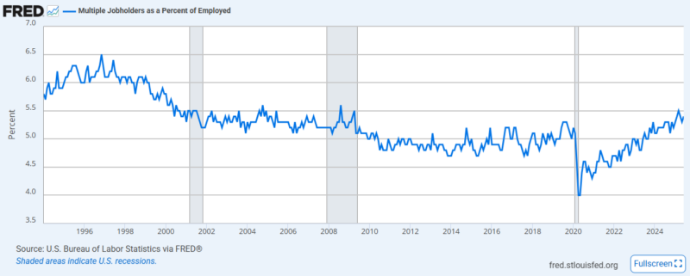

Weak Job Creation Breadth Across Industries
As has been the case for several months now, job growth is mainly being driven by non-cyclical areas of the economy:
- Government: +73,000 (50% of June payrolls)
  - Mostly state/local payrolls which, rose 80,000
  - Federal payrolls fell by 7,000
- Healthcare and social assistance: +59,000 (40%)
These two areas accounted for 90% of June payroll growth. There's likely something funky with seasonal adjustments going on here, especially for state/local government payrolls, which were boosted by education. In any case, these non-cyclical areas account for 69% of the 782,000 jobs created this year:
- Healthcare and social assistance: +405,000
- Government: +138,000
Leisure and Hospitality jobs have increased 64,000 this year, and construction is not bad either, with payrolls increasing by 35,000 year to date. The problem is that relatively high-paying cyclical areas have seen payrolls shrink:
- Manufacturing: -10,000
- Professional and business services: -11,000
- Tech (within information): -11,000
- Wholesale trade: -3,600
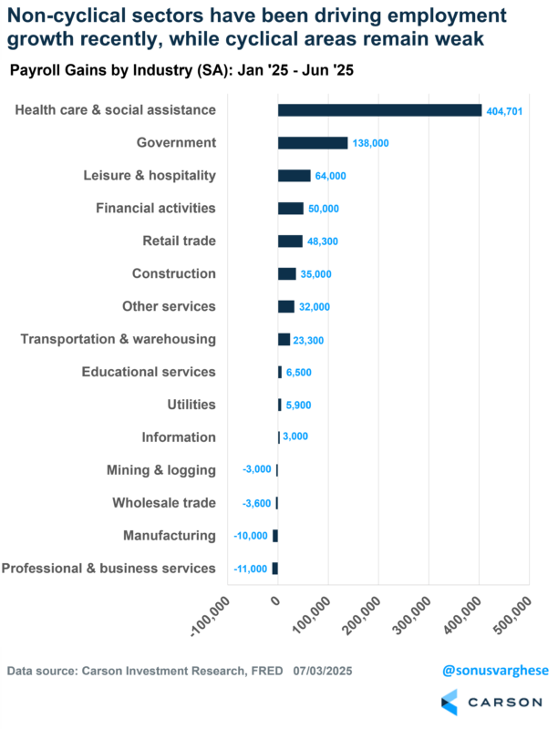
Goldman Sachs estimates that job growth in the industries most exposed to immigration policy changes declined to 7,000 on a three-month average basis through May, the latest month for which payroll employment data is available at the detailed industry level. That compare to 12,000 in April and 27,000 on average in 2024. Payroll employment in the industries most exposed to negative effects from higher tariffs declined by 1,000 on a three-month average basis through May (versus -4,000 in April and -3,000 on average in 2024), while employment in the industries most exposed to positive effects from higher tariffs increased by 1,000 (versus -5,000 on average in 2024).
So policy is definitely having an impact in different pockets of the economy.
Income Growth Is Easing
Average hourly earnings eased to an annualized pace of 2.7% in June and ran at an annualized pace of 3.1% over the past three months. For non-managers ("production and supervisory workers"), wage growth ran at an annualized pace of 3.5% over the last three months. This pace is almost exactly where we were pre-pandemic (January 2019–February 2020). By itself this is not a bad pace for wage growth, and clearly not a driver of inflation. It also tells you that that any supply shortages in the labor force are not having an aggregate impact on wages (lower supply would otherwise boost wages).
The big problem is that interest rates are in a very different place. Back in 2019 the fed funds rate was at 1.9% whereas it’s at 4.4% now. Of course, inflation is now running higher. Core personal consumption expenditure inflation (the Fed’s preferred inflation measure) is at 2.7% versus about 1.6% in 2019.
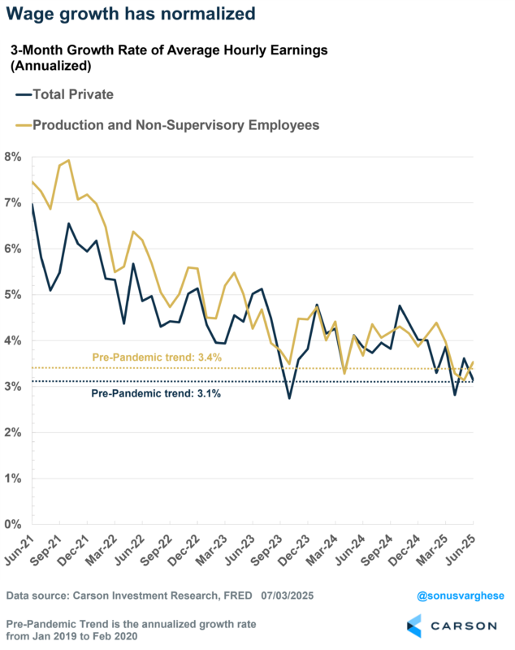
Easing wage growth along with easing job growth means aggregate income growth across the economy is also pulling back. Aggregate income growth is the product of…
- Wage growth, which is easing
- Payroll growth, which is easing
- Hours worked, which is slightly easing
Over the past three months, aggregate income growth has slowed to an annualized pace of 3% over the past three months, the slowest pace we've seen in a very long time (including 2018–2019). Note that this is nominal income growth and should give you a sense of the speed of nominal consumption growth and GDP growth (unless borrowing surges).
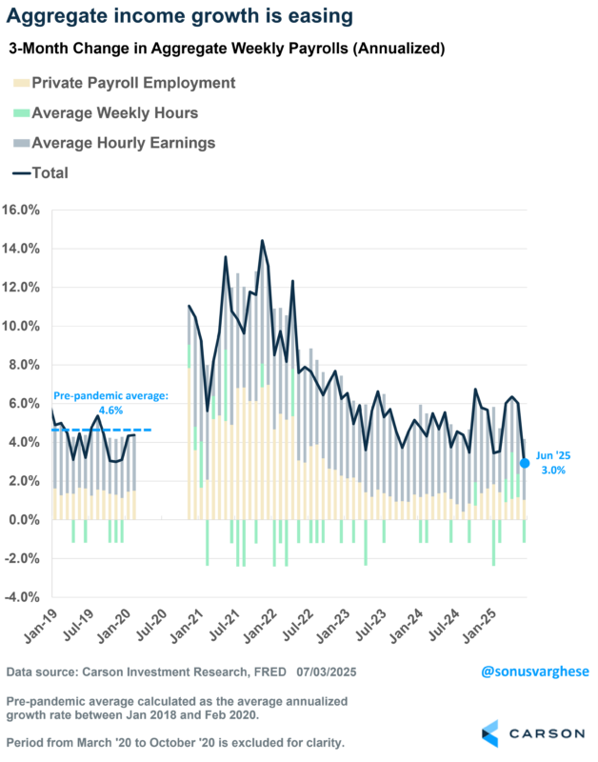
The big picture is that the labor market is cooling, with slowing job growth and wage growth, and that's driving aggregate income growth. That will likely pull down the rate of economic growth to something like 1–2%, especially since cyclical areas like manufacturing and housing are also a drag on growth right now thanks to tariff uncertainty and elevated rates. By no means is this recessionary, but the economy is clearly slowing. For any sort of acceleration going forward we need a catalyst, whether from fiscal or monetary policy.
This newsletter was written and produced by CWM, LLC. Content in this material is for general information only and not intended to provide specific advice or recommendations for any individual. All performance referenced is historical and is no guarantee of future results. All indices are unmanaged and may not be invested into directly. The views stated in this letter are not necessarily the opinion of any other named entity and should not be construed directly or indirectly as an offer to buy or sell any securities mentioned herein. Due to volatility within the markets mentioned, opinions are subject to change without notice. Information is based on sources believed to be reliable; however, their accuracy or completeness cannot be guaranteed. Past performance does not guarantee future results.

S&P 500 – A capitalization-weighted index of 500 stocks designed to measure performance of the broad domestic economy through changes in the aggregate market value of 500 stocks representing all major industries.

The NASDAQ 100 Index is a stock index of the 100 largest companies by market capitalization traded on NASDAQ Stock Market. The NASDAQ 100 Index includes publicly-traded companies from most sectors in the global economy, the major exception being financial services.

The views stated in this letter are not necessarily the opinion of Cetera Advisor Networks LLC and should not be construed directly or indirectly as an offer to buy or sell any securities mentioned herein. Investors cannot invest directly in indexes. The performance of any index is not indicative of the performance of any investment and does not take into account the effects of inflation and the fees and expenses associated with investing.

A diversified portfolio does not assure a profit or protect against loss in a declining market.

Compliance Case # 8141881.1_070725_C

