Stocks Pause on Geopolitical Risk, Fed

- Worries over geopolitics continue to swirl, with stocks flat on the week after falling slightly the week before.
- The third years of a bull market tends to be choppy, but most bull markets have powered forward, especially over the last 50 years.
- The Fed forecasted slower growth and higher inflation in its latest economic projections and kept rates on hold.
- Right now, the Fed is more focused on keeping inflation in check than supporting employment given the uncertain impact of tariffs.
- Thus far, the data suggests that tariff costs are mostly being paid by US businesses and consumers, but how this might feed through to inflation data remains uncertain.

Stocks fell three days in a row to end the holiday-shortened week but still managed to finish the week near flat thanks to Monday’s gains. Worries over the fallout from the Middle East conflict has traders on edge, while US economic data has been slowing some, and the Federal Reserve (“Fed”) is continuing to hold rates firm (which we discuss in more detail below).
This week though we want to highlight that the choppy action we’ve seen thus far in 2025 is actually perfectly normal for the third year of a bull market.
Year Three Tends To Be Choppy
The S&P 500 gained more than 22% the first year off the October 2022 bear market lows, followed by nearly another 34% in the second year. As anyone who has invested lately knows, things have been quite choppy and frustrating so far in 2025, especially from the February 19 peak to the near-bear market April lows.
As we noted in our Outlook 2025 coming into this year, the third year of a bull market tends to be choppy historically after a typical two-year surge off of lows. This didn’t mean we were bearish, as we said 2025 could still see stocks up 12 – 15%, but it did imply there could be some frustrating moments early in the year. Well, that has sure played out, so maybe we shouldn’t be so surprised by the third-year itch?
Here’s a table we’ve shared before and it shows that bull markets that make it to their second birthday tend to be rather weak in that third year, up just over two percent on average. In fact, the third year hasn’t been up double digits since the third year of the 1982 – 1987 bull market.
The good news? Years four and five of bull markets tend to be quite strong after the well-deserved break in year three. We’ll worry about that when we get there, but we remain constructive on this bull market (and the remainder of 2025) and we very well could have more gains coming down the road after this choppy year-three action.
This Looks Familiar
We love the quote from Mark Twain that “History doesn’t repeat, but if often rhymes.” Well, looking at past bull markets more closely shows similar action to what we’ve seen this year.
One of the longest bull markets ever was the 11-year bull market that started in 2009 after the Great Financial Crisis. Look at how that one saw a near-bear market at nearly the exact same time as this one. Back then we almost saw a bear market after the first US debt downgrade in August 2011, but what matters to us as investors is how things rebounded and continued to move higher.
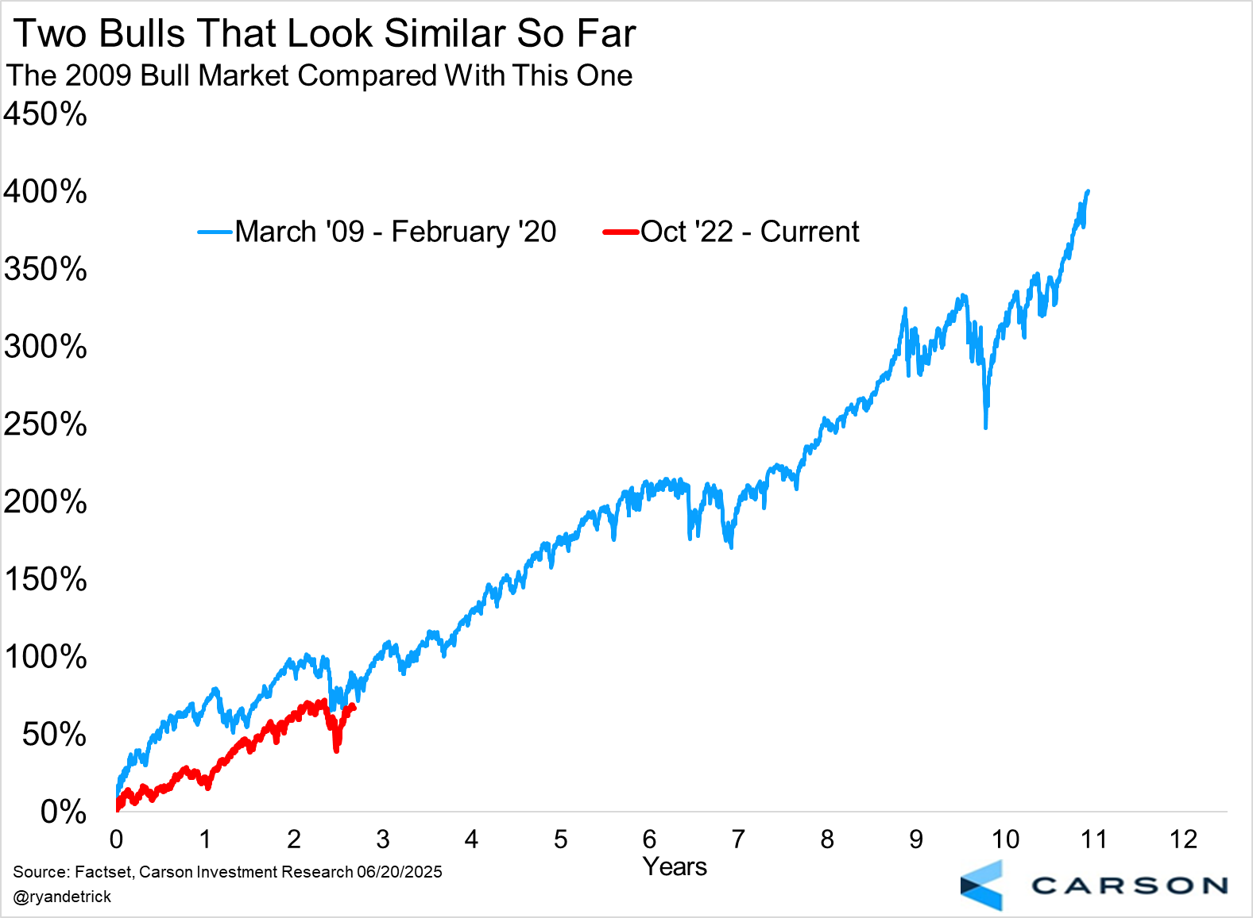
Here's another look at our current bull market, but this time compared to the longest bull market ever, from 1987 to 2000. That bull market was weak from around now until the end of its third year, but again, better times were coming once we got past the third-year itch.
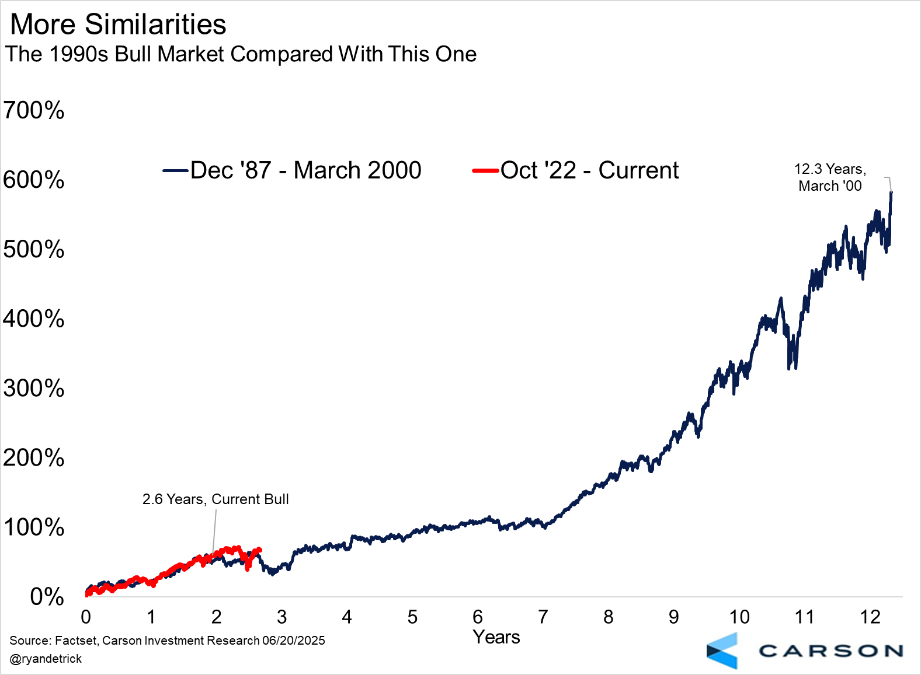
Lastly, here are the five bull markets over the past 50 years that made it past their second birthday and into their third year. Chop and frustration were perfectly normal in year three much of the time, but so was a bull market that lasted several additional years. In fact, five years is the shortest bull market we’ve seen for those that made it as far as we are now, with an average of eight years. We don’t think any investors will be too upset if there were that many years left to this bull market.
The Fed Stays on the Sidelines, Paralyzed by Tariffs and Who Is Paying Them
The Federal Reserve (“Fed”) kept rates unchanged at 4.25 – 4.50% at their June meeting, as was expected. The most notable change in their official statement was that they believed uncertainty about the outlook had decreased, but that’s only relative to a couple of months ago (post-Liberation Day). They still think uncertainty remains high, and this is the main theme behind everything we saw coming out of the meeting.
The Fed releases their Summary of Economic Projections, including the “dot plot” of rate forecasts, every quarter (March, June, September, December). The June update was widely anticipated as investors wanted to see how Fed members’ views have evolved on inflation, especially amid tariffs, and even unemployment since it's been rising recently (albeit, very slowly). Investors were also eager to see whether the December projection of two cuts (each worth 0.25%-points) in 2025 would change.
The Fed’s forecast moved in a "stagflationary" direction, with higher inflation expectations, higher unemployment, and slower real GDP growth. For 2025:
- Core inflation projection rose from 2.8% to 3.1%. It was 2.5% six months ago (Dec '24).
- Unemployment rate projection rose from 4.4% to 4.5%. It was 4.3% six months ago.
- Real GDP growth projection fell from 1.7% to 1.4%. It was 2.1% six months ago.
Given the core inflation projection, you would expect them to project a higher fed funds rate. On the other hand, the higher unemployment rate projection, along with lower output, would imply more cuts.
Net result: They did neither. The median rate projection for 2025 remained unchanged at 3.9%, or two cuts over the remainder of 2025.
Even looking beyond 2025, the Fed is now projecting higher inflation in both 2026 and 2027. They've reconciled this by reducing the number of rate cuts in 2026 to just one (each cut worth 0.25%-points). So including the 2 cuts in 2025, the Fed is now projecting a total of three cuts by the end of 2026 and four by the end of 2027. That's down a cut from what they projected in March.
In other words, the median Fed member expects the policy rate in 2027 to be 3.4%, only 1%-point lower than it is now. Note that the Fed's estimate of the "neutral rate" is 3.0% (the rate that is neither too accommodative, nor too restrictive). Of course, in reality it could be higher or lower. Still, it’s instructive that they think that policy has to be on the more restrictive side for the next three years.
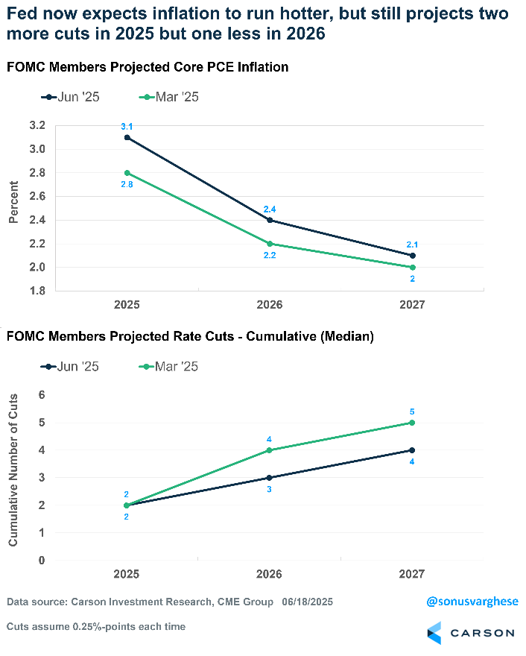

At the same time, the Fed is willing to tolerate higher unemployment for longer. Last September, when they started rate cuts with a bang (with a 0.5%-point cut) it looked like they weren't willing to tolerate an unemployment rate above 4.4%. And their actions at the time, 1%-point worth of cuts over three meetings, reflected that. But now, they've moved expectations of the unemployment rate to 4.5% for both 2025 and 2026 before dropping to just 4.4% by 2027.
This means that if it comes to choosing between their inflation mandate and their maximum employment mandate, the Fed will likely prioritize the former. Keep in mind that even if they cut rates twice this year to 3.9%, that still leaves rates in restrictive territory.
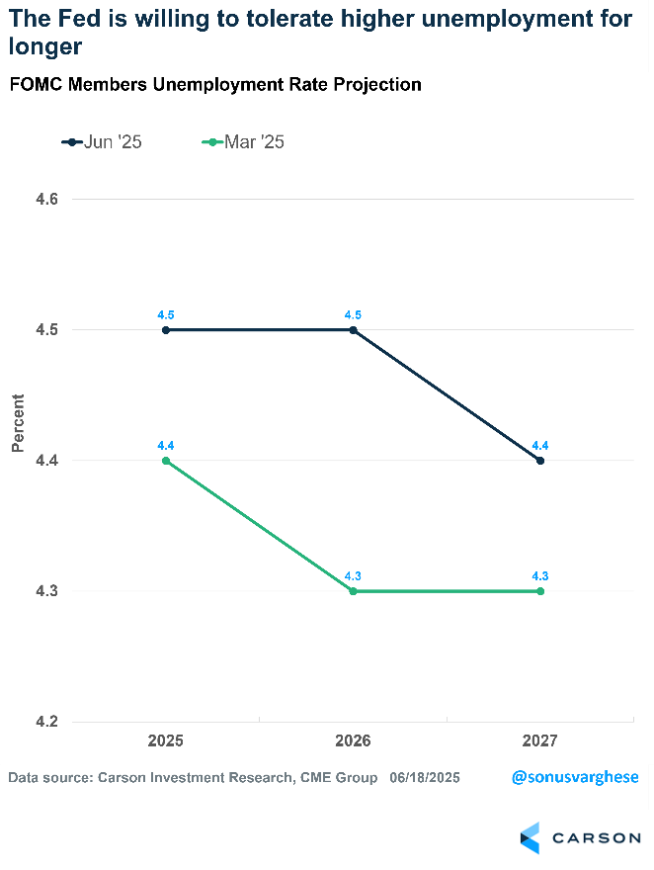
Nobody Believes the Forecasts and Things Can Still Shift a Lot
At the same time, Fed Chair Powell suggested we should be skeptical of the dot plots, or at least cautious, in his post-meeting press conference. He pointed out that the dot plot projections reflect a wide range of views, and that these are just point-in-time forecasts. They can change a lot.
Take the projected rate for 2025, for example. The median landed at 3.9% (implying two cuts), but there was a shift under the hood. In March, nine members projected two cuts for 2025, four members projected one cut, and four projected none (two more projected three cuts).
In June, eight projected two cuts while two remained at three cuts, which is why the median didn't move. However, as you can see below, seven members projected no cuts (three more than in March). And for 2026, forecasts were more widely dispersed than in March.
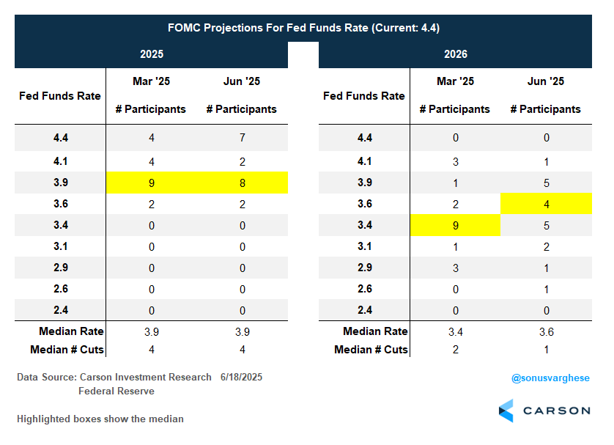
All this to say, members are all over the place and things can shift, by a lot. Exactly a year ago, Fed members projected just one cut across the rest of 2024. However, within six months, they'd cut the fed funds rate by a whole percentage point. This was because the data showed that labor market conditions were weakening, and they went big.
We could very well see inflation pick up, with core inflation rising from 2.7% to 3.1% (as they project), but it'll be interesting to see if they actually follow through on rate cuts if that happens, especially if the unemployment rate is below 4.5% (their estimate for 2025). Upward-trending inflation tends to spook central bankers, even more so because they missed the boat in 2021. If the unemployment rate doesn't pick up meaningfully from here, we may very well see no cuts in 2025, or perhaps just one cut in December. On the other hand, if the unemployment rate starts to move above 4.5%, the Fed may step in (unless inflation starts moving closer to 3.5%).
If that all sounds confusing, it is. There's a lot of uncertainty now, which is why the Fed feels stuck.
Paralysis

At the end of the day, the Fed seems paralyzed by the prospect of higher unemployment and higher inflation. For now, they are taking comfort in the notion that labor market conditions are consistent with maximum employment. This doesn't seem to reflect the reality we see in the underlying data, whether it’s payroll growth being driven by a few non-cyclical sectors, climbing continuing claims, or even an unemployment rate that has been rising ever so slightly since January (even though it still remains relatively low at 4.2%). Nevertheless, it’s the Fed's internal view that matters. The Fed is choosing to err on the side of believing the labor market is the lesser concern, which may work out well if the unemployment rate only ticks up ever so slowly (as it has over the first five months of the year).
On the inflation side, despite lower inflation data, they're forecasting inflation to be higher due to tariffs — essentially erring on the side of tight policy since they think inflation risk is skewed to the upside. Powell was quite explicit in saying that they're waiting to understand what will happen with tariff inflation, because somebody has to pay for the tariffs, whether it’s the manufacturer, the exporter, the importer, the retailer, and/or the consumer. He noted that each one of them is going to try not to be the one to pay for the tariffs. But ultimately, somebody will pay.
Who's Paying the Tariffs?
Somebody is already paying the tariffs because federal government revenue from import duties has surged. This shouldn't be a surprise. Despite the Liberation Day tariff pause, average tariff rates are about 10%-points higher than they were at the beginning of the year. But who is paying? For starters, right now, it does not look like foreign exporters are paying the tariffs.
May import prices were flat but if you exclude fuels, import prices rose 0.3%. Import prices exclude the tariff duty paid at US customs. If foreign exporters were paying for the tariffs, you would expect them to reduce prices for goods they export to the US pre-tariff, and import prices would be much lower. Instead, it's gone the other way across the board for every end-use category
- Capital goods: +0.2% (2-month April – May annualized pace: 5.5%)
- Industrial supplies/materials ex fuels: +1.3% (2-month annualized 10.7%)
- Autos & parts: +0.1% (2-month annualized 1.8%)
- Consumer goods ex autos: +0.2% (2-month annualized 4.3%)
Bloomberg constructed "tariff-inclusive" import price indexes for major US trading partners by adding the tariff increase to the published price index data for each month. They found that the "tariff-inclusive" import price index increased in line with tariffs, or by about 11% through the end of May, versus the year-to-date effective tariff increase of 11.1%-points.
Looking specifically at China, tariff-inclusive import prices fell 34.5% in May, but that reflects the temporary rollback in tariffs negotiated last month in Geneva. Tariff-inclusive import prices are up 26.4% since January, compared to the 28.3%-point increase in tariff duties through May.
Canada and Mexico seem to be absorbing more of the duties.
- Tariff-inclusive prices for Mexico are up 4.4% year to date while tariffs are up 5.1%-points.
- Tariff-inclusive prices for Canada are up 2.7% year to date while tariffs are up 4.8%-points.
On the other hand, tariff-inclusive import prices from Europe are up 9.9% year to date, which is more than the 9.1%-point increase in tariffs this year.
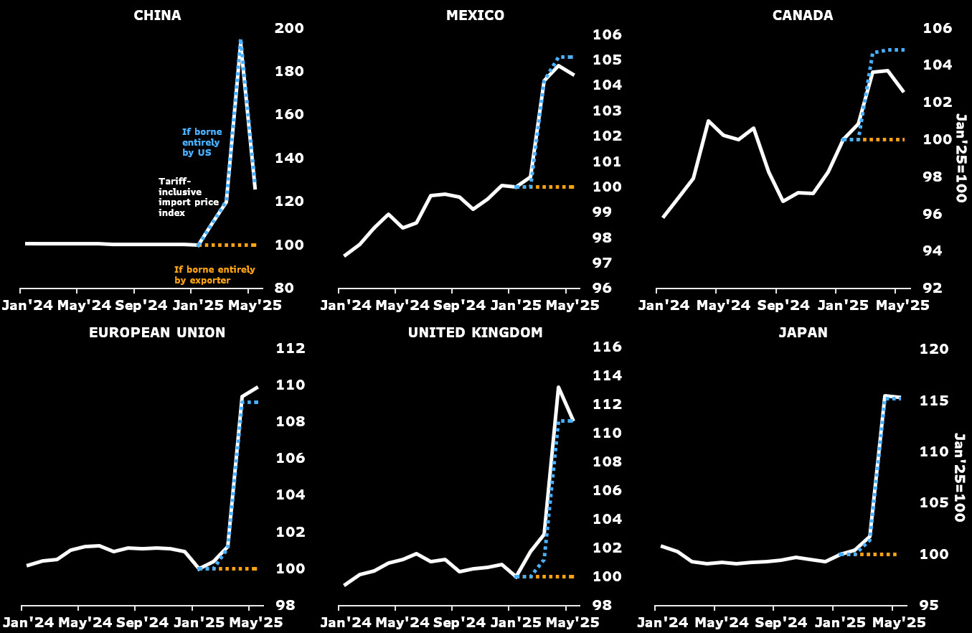
All this suggests that most of the cost increase is being eaten on the US side. Of course, the question is whether businesses eat it (via a hit to margins) or consumers (via inflation).
The other consequential question is when and how all this shows up in the data. The answer to the second question is especially relevant for the Fed, as they’re going to wait till the data tells them what’s happening with tariffs. And we could be waiting a while, especially given the vagaries of how official inflation data is measured. As we’ve found out over the last few years, there are significant lags in the official data relative to what’s happening on the ground. So even if tariffs push up inflation for a month or two (as businesses pass higher costs to consumers), we may not see it reflected in the official data until later. It may not even show up all at once, with prices for different items not rising in tandem.
The Fed has the option of looking through all of this, since tariffs are likely to be one-off price increases anyway. They can focus on protecting the labor market, which is weakening. However, instead of getting ahead of the data, they’ve opted to wait. The risk there? If the unemployment rate starts to surge, it can get out of control quickly, and policy by design is going to be behind the curve.
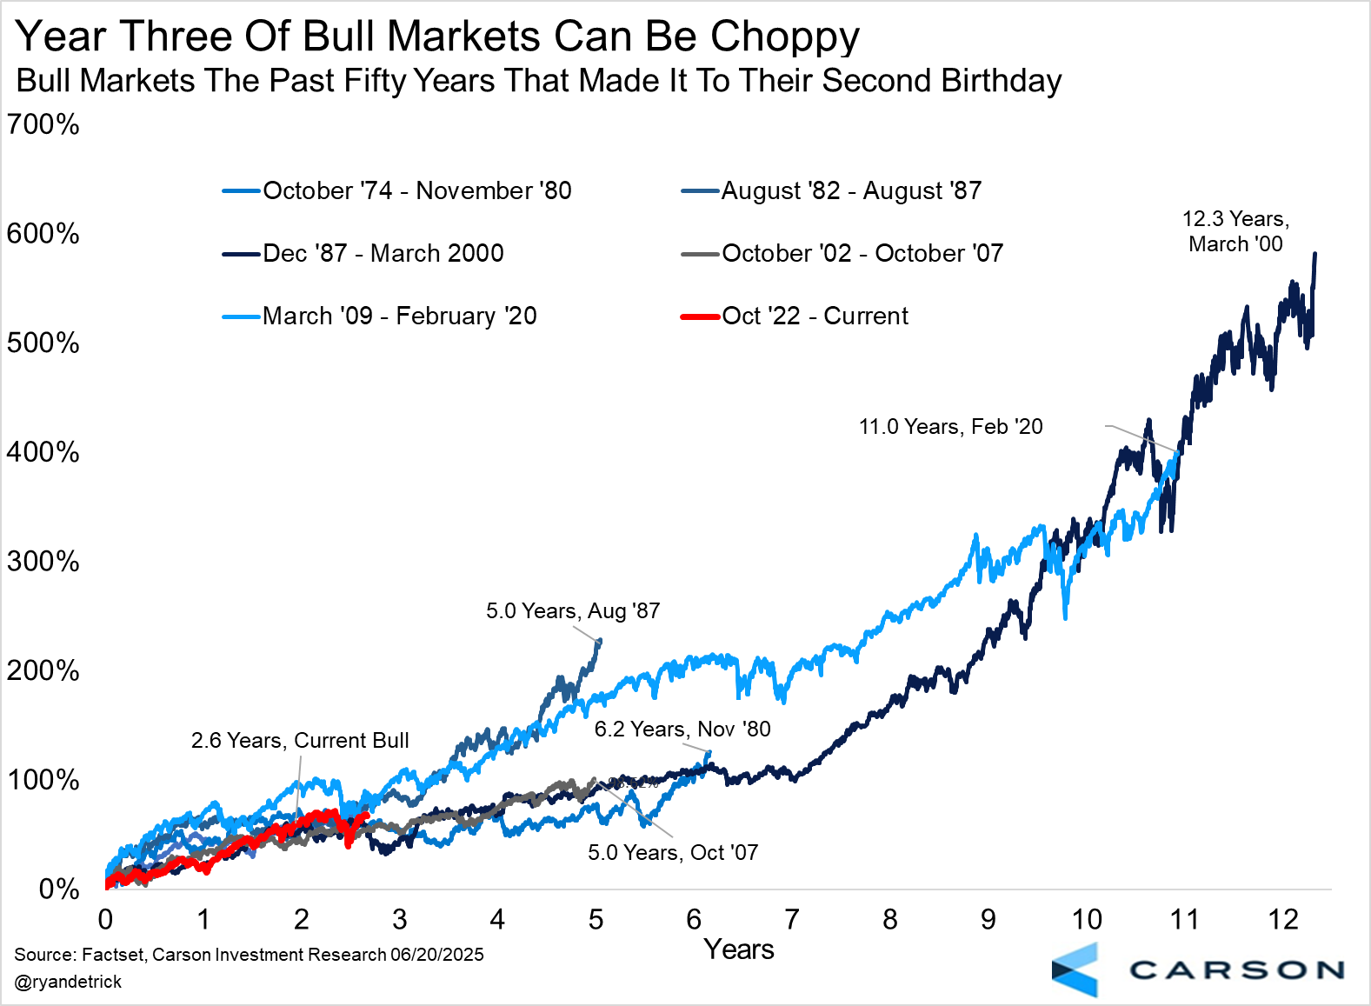

This newsletter was written and produced by CWM, LLC. Content in this material is for general information only and not intended to provide specific advice or recommendations for any individual. All performance referenced is historical and is no guarantee of future results. All indices are unmanaged and may not be invested into directly. The views stated in this letter are not necessarily the opinion of any other named entity and should not be construed directly or indirectly as an offer to buy or sell any securities mentioned herein. Due to volatility within the markets mentioned, opinions are subject to change without notice. Information is based on sources believed to be reliable; however, their accuracy or completeness cannot be guaranteed. Past performance does not guarantee future results.

S&P 500 – A capitalization-weighted index of 500 stocks designed to measure performance of the broad domestic economy through changes in the aggregate market value of 500 stocks representing all major industries.

The NASDAQ 100 Index is a stock index of the 100 largest companies by market capitalization traded on NASDAQ Stock Market. The NASDAQ 100 Index includes publicly-traded companies from most sectors in the global economy, the major exception being financial services.

The views stated in this letter are not necessarily the opinion of Cetera Advisor Networks LLC and should not be construed directly or indirectly as an offer to buy or sell any securities mentioned herein. Investors cannot invest directly in indexes. The performance of any index is not indicative of the performance of any investment and does not take into account the effects of inflation and the fees and expenses associated with investing.

A diversified portfolio does not assure a profit or protect against loss in a declining market.

Compliance Case # 8096786.1_062325_C

