S&P 500 Approaching All-Time High but US Economic Momentum Slowing
- The S&P 500 moved higher again last week, inching closer to a new all-time high with the index breaking back above 6,000 on Friday.
- It isn’t just the US—this is a global bull market, with many countries around the globe up double digits and hitting new highs.
- 2025 has seen unusual strength the day after a down day, another clue this is a strong bull market.
- The Dow Jones Industrial Average turned 129 recently and we take a look at 12 interesting facts about ol’ Papa Dow this week.
- May payrolls were ok, but there was some weakness under the hood and US economic momentum has been slowing (but not stalling).
Inching Closer to New Highs
Stocks had some drama last week as the president of the United States and the world’s richest man had a very public falling out, but that did little to slow down the bull market. The S&P 500 is now just a chip shot away from new highs, something that was unfathomable to most this time two months ago.
Although US returns have been fairly muted this year after the back-to-back 20% gains the previous two years, what might surprise many US investors is that most global stock markets are up nicely, with many making new 52-week or all-time highs. This is why having a globally diversified portfolio can benefit US-centric investors, as the US won’t always lead. The good news is we do anticipate the US may play catch up the rest of 2025, but big picture, this is a global bull market and investors are being rewarded for being in risk assets.
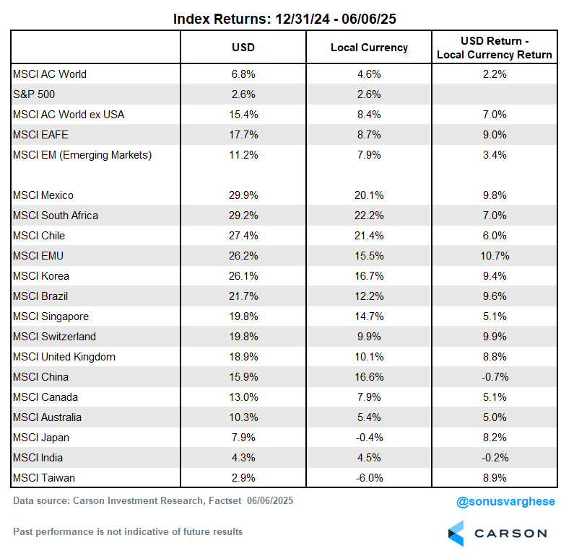
The Rocky Balboa Market
Something unique about 2025 so far is how stocks have bounced back when they’ve been down. We playfully have dubbed it the Rocky Balboa market, as Rocky might get knocked down, but he always got back up (except in his first fight with Clubber Lang in Rocky III, but he won the climactic rematch).
In fact, the day after a down day has seen the S&P 500 up an average of 0.29% this year, which would rank as one of the best years ever. Since 1980, only 2020 would be better than 2025 so far. Other years that saw big returns after down days were 2003, 2008, 2009, 2020, and of course now. Yes, 2008 was a horrible year for stocks, but those other three years all were solid years after hiccups in the first quarter. This is another reason we expect to potentially see this bull market continue with a solid second half of the year.
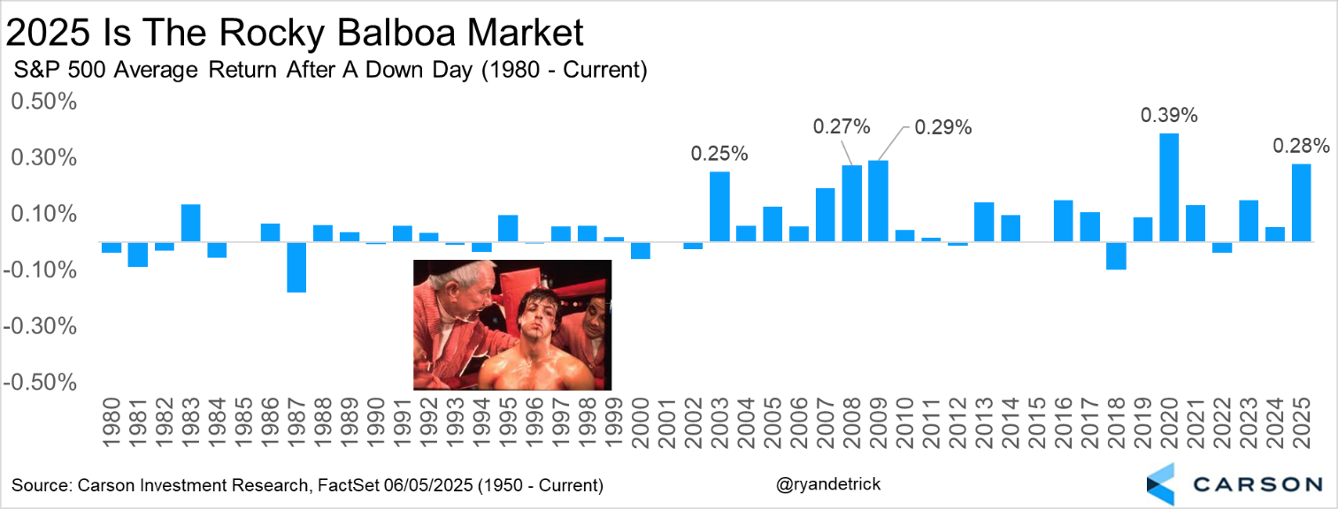
Happy Birthday, Papa Dow!
We had a big birthday last week, as the Dow Jones Industrial Average turned 129 years young! It is the second oldest index (the Dow Jones Transportation Average is older) and was first calculated on May 26, 1896 by Charles Dow, co-founder of both the Wall Street Journal and Dow Jones & Company.
The index started with just 12 companies, representing major segments of the economy at the time, like leather, steel, and sugar. It was meant to gauge the overall health of the industrial sector. Of course, today it has 30 of the largest publicly traded companies (as it has been since October 1928) and is still widely considered one of the most well-known and cited indices in the world, as well as one of the best gauges for the overall health of the US economy.
Here are 12 fun stats to celebrate the big birthday:
- None of the original 12 are left. General Electric was the most recent of the 12 to be included, but was it removed October 2018. Another fun stat, it was removed two other times in 1898 and again 1901, for a total of three times.
- The Dow started with 12 stocks, but moved to 20 in 1916 and 30 in 1928. To this day, many think 30 is still too small a sample size, but it doesn’t look like this will change anytime soon. The Dow includes three of the “magnificent seven” technology-oriented megacap stocks, Apple, Microsoft, and Nvidia. (These are also the three oldest.)
- A committee at S&P Dow Jones Indices picks the components and there isn’t a ridged process or formula.
- The best year ever? A cool 82% gain in 1915, which also happened to be in the middle of World War I.
- 1931 takes the cake for the worst year ever, down nearly 53%. The Great Depression sparked this weakness, as stocks eventually fell 86% from their peak in 1929.
- The index is price weighted, meaning a stock with a higher price will have more impact on the daily change. For example, when UnitedHealth Group (UNH) had their recent troubles, this made the Dow returns look worse than it was under the surface or compared with market-weighted indexes like the S&P 500.
- Average is in the name, but it isn’t an average, it is an index.
- It was up a record nine years in a row in the 1990s.
- It fell 20.5% on December 14, 1914 as World War I broke out, but the worst day ever was the 22.6% crash on October 19, 1987, better known as the Crash of 1987 or Black Monday today.
- The Dow has gained double digits in one day nine times, with the most recent coming off the COVID lows on March 24, 2020. The best single day ever was a 15.3% gain on March 15, 1933. Ides of March indeed.
- The best part about the Dow is how much wealth it has created over generations for investors (if you were able to track the index). It started trading at 40.94 and recently peaked at more than 45,000. And that doesn’t even include dividends! Along the way there have been many crises, worries, and panics, yet stocks have eventually moved higher every single time. Here’s our always popular Chart of Worries showing just this.
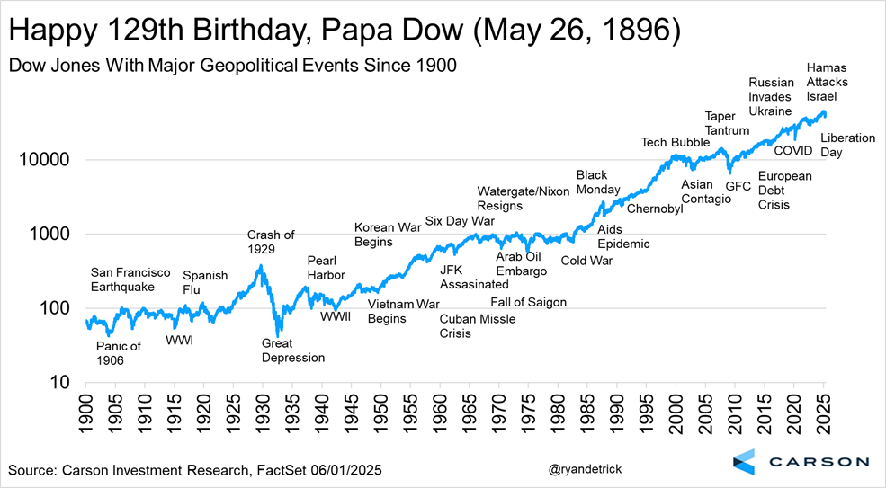
- Lastly, the Dow closed at about 100 in 1906 and 1,000 in 1972. It took until 1999 to get over 10,000 and recently peaked above 45,000 in December. The fasted 1,000 point milestone to milestone interval ever was only five days from 32,000 to 33,000 in March 2021. Any bets on when it breaks 100k?
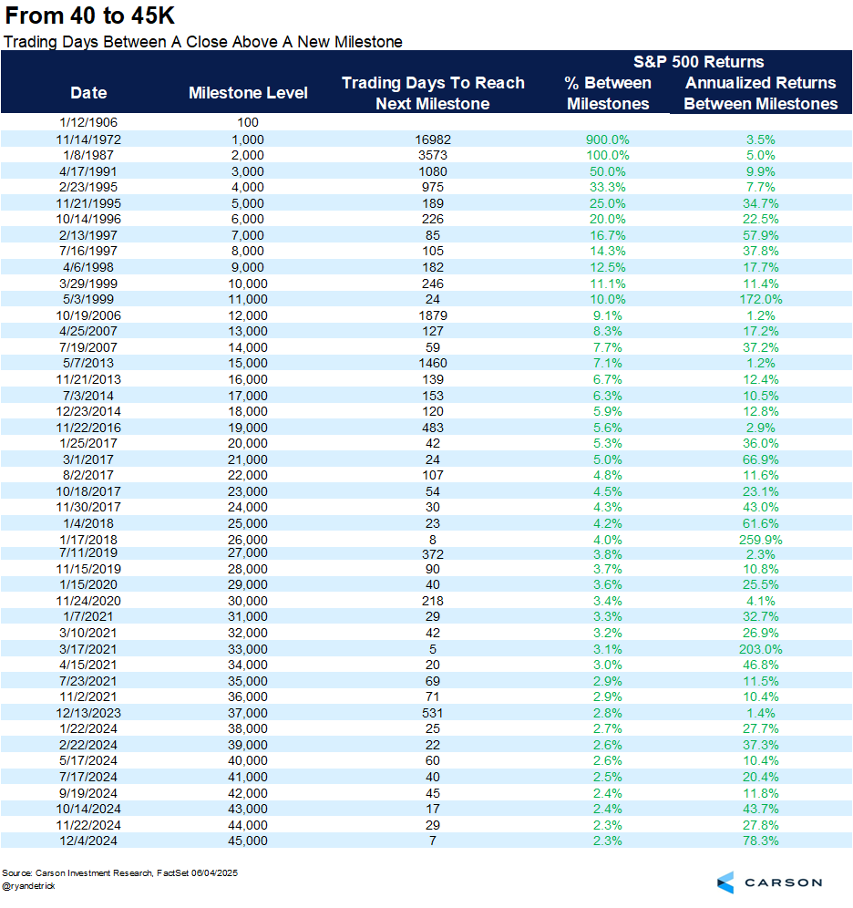
Congrats again to the Dow on an amazing run and to all the investors over the years who have benefited by sticking to their investment plans.
May Payrolls Were OK, but There’s Weakness Under the Hood
On the face of it, the May payroll report was ok. The economy created 139,000 jobs in May (above expectations for a 126,000 increase) and the unemployment rate was unchanged at 4.2%. But pop the hood and there’s cause for concern.
For one thing, we got a net 95,000 downward revision of jobs created in March and April:
- March was revised down by 65,000, from 185,000 to 120,000. Remarkably, this was first reported as 228,000.
- April was revised down by 30,000 from 177,000 to 147,000.
This brings the 3-month average to 135,000. That’s well below the 209,000 average we saw back in December, and even below the 2019 pace of 166,000.
The payroll data is based on surveys of over 120,000 businesses representing over 630,000 worksites. This is much larger than any private surveys but there’s still noise associated with it (which is why we get large revisions). The “statistical significance at the 90 percent confidence level” is 136,000. What does that mean? If you’re well above this number, you can be fairly sure job growth is positive. If you’re at this number, like right now (and also seeing downward momentum), we can’t be sure the economy is actually creating any net jobs.
Because immigration has more or less completely collapsed, the economy probably needs about 100,000 jobs (if not less) to keep up with population growth, since it’s growing more slowly. And if it does this, as seems to be the case if you take the 3-month average at face value (and assume no more downward revisions), the unemployment rate shouldn’t increase.
The unemployment rate actually comes from a survey of about 60,000 eligible households, and it is much noisier than the payroll survey. That’s why it’s more useful to look at ratios for this survey like the unemployment rate or employment-population ratio. The May household survey showed that employment fell by almost 700,000, but the confidence interval here is 600,000 (like I said, it’s noisy). At the same time, the denominator for the unemployment rate, i.e. the labor force, also fell by 625,000. That’s why the unemployment rate remained unchanged at 4.2%. A labor force that is shrinking is not great for the economy, but it will hide weakness when calculating the unemployment rate.
Meanwhile, the prime-age (25-54) employment population ratio pulled back from 80.7% to 80.5%. By itself, that’s still pretty good and higher than anything we saw from 2001-2019, but the question is whether it sticks around here. I like to look at this metric because it helps offset demographic issues (due to an aging population) and issues around how “unemployment” is defined.
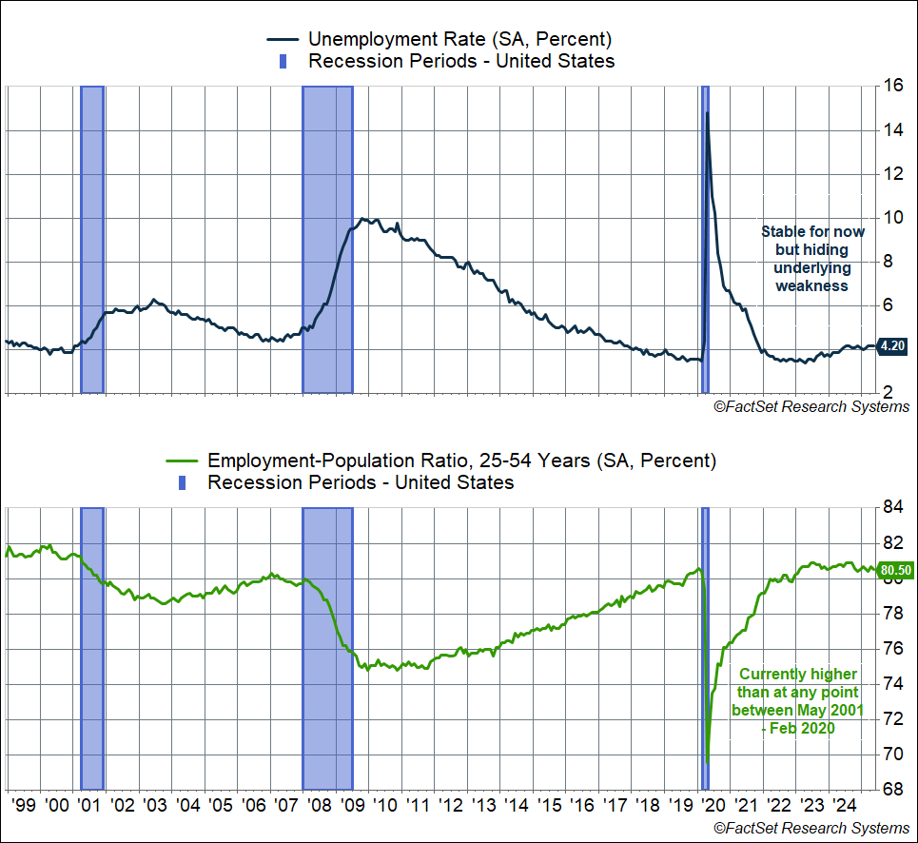
Distribution of Job Growth Isn’t Great
The composition of job growth across sectors also gave less cause for comfort. Close to 63% of jobs created in May were in the non-cyclical sectors of health care and social assistance and private education (+87,000). Employment in cyclical areas like professional and business services, information (including technology jobs), and manufacturing fell by 24,000. The one positive is that leisure and hospitality jobs rose by 48,000—these aren’t high-paying jobs but it tells you that service sector activity like restaurant spending and travel remain healthy.
The composition of job growth in May follows a theme we’ve seen over the past year, and especially year to date. Over the first five months of this year, the economy has created 619,000 jobs (averaging 124,000 per month). Here’s the distribution among some key sectors:
- Health care, social assistance, and private education: 379,00 (61%)
- Government: 33,000 (5%)
- Leisure and hospitality: 74,000 (12%)
That’s really skewed, and not exactly what you would see if the economy were firing on all cylinders. The big picture is that cyclical areas of the economy are weak, buffeted by both tariffs / tariff uncertainty, and high interest rates.
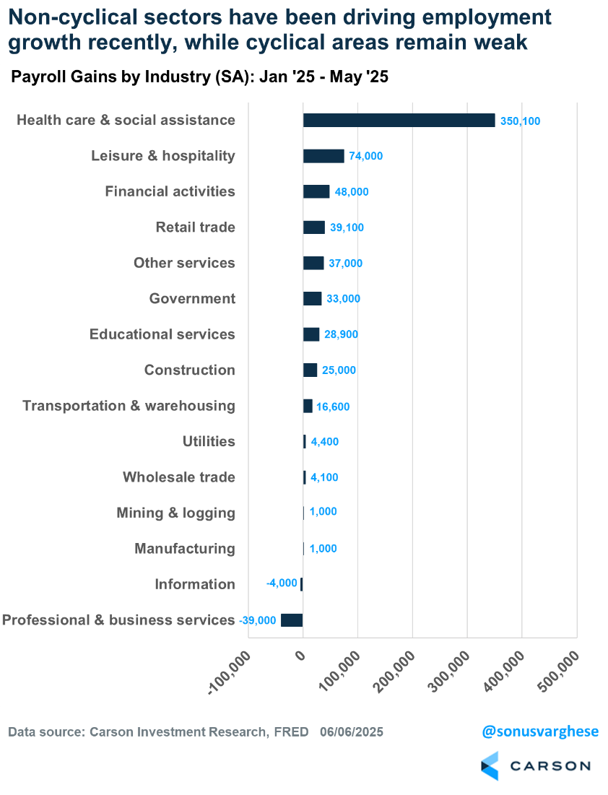
Tariff Uncertainty + Fed Pause = More Slowing
We still have no idea what the end game is yet with many of the announced but paused tariffs. The average effective tariff rate in the US was about 2% at the start of the year. It’s certainly going to be much higher than that. It’s currently around 15%, but it’s an open question whether it stays there, or moves closer to 10%, or moves even higher than 20%.
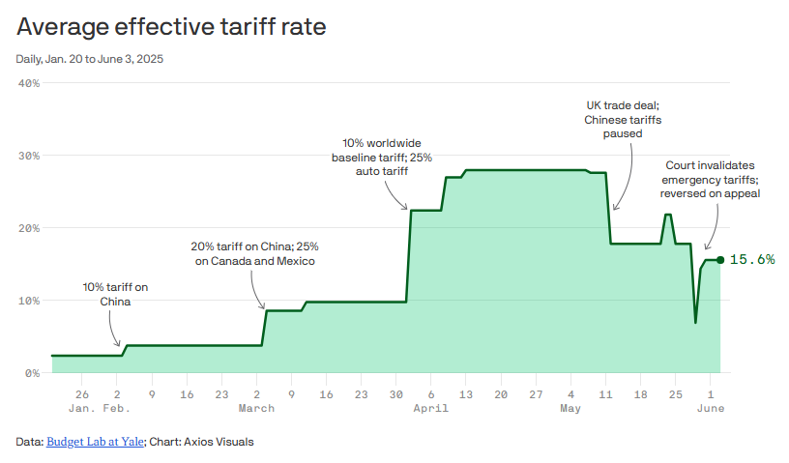
Ultimately, American businesses will figure out how to live with these tariffs. Either they take the hit to their margins or pass price increases to consumers. But the ongoing uncertainty, and possibility of inflation flaring up again, is likely to keep the Fed on the sidelines for longer.
Moreover, with the headline data (like the unemployment rate) suggesting the labor market is ok, the Fed may believe it has time to wait for more data. The market’s currently expecting about two more 0.25%-point cuts from the Fed this year, but we may not even see one if the unemployment rate doesn’t move much higher than 4.5% (and given the falloff in immigration, it may not). So what looks like labor market resiliency on the surface may hide weakness under the surface.
US LEI Deteriorates
Right now, our proprietary US Leading Economic Index (LEI) is telling us that economic momentum is slowing and the economy is growing below trend. At the same time, the current level of the LEI is still above levels we would normally associate with a recession, or even just prior to it—you can see in the chart below that the LEI had deteriorated much more even prior to the start of the 2001 and 2008 recessions.
Current levels are similar to what we saw in mid-2022, when recession risks were elevated but the economy never plunged into an actual recession. This was a big reason why we didn't call for a recession anytime between 2022 and 2024. This was in sharp contrast to all the recession calls you saw in 2022 and 2023, including signals from other popular leading economic indicators. You can also see that the LEI deteriorated in a sharp manner back in 2018 amid the trade war and Fed tightening. But the economy avoided a recession back then too.
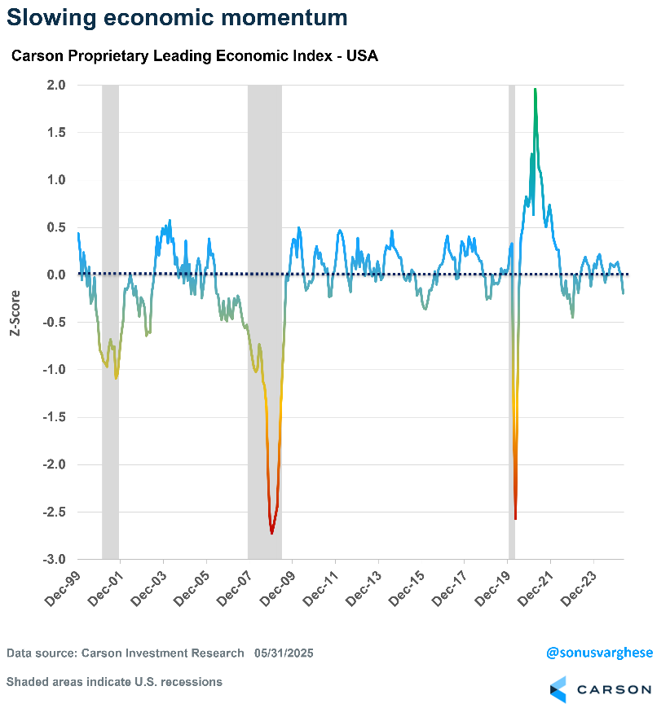
Monetary Policy Getting Tighter
Also keep in mind that the Fed’s pause on rate cuts is not just maintaining a benign status quo—policy is implicitly getting tighter because wage growth is easing. Historically, when the fed funds rate rises well above the pace of wages, it means increasingly tight monetary policy, which has constricted the economy and ultimately led to recessions.
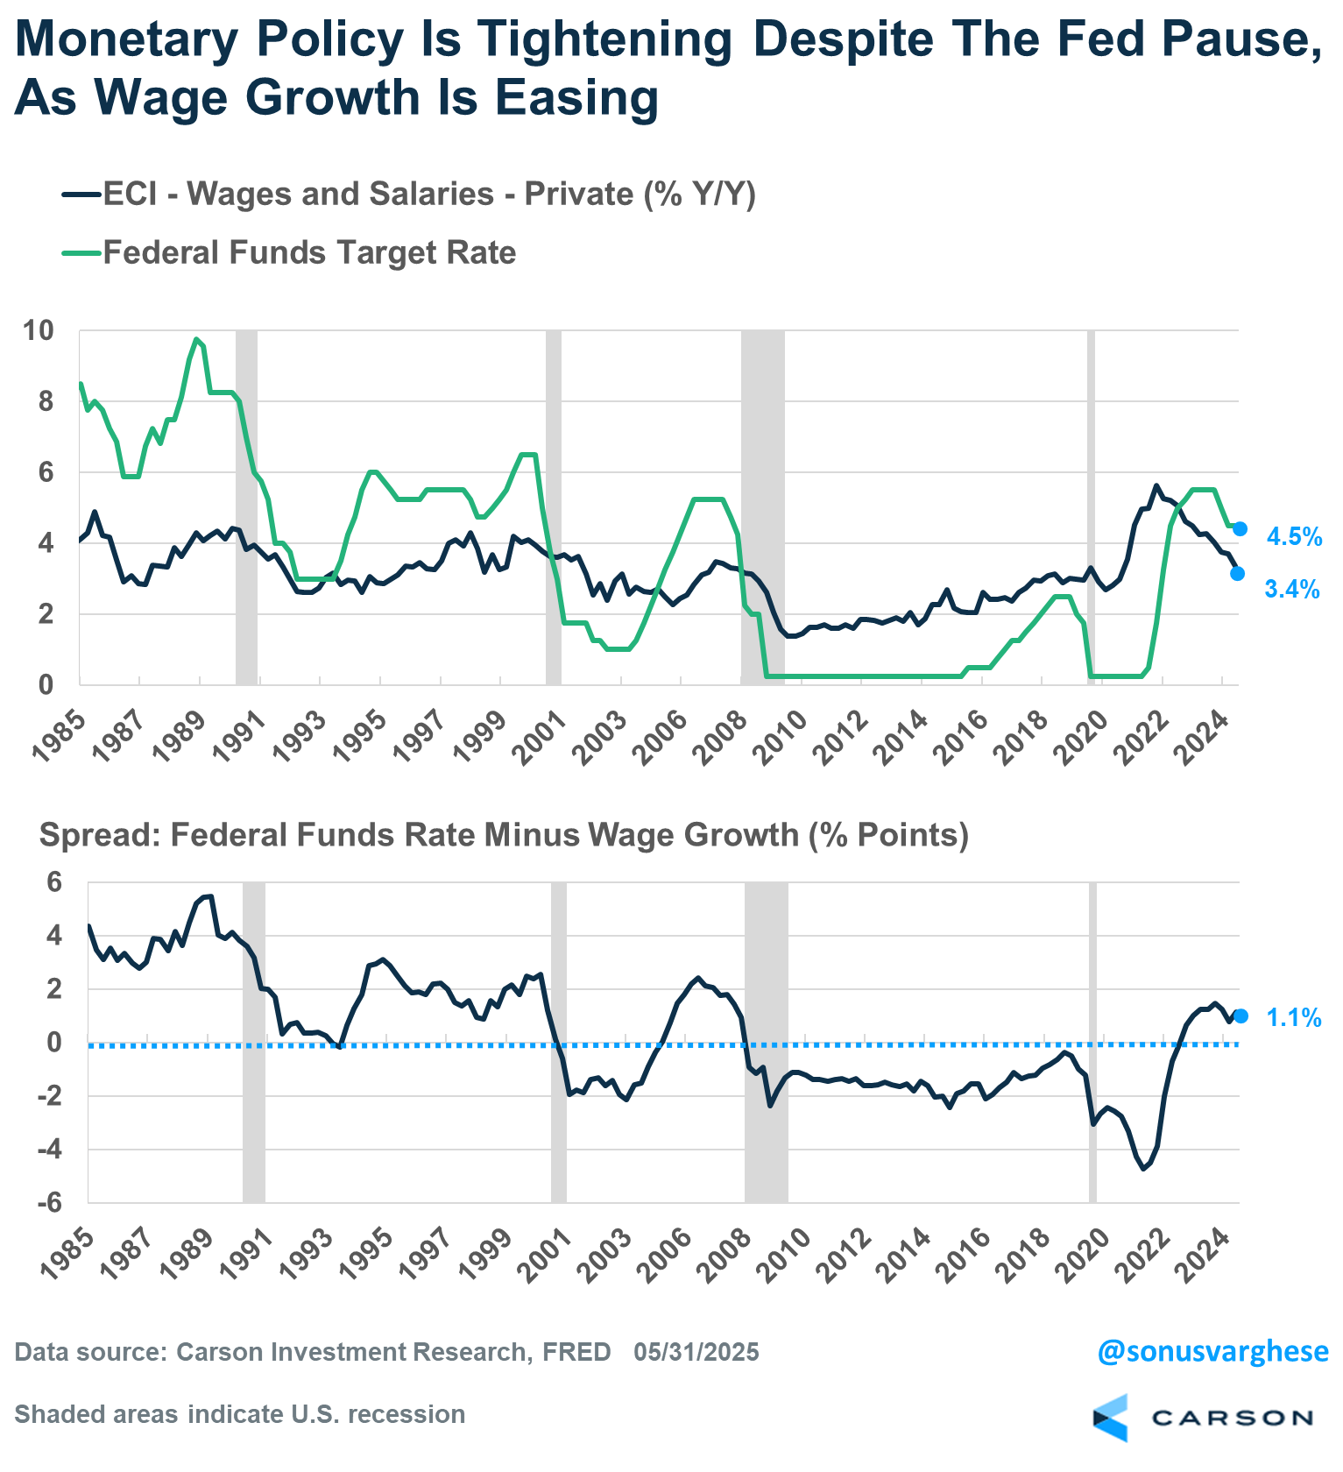
Trouble in Housing
In short, policy is tight right now and it’s going to remain tight until the Fed sees more data. And that’s going to drag even more on cyclical areas of the economy, notably housing. We have a big problem in housing and some of that is because of what happened soon after Covid.
Most homeowners were able to buy or refinance at mortgage rates close to 3% in 2020 – 2021, and that meant more money in household pockets. But once rates surged in 2022, new homebuyers were locked out of the market as affordability collapsed. In addition to high mortgage rates, inventory was low and so prices moved higher. Existing homeowners were reluctant to put their house on the market because that would involve switching from an ultra-low mortgage rate to something well above 6%. Higher home prices are good for homeowners unless you want to move to another home (because that home is also more expensive) with a higher mortgage rate. Of course, this can go on for only so long. If you have to move, you have to move and this year we’re starting to see inventory normalizing as more homes are put on the market. But that also means prices are easing in several cities across the country, notably in the South.
Even as supply is increasing, elevated mortgage rates close to 7% are creating a demand side problem as well. Mortgage applications are up 17% since last year, but they’re still a whopping 40% below average 2019 levels. Refinancings are down 65% from average 2019 levels. Remember, this a key mechanism by which homeowners can access home equity (which they have more of), but the door is shut because of elevated rates.
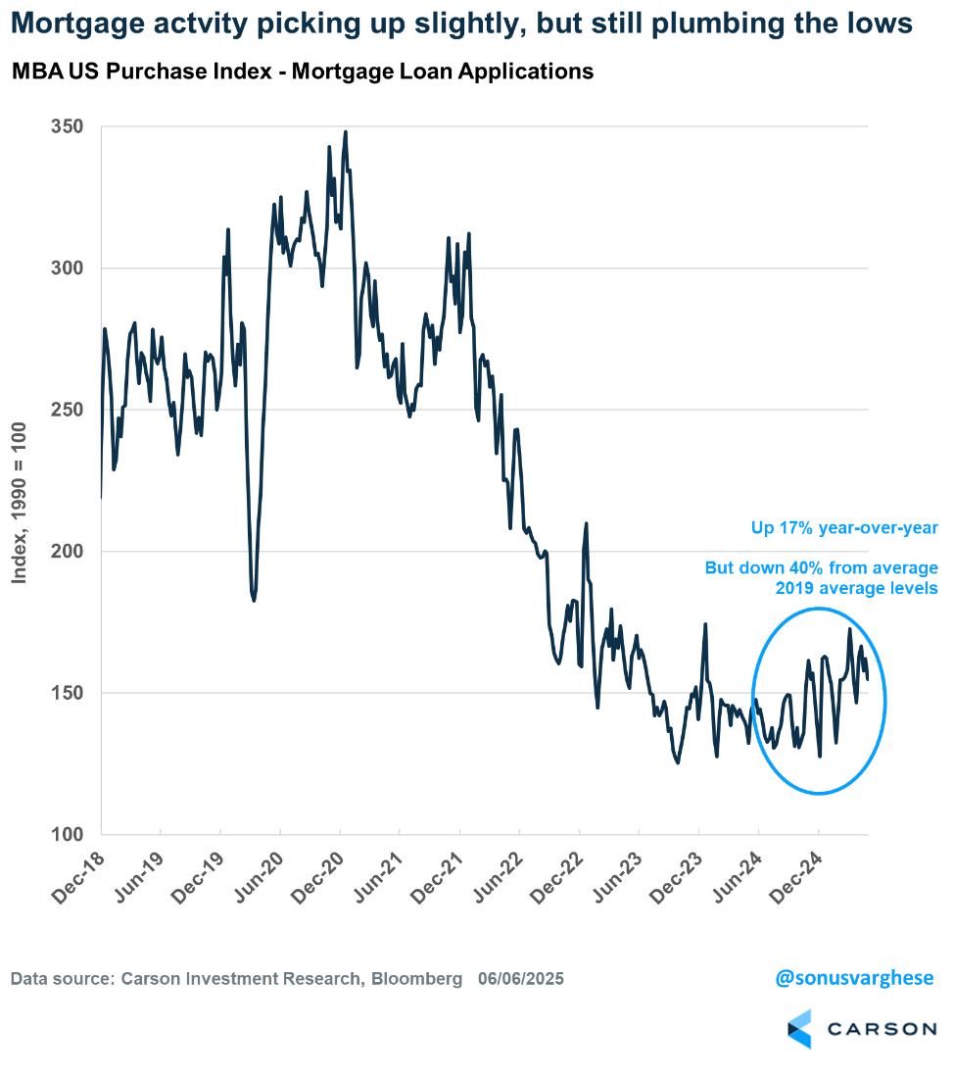
What to make of all this? The tariff mess in April led some forecasters to predict an economic crash as early as this summer. We were not in that camp, but that doesn’t mean we’re out of the woods. The whole tariff situation and accompanying uncertainty, along with headline labor market data hiding underlying weakness, simply increases the risk of tight monetary policy, with elevated interest rates becoming a larger and larger drag on the economy. That’s a slow burn, but a burn nonetheless with economic risks increasing as we get closer to year end and into early 2026.

This newsletter was written and produced by CWM, LLC. Content in this material is for general information only and not intended to provide specific advice or recommendations for any individual. All performance referenced is historical and is no guarantee of future results. All indices are unmanaged and may not be invested into directly. The views stated in this letter are not necessarily the opinion of any other named entity and should not be construed directly or indirectly as an offer to buy or sell any securities mentioned herein. Due to volatility within the markets mentioned, opinions are subject to change without notice. Information is based on sources believed to be reliable; however, their accuracy or completeness cannot be guaranteed. Past performance does not guarantee future results.

S&P 500 – A capitalization-weighted index of 500 stocks designed to measure performance of the broad domestic economy through changes in the aggregate market value of 500 stocks representing all major industries.

The NASDAQ 100 Index is a stock index of the 100 largest companies by market capitalization traded on NASDAQ Stock Market. The NASDAQ 100 Index includes publicly-traded companies from most sectors in the global economy, the major exception being financial services.

The views stated in this letter are not necessarily the opinion of Cetera Advisor Networks LLC and should not be construed directly or indirectly as an offer to buy or sell any securities mentioned herein. Investors cannot invest directly in indexes. The performance of any index is not indicative of the performance of any investment and does not take into account the effects of inflation and the fees and expenses associated with investing.

A diversified portfolio does not assure a profit or protect against loss in a declining market.

Compliance Case # 8051655.1_060925_C

