Stocks Have a Very Merry Month of May
- The S&P 500 finished up 6.2% in May for one of the best months of May ever, rewarding investors who didn’t panic in April.
- Better-than-expected earnings and positive tariff news sparked the huge rally.
- The good news is strength in May could kick off better times for the bulls going forward.
- The US Court of International Trade ruled that the Trump administration could not use the International Emergency Economic Powers Act (IEEPA) as a basis for tariffs.
- IEEPA was used for “Liberation Day” reciprocal tariffs and tariffs on Mexico and Canada.
- An appeals court temporarily stayed the decision, which will likely work its way up to the Supreme Court.
What a Month!
At the start of the month investors were still battered from March and April volatility and uncertainty around trade and the economy. As we noted at the start of the month though, stocks were extremely oversold and any good news (which we expected) could spark a big rally. Sure enough, that’s what we saw, as the S&P gained 6.2% for the best May return since 1990.
The huge rally was supported by some good news on trade and a strong earnings season, showing that all of those over-the-top worries in April were indeed overblown. Congrats to everyone who stuck with their investment plan and didn’t panic sell in April. Investing isn’t meant to be easy and times like that are extremely trying for everyone, but we’ve weathered many rough storms before and this time wasn’t any different.
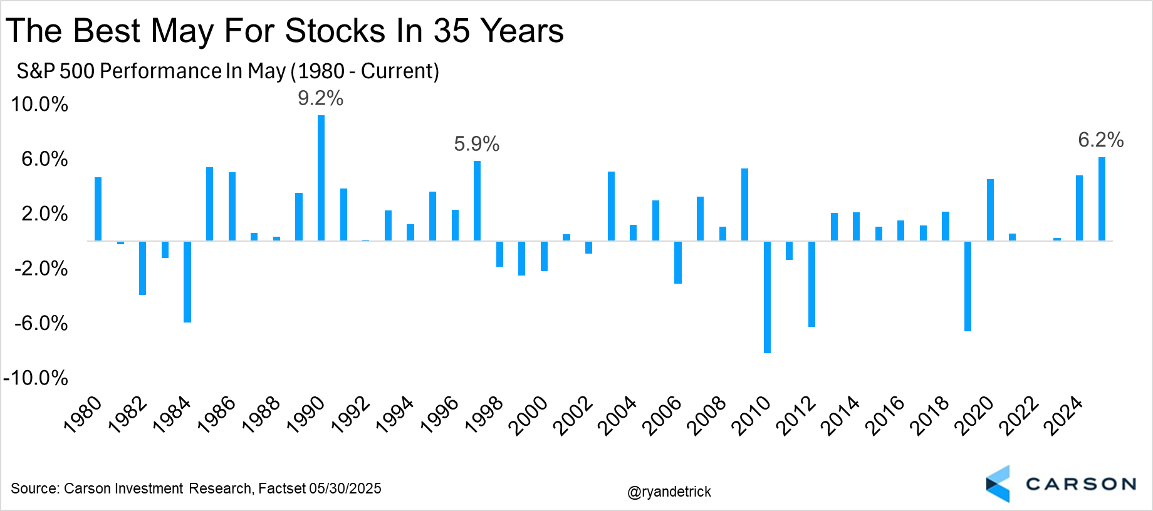
Now What?
What now? Well, the good news is that strength in May is better for the bulls than strength in most other months. We looked at all 12 months and what happened after a 5% monthly gain. Well, after a strong May the S&P 500 has never been lower a year later and is up nearly 20% on average, something for the bulls to smile about for sure! Additionally, a year after any 5% monthly gain saw stocks up 13.7% on average and higher more than 84% of the time.
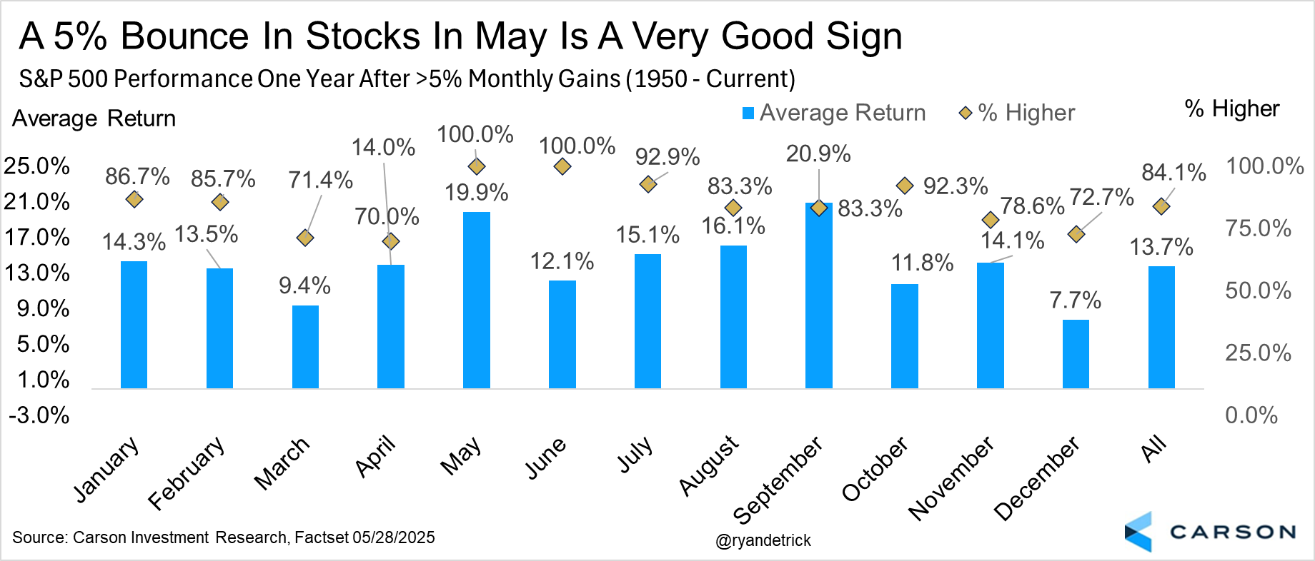
Here are the six times the S&P 500 gained at least 5% in May and what happened next. You can see stronger returns across the board and a year later up double digits five of six times. Not bad. A 5% gain in May also improves the picture for the historically weak month of June. After a big May gain, June is higher five out of six times and up 1.2% versus an average June return of 0.7%.
Lastly, we’ve noted many times how historically bearish sentiment was last month and why from a contrarian point of view that could be quite bullish. Well, better news on trade and a strong earnings season helped us bounce back at a historic pace. Even the biggest bulls were calling for a recession or drastically cutting their S&P 500 targets back in April, but we’ve definitely seen a shift in sentiment after the nearly 20% rally off of the April lows.
Just one such example: After 15 consecutive weeks, the AAII Sentiment Survey finally had more bulls than bears last week. We looked at what happened after previous long streaks ended and the good news is the bulls remained in control. This is a fun one, as seven of eight times saw stocks up at least double digits. The one time it didn’t work? Yep, 2008 and a total market crash. So there is something for everyone here, but we don’t see any reason to see a once in a lifetime crisis this time around and we’d file this under the ‘reasons to remain bullish’ category.

RIP Liberation Day?
Well, this came out of the blue. On Wednesday, May 28, the US Court of International Trade (CIT), a US court specifically assigned to trade issues, essentially cancelled the tariffs that set off a global trade war (technically paused until July). The decision was later temporarily stayed by an appeals court while the case works its way through the system, likely ending up with the Supreme Court.

The CIT struck down all of the "IEEPA" tariffs imposed by President Trump. IEEPA is the International Emergency Economic Powers Act. It was passed in 1977 and allows the president to "regulate international commerce" after declaring a national emergency. It was under IEEPA authority that the president imposed the following tariffs:
- China, Mexico, and Canada tariffs in response to fentanyl trafficking
- Liberation Day (April 2nd) "reciprocal" tariffs imposed in response to "they're ripping us off because of trade surpluses"
The court's three-judge panel (including a Reagan and Trump appointee) unanimously ruled that the President exceeded IEEPA authority and that the Act does not grant "unbounded tariff authority." Specifically, they said the emergencies used to justify the tariffs were not valid. The immigration/fentanyl tariffs imposed on Canada, China, and Mexico do not “deal with” the emergency cited by the administration. Also, chronic trade deficits used to justify the Liberation Day tariffs do not meet the test of an “unusual and extraordinary” threat.

Tariffs Aren’t Going Away for Good

The court ruling against the IEEPA tariffs would lower US average tariff rates by about 10%-points, leaving behind tariffs on cars, steel, and aluminum after everything we’ve seen over the past four months. At the same time, the ruling doesn't mean the President cannot impose tariffs anymore. He can, but he'll have to use other authority.

In fact, the court directed the president to use non-emergency authority in "Section 122" to respond to an imbalance in trade that results in a trade deficit. However, this authority is much more limited. Under it, the president can impose tariffs of as much as 15 percent for up to 150 days against one or more countries that have "large and serious" balance-of-payment surpluses with the US. After 150 days, it'll have to be authorized by Congress.

The President can always use other authority to impose tariffs. There's an entire number soup of tariff-related sections for this:

- Section 301 (Trade Act of 1974) - for retaliatory tariffs on unfair trade practices
- Section 232 (Trade Expansion Act of 1962) - for national security-based tariffs
- Section 201 Trade Act of 1974) - for safeguard measures

In fact, these are the authorities the president used during the 2018 trade war (with tariffs imposed on steel and aluminum, washing machines, solar panels, and a broad array of Chinese imports).

Even this time around, the Trump administration is using the national security-based Section 232 authority for implementing sectoral tariffs, including steel and aluminum, autos, pharmaceuticals, chips, electronics, and lumber. There's less legal uncertainty related to the use of Section 232 tariffs, and we could see the president starting to refocus on these, though these do require an investigation that could take up to nine months.

The president could also direct the US trade representative to launch "Section 301 investigations" on key trading partners. Now, this is a more drawn-out process and would probably take months to be fully completed. At the same time, the president has no limit on the level or duration of these tariffs.

There is also something called Section 338 authority. It's from the Smoot-Hawley 1930 Tariff Act and allows the President to impose "proportionate" retaliatory tariffs on imports from a country that is imposing unreasonable tariffs and restrictions on US goods or discriminating against the US. It's not been used since WWII, since new trade laws (like Section 301) were authorized. But the Trump administration is likely looking at this authority at this very moment.

Court Ruling Is a Big Deal but It May Just Prolong Uncertainty

At the end of the day, the big difference between IEEPA and these other tools is that the latter impose significant procedural hurdles. That’s why the court ruling could be a fundamental blow to the Trump tariff agenda. It also rules out the use of a tariff dial by the president during negotiations, removing his ability to ratchet tariffs up and down by Oval Office (or Truth Social) pronouncement.

We’re also now unlikely to see any trade deals before the 90-day pause on reciprocal tariffs, which ends July 9. The court ruling will probably shift other countries approach to trade negotiations with the US. Trade deals take a lot of time anyway, but expect most countries, if not all, to start dragging their feet. Even the UK, which is the only country that reached any sort of "trade deal" with the US recently is in a better position — they no longer face the 10% baseline tariff, and they have the option of slow walking finalization of their proposals to the US side (like opening up their market to US ethanol and hormone free beef produced in the US).

Ultimately, the tariff mess, and ongoing uncertainty, is only going to be prolonged. The final destination may still be significantly higher tariffs, with the average effective tariff rate ranging from 15 – 20% versus 2 – 3% last year, but getting there is going to take longer, with even more curves and U-turns.

We're likely going to become really familiar with the entire number soup of tariff authority, assuming the court's decision is not reversed by higher courts. Keep in mind that if the president ends up using authorities like Section 301 and 232, they're going to be more enduring and able to withstand future legal challenges (assuming they go through the required procedures).

At the same time, the court ruling significantly reduces the tail risk of tariffs going from 10% to 50% over the course of a day (only to potentially be reversed again). We’re probably done with that, unless the ruling is reversed.

This newsletter was written and produced by CWM, LLC. Content in this material is for general information only and not intended to provide specific advice or recommendations for any individual. All performance referenced is historical and is no guarantee of future results. All indices are unmanaged and may not be invested into directly. The views stated in this letter are not necessarily the opinion of any other named entity and should not be construed directly or indirectly as an offer to buy or sell any securities mentioned herein. Due to volatility within the markets mentioned, opinions are subject to change without notice. Information is based on sources believed to be reliable; however, their accuracy or completeness cannot be guaranteed. Past performance does not guarantee future results.

S&P 500 – A capitalization-weighted index of 500 stocks designed to measure performance of the broad domestic economy through changes in the aggregate market value of 500 stocks representing all major industries.

The NASDAQ 100 Index is a stock index of the 100 largest companies by market capitalization traded on NASDAQ Stock Market. The NASDAQ 100 Index includes publicly-traded companies from most sectors in the global economy, the major exception being financial services.

The views stated in this letter are not necessarily the opinion of Cetera Advisor Networks LLC and should not be construed directly or indirectly as an offer to buy or sell any securities mentioned herein. Investors cannot invest directly in indexes. The performance of any index is not indicative of the performance of any investment and does not take into account the effects of inflation and the fees and expenses associated with investing.

A diversified portfolio does not assure a profit or protect against loss in a declining market.

Compliance Case # 8025981.1_060225_C

