Stocks Climb on Greater Clarity, but Rate Uncertainty Remains Elevated
- Stocks had one of their best weeks of the year, with the S&P 500 gaining more than 3% on Monday and closing higher every day of the week.
- Incredibly, the S&P 500 is now positive on the year, the first year since 1982 to be down 15% then move positive within six weeks.
- Early weakness this year wasn’t a surprise, but now the big question is can the rally continue? We think it can, as we saw a rare buying thrust last week.
- Uncertainty around tariffs hasn’t disappeared but it has declined, while a likely market-friendly tax bill is making its way slowly through Congress.
- But tariffs and the tax bill will also contribute to inflation uncertainty, which we believe will leave rates higher for longer, creating on-going challenge for parts of the economy.
What a week last week was, as the S&P 500 gained more than 3% on Monday after a 90-day pause in tariffs with China was announced. Incredibly, stocks gained the next four days as well. March 2003 was the last time we saw a Monday that strong, followed by the next four days green as well. That time marked the end of the post-tech bubble bear market and the start of a new bull market. Hmm.
Incredibly, the S&P 500 is now up on the year, a long way from the down 15% year-to-date return back in early April. Want another amazing stat? This is the first year since 1982 to be down at least 15% for the year and then turn positive within six weeks. As violent as the sell-off was in March and April, the recovery has been nearly as explosive. The chart below shows that only three times in history has the S&P 500 been down 15% YTD and come all the way back to positive by the end of the year. Well, this year very well could be the fourth and those other three all finished up double digits when all was said and done, something that should have investors smiling should it happen again this year.
Early Weakness in 2025 Wasn’t a Surprise
No we didn’t see a 10% market crash after Liberation Day on April 2 coming, but we thought some type of early year weakness was very possible. We’ve noted in these very commentaries many times that the year after a 20% gain, as well as early in a post-election year, and the first quarter of the year the past 20 years have all tended to be weak historically for stocks.
Here’s a good chart that shows early weakness in a post-election year is perfectly normal, but so is a major low in early April and then better times coming. Could history repeat itself in 2025? We think it may.

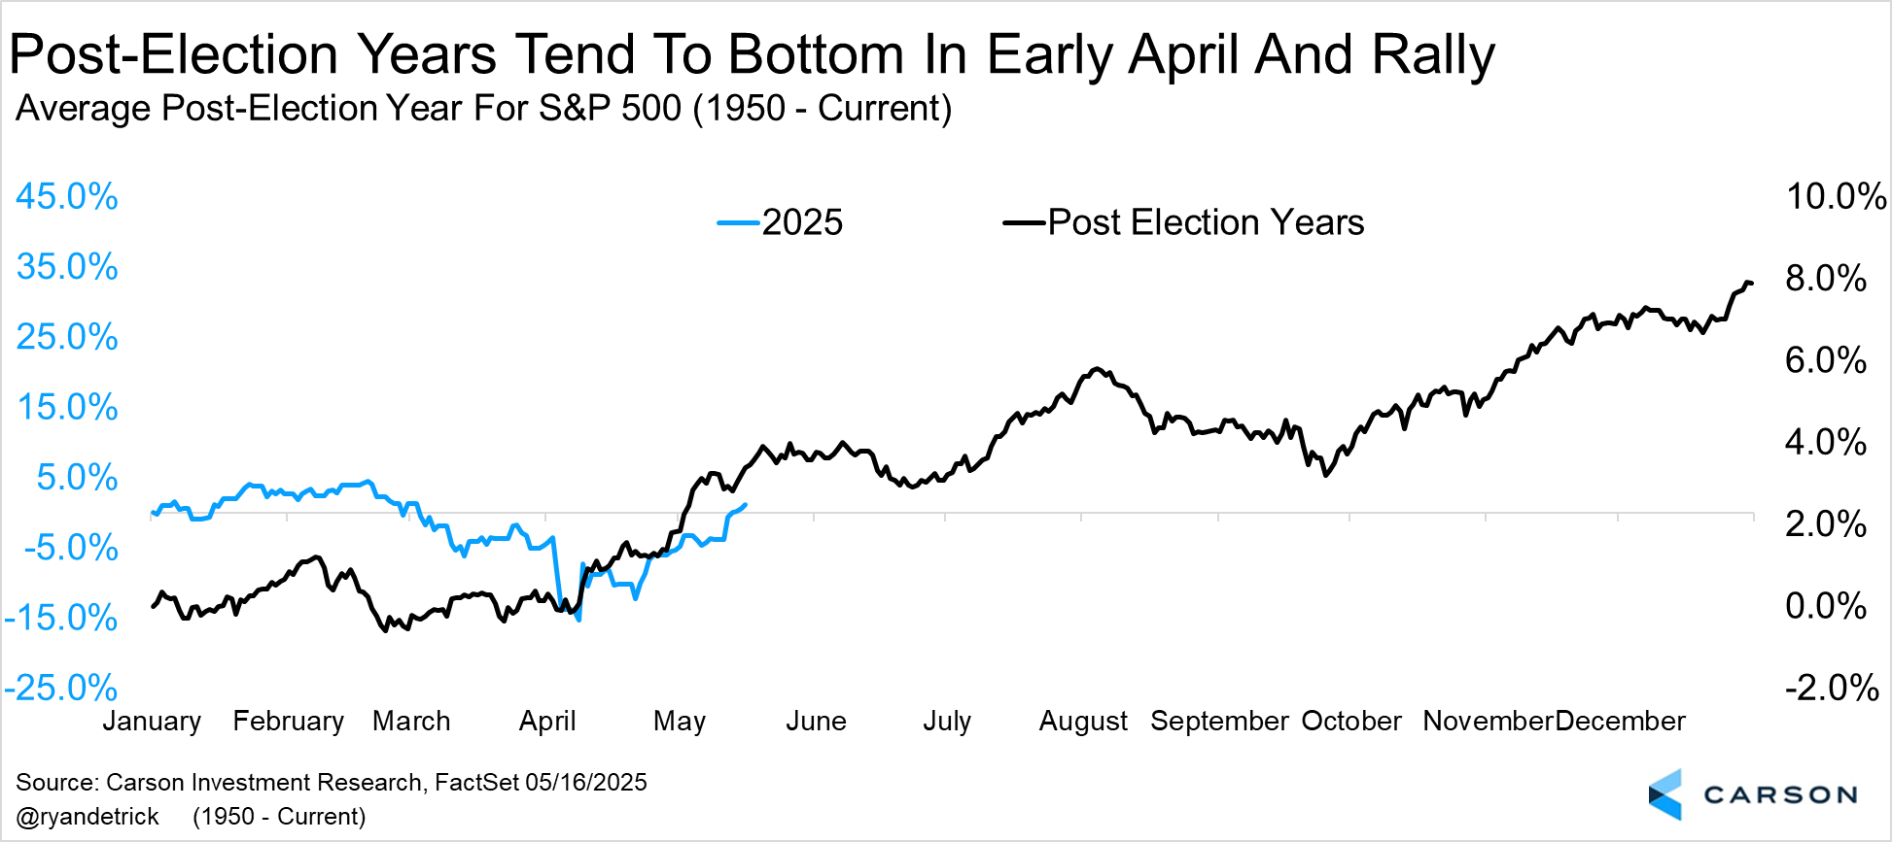

Another Buying Thrust
The past few weeks we’ve been noting many rare and potentially bullish signals that suggested the worst was indeed over. Well, last week we got another one. 58% of all the components in the S&P 500 made a 20-day high last Monday, a very rare event and another clue the strength we’ve been seeing isn’t just another bear market rally.
Incredibly, a year later stocks have been higher 20 out of 20 times, with extremely strong returns going out a year as well. Don’t take any study like this by itself too seriously, but stacked on top of the many other data points we’ve been sharing the past few weeks, 2025 might just end up being a solid year for the bulls.
Two Big Things To Keep an Eye On
In our 2025 Outlook, we highlighted the threat of tariffs and risk of elevated interest rates if the Federal Reserve doesn’t cut. Well, both have manifested now.
Average tariff rates, even after the China pause, are at the highest level since 1934 — rising from 2.4% at the start of the year to 17.8%. If you assume imports will fall as Americans switch to locally produced goods, the average tariff rate would be at 16.4%, the highest since 1937. The good news is that we have tariffs, and now there’s less uncertainty about it. Markets can price in what we know, not what we don’t know.
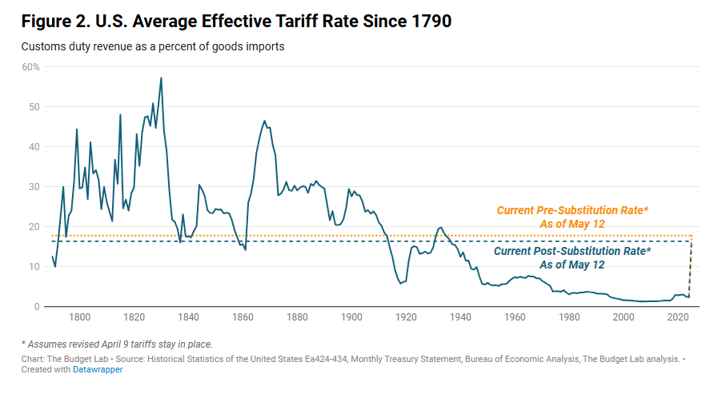
One big impact of the tariff uncertainty is that interest rate cuts have been taken off the table until at least September. The market-based probability of at least one rate cut by July is currently less than 40%. So the risk of elevated rates remains in place and the status quo is not benign — policy is actually getting tighter since wage growth is easing.
What hasn’t manifested yet are the opportunities we talked about in our 2025 Outlook, and the main one there was tax cuts (in addition to deregulation). Let’s talk about that.
How Big Will the Tax Bill Be?
When I ask how big the tax bill will be, I’m really talking about deficits. All else equal, deficit-financed spending will boost profits (as they did in 2016-2019, 2020-2021, and even 2023-2024). If Congress does nothing, tax rates for households will revert back to pre-2017 levels. Simply put, there’s no way Republicans in Congress will allow that to happen, especially going into a midterm year. But renewing all the tax cuts could cost about $4 trillion over the next decade. In other words, that’s the cost of maintaining the status quo. To provide an additional boost to the economy, the bill likely has to be larger, perhaps closer to $5 trillion, with most benefits front-loaded. Also keep in mind that tariffs are effectively a tax on businesses and consumers that pulls money away from the private sector into the federal government’s coffers — so the tax bill will also have to neutralize that.
The House version of the tax bill looks like it’s going in this direction. The Committee for a Responsible Federal Budget (CRFB) estimates that the deficit will surge by almost 1.8% of GDP by 2027 (about $600 billion), the first year in which the policies would be fully in effect. As I noted above, whatever the problems with deficits, they provide a boost for corporate profits in the near term.
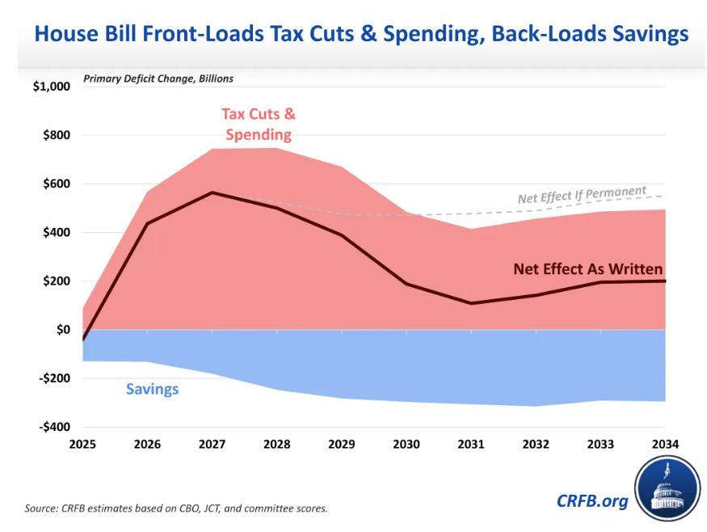
Of course, there’s still a long way to go. The Senate will likely overhaul the House bill in a big way (and probably in a fashion that leads to even larger deficits). In any case, this will be a big deal and is something we’re keeping a close eye on.
How Will the Bond Market Take Higher Deficit Spending?
Whatever challenges deficits create, they are generally good for profits, which tends to flow through to stock prices. Interest rates are a different story. Rates have been rising recently, even after a soft inflation report. The 10-year Treasury yield rose above 4.5% before pulling back to 4.45%. The 30-year Treasury yield surged to 4.97%, inching close to the peak level of 5.11% we saw back in October 2023 (which was the highest since 2007). The surge in the 30-year yield should tell you that this is not a story about higher growth expectations. Long-term growth expectations haven't really changed much (likely around 2 – 2.5%), and so this surge is being driven by something else.
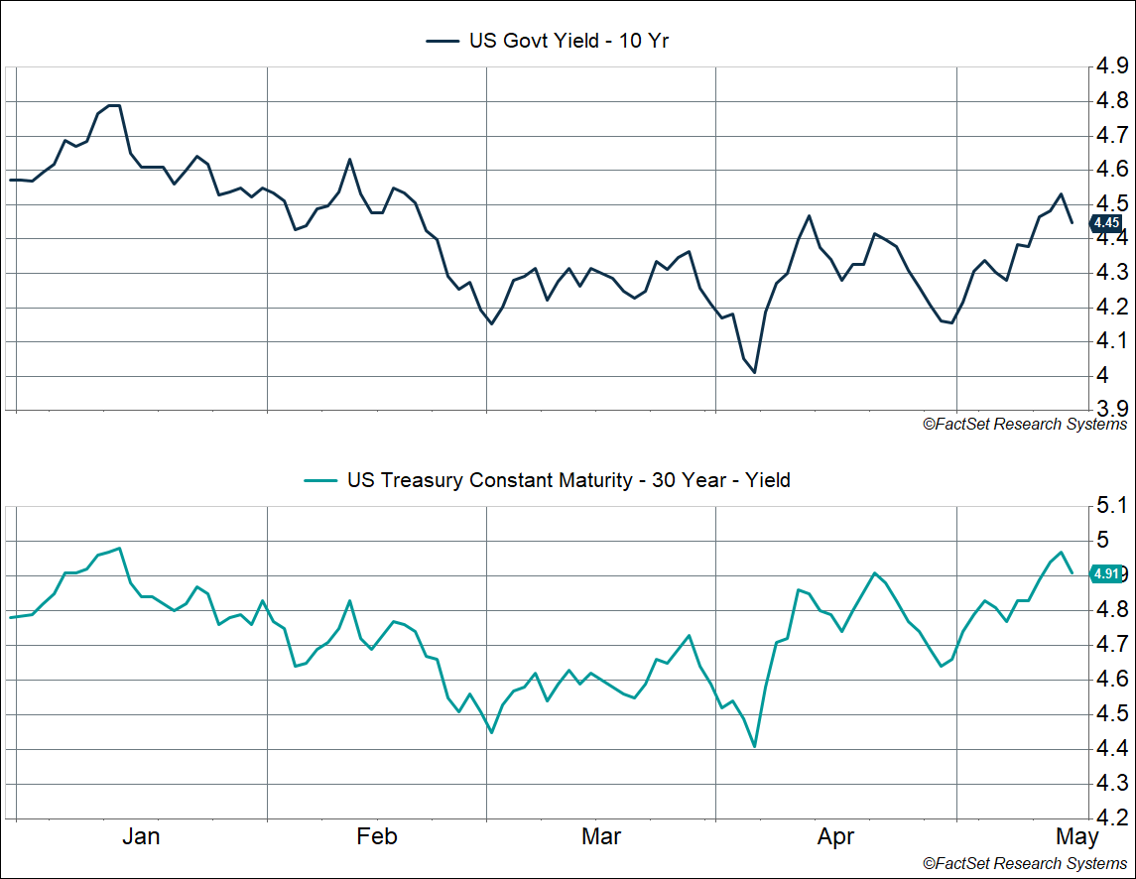
It isn’t because of higher inflation expectations. One year ahead inflation expectations, as measured by inflation swaps, are running around 3.2% — not a surprise given the expected hit from tariffs. But long-term inflation expectations, as measured by the difference between nominal and real Treasury yields, are consistent with the Fed’s target of 2% inflation.
The fact that long-term inflation expectations remain “anchored” to the Fed’s target tells you that the market still finds the Fed's commitment to keeping inflation close to their target of 2% credible. Of course, they may need to keep rates higher to maintain that credibility. After all, to a first approximation, long-term rates are an average of expected short-term rates over the next several years. But there's another factor beyond this as well, the "term premium."
The term premium is the additional return longer-term investors demand for future uncertainty, including inflation uncertainty. If there is more inflation uncertainty, they'll demand more or a "term premium" when buying a long-term bond instead of a series of short-term bonds.
One thing to keep in mind here is that the Fed's inflation mandate is to keep inflation "low and stable." Usually the focus is on the first word (“low”), but "stable" is critical as well. Inflation may very well average 2% over the next decade, but it could still be very volatile. If that’s what investors expect, they would likely charge a higher term premium.
The term premium is hard to calculate and has to be modeled, which is what several researchers, including some at the Fed, have done. One model from the New York Fed shows that the 10-year term premium is now at 0.74%, which is the highest level in over a decade and more consistent with the typical range we saw in the mid-2000s.
When the term premium moves higher, it’s often because of one or both of these two reasons (broadly speaking):
- More inflation volatility
- Excess supply of Treasuries (beyond what demand can/wants to meet)
Arguably, we have both now. Despite the pullback in extreme tariffs, the toothpaste is now out of the tube, and there's no guarantee that tariffs won't rise even further from here. Even if we get a trade deal (or deals), there's no certainty that President Trump will maintain that. He’s already replaced several of his own trade deals from the first term, including USMCA (the NAFTA replacement) and trade agreements with Japan and South Korea. And even beyond the next three years, there's enormous uncertainty as to what future administrations will do with the tariffs, and how they will treat any existing trade deals (which may not even have been fully negotiated by then). All this is a recipe for more inflation volatility, and why shouldn't investors demand a higher premium from long-term Treasuries if that’s what we have?
The other factor is the tax bill being debated in Congress right now, which as I noted above could increase the deficit by $4-$5 trillion, including higher interest on the debt. That means there's going to be a much higher supply of US Treasuries coming onto the market, and so even a marginal decrease in demand for Treasuries could result in much higher "net supply," driving term premiums (and yields) higher.
You may be thinking that it'll be foreigners who have a reduced appetite for Treasuries. Perhaps, but even the US private sector may not want Treasuries to the same degree they did back in the 2010s. If inflation volatility is expected to be high, the stock-bond negative correlation would break down, and there would be less "hedging" utility for long-term Treasuries.
None of this is to say that yields will jump higher if we get a massive deficit-financed tax bill. But even if interest rates stay where they are now, that’s going to take a toll on the economy, especially cyclical areas like housing.
Equity markets have been on a nice run recently, perhaps in anticipation of a big, beautiful tax bill (which would boost profits). But from the perspective of portfolio construction, the above two questions (and their answers) matter a lot for what can potentially provide diversification.

This newsletter was written and produced by CWM, LLC. Content in this material is for general information only and not intended to provide specific advice or recommendations for any individual. All performance referenced is historical and is no guarantee of future results. All indices are unmanaged and may not be invested into directly. The views stated in this letter are not necessarily the opinion of any other named entity and should not be construed directly or indirectly as an offer to buy or sell any securities mentioned herein. Due to volatility within the markets mentioned, opinions are subject to change without notice. Information is based on sources believed to be reliable; however, their accuracy or completeness cannot be guaranteed. Past performance does not guarantee future results.

S&P 500 – A capitalization-weighted index of 500 stocks designed to measure performance of the broad domestic economy through changes in the aggregate market value of 500 stocks representing all major industries.

The NASDAQ 100 Index is a stock index of the 100 largest companies by market capitalization traded on NASDAQ Stock Market. The NASDAQ 100 Index includes publicly-traded companies from most sectors in the global economy, the major exception being financial services.

The views stated in this letter are not necessarily the opinion of Cetera Advisor Networks LLC and should not be construed directly or indirectly as an offer to buy or sell any securities mentioned herein. Investors cannot invest directly in indexes. The performance of any index is not indicative of the performance of any investment and does not take into account the effects of inflation and the fees and expenses associated with investing.

A diversified portfolio does not assure a profit or protect against loss in a declining market.

Compliance Case # 7981415.1_051925_C

