S&P 500 on Historic Run with Little Tariff Impact on Jobs Numbers
- Stocks ended the week up nine days in a row, the longest winning streak for the S&P 500 in more than 20 years.
- Last month saw a huge reversal off the lows, another potential bullish signal that the lows for 2025 are in.
- The ‘Sell in May’ seasonal period is here, as these upcoming six months are historically the worst six months of the year, but we think this year could see solid gains and you don’t want to sell.
- The economy added a solid 177,000 jobs in April, although this will likely keep the Fed on hold longer.
- GDP fell 0.3% annualized in the first quarter but the impact of tariffs is making the reading very noisy and the underlying data says we’re not in a recession.
What an end to April, and May is off to a strong start as well. In fact, the S&P 500 finished higher the last seven days of April, tying the longest win streak to end that month ever. It didn’t end there though, as stocks have gained the first two days of May, for an incredible nine-day win streak, the longest win streak since November 2004.
How Large Was April’s Reversal?
In the end, the S&P 500 fell less than 1% in April, but it was anything but easy for investors. In fact, during the second week of April stocks were down more than 20% intraday off of the February peak, causing historic worry and bearishness. Just in April, the S&P 500 was down more than 11% for the month at the lows, but then managed to close up more than 10% off of those lows. The last time we saw a reversal anything like that was in March 2020 and the lows of the Covid bear market.
We found six other times the S&P 500 was down at least 10% in a month, but finished more than 10% off the monthly low. Potential weakness or choppiness is normal in the near term, but a year later stocks have never been lower, up more than 22% on average. As we discussed last week, there were multiple rare bullish signals and the lows for 2025 are likely in, but this doesn’t mean it will be straight up and some back-and-forth volatility would be perfectly normal.
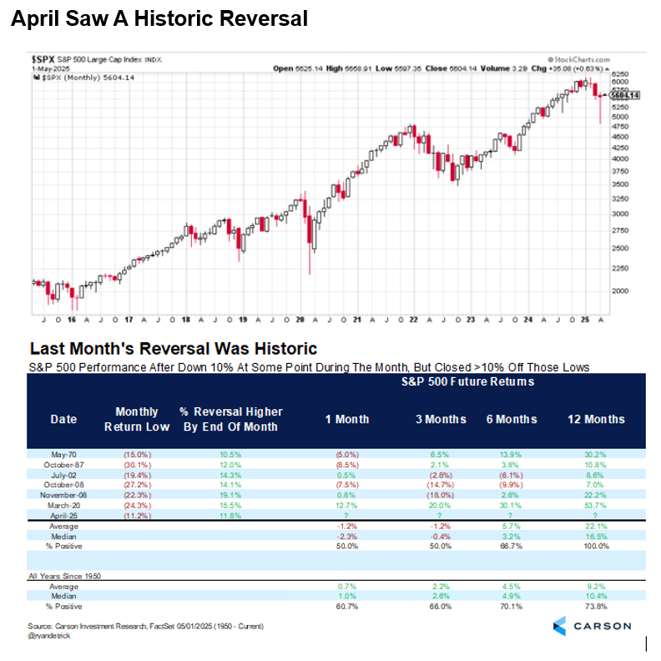
Let’s Talk About ‘Sell in May’
Buckle up, as the trigger points for one of the most well-known investment axioms, “Sell in May and go away,” is here. This gets a ton of play in the media, as the six months starting in May are indeed the worst six consecutive months on the calendar historically. The S&P 500 has averaged only 1.8% over those six months and been higher just over 65% of the time.
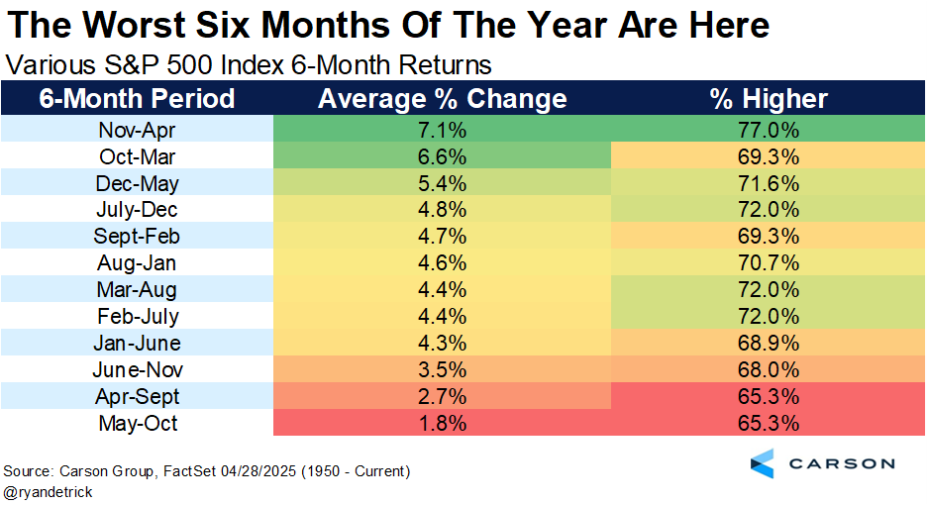
Let’s be clear, up 1.8% might not sound like much, but it is still an increase. Also, we do not advocate blindly selling due to the calendar. But it is worth being aware of this calendar effect, as you will hear a lot about it this week.
Let’s Dig Into May
Now here’s something that might be less well known. These “worst six months” have gained in eight of the last 10 years. (In fact, we noted last year why “Buying in May” made more sense at that time, and those “worst six months” soared more than 13%.)
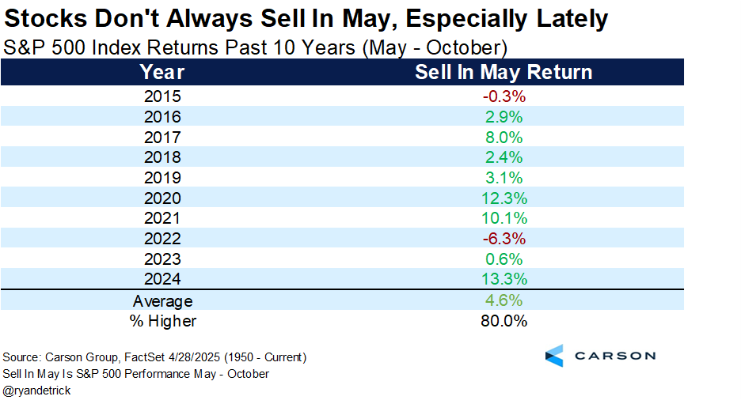
Not to mention the month of May has been higher nine of the past 10 years, so maybe we should call it, “Sell in June and go away”?
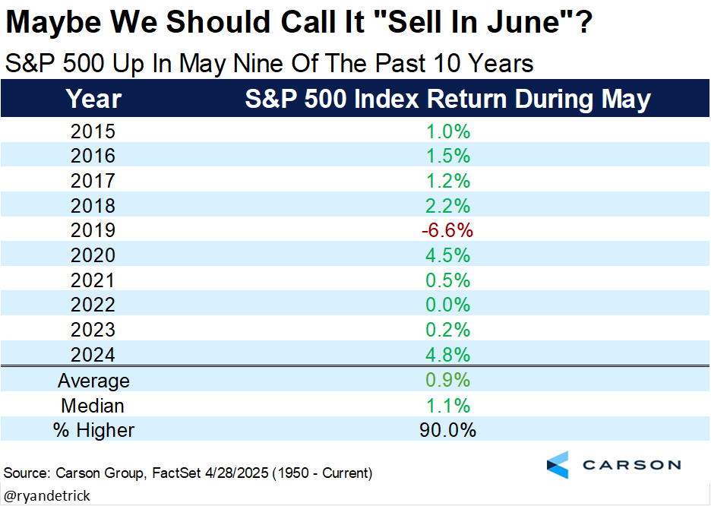
Lastly, regarding May, post-election years tend to be strong, up 1.6% on average, which is the 4th best month of the year in a post-election year. Then again, April is usually strong and that clearly didn’t work this year, but we did close well off the lows at least.
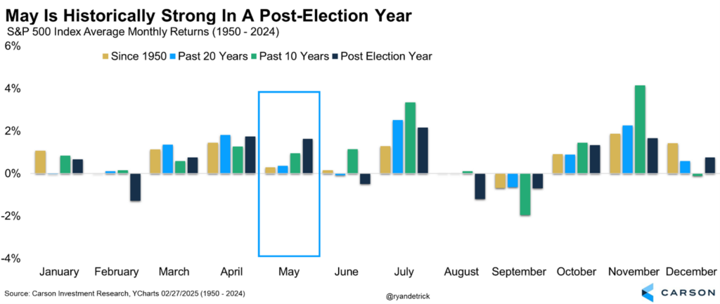
Think about what we’ve seen in the last month:
- Widespread over-the-top negativity
- Strong buying thrusts (discussed last week)
- A historic reversal in April
- With some good news on the trade front sprinkled in
Put it all together, and we don’t think these next six months will be a time for investors to panic and sell, but likely a time for potential strong performance.
The Labor Market Hasn’t Cracked, but That Means Higher Rates for Longer
The April jobs report was released on Friday, May 2 and the news was pretty good overall. The economy created 177,000 jobs in April, above expectations for 138,000 jobs. At the same time, this number can be revised quite a lot. (Job creation in February and March were revised down by a combined 58,000.) This is why the 3-month average is more useful, and right now that’s at 155,000. That’s not great, but not too bad either since it’s likely more than enough to keep up with population growth (especially since immigration has fallen). It’s also why the unemployment rate remained unchanged at 4.2%. Slightly more positive is the fact that the prime-age (25-54) employment-population ratio rose to 80.7%, higher than at any point between 2001 and 2019, and not too far below the recent peak of 80.9%.
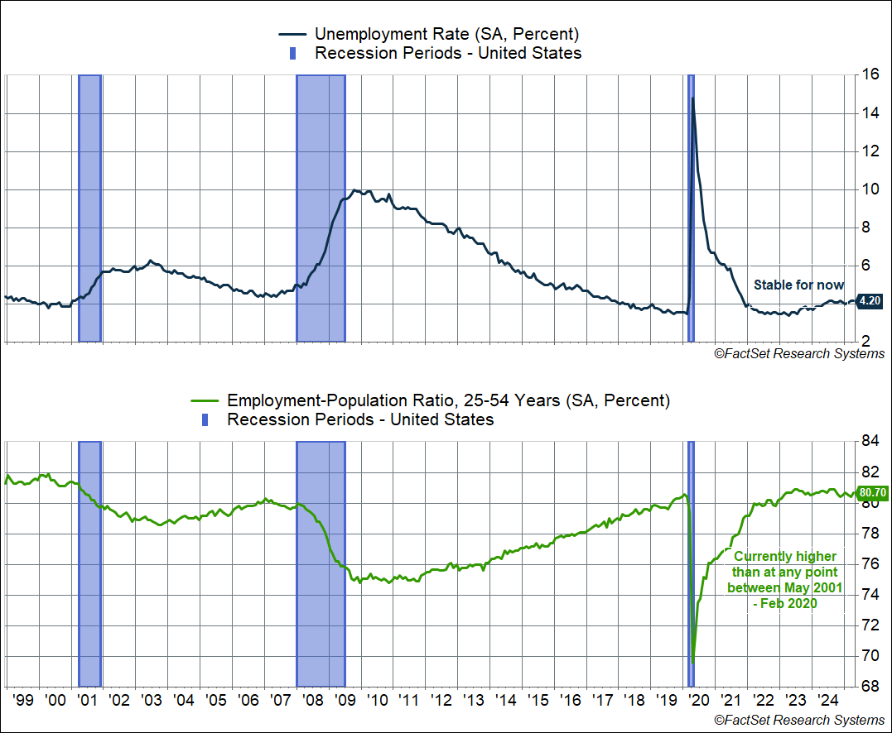

If you were expecting Liberation Day to result in a poor payroll report in April, this was not it. And that should not have been the expectation either, since the data for this report was gathered in the second week of April — before any impact from the more extreme tariffs on China.
At the same time, the details of the report show that job creation continues to be dominated by the non-cyclical areas of the economy. Healthcare and social assistance, private education, and government created 80,000 of the jobs in April (45%). Cyclical areas like construction, manufacturing, and professional and business services added just 27,000 (15%). This continues the theme of what we’ve seen over the last 6–12 months, with cyclical areas on the weaker side and job creation driven by non-cyclical areas of the economy (greater than 50% over the last six months).
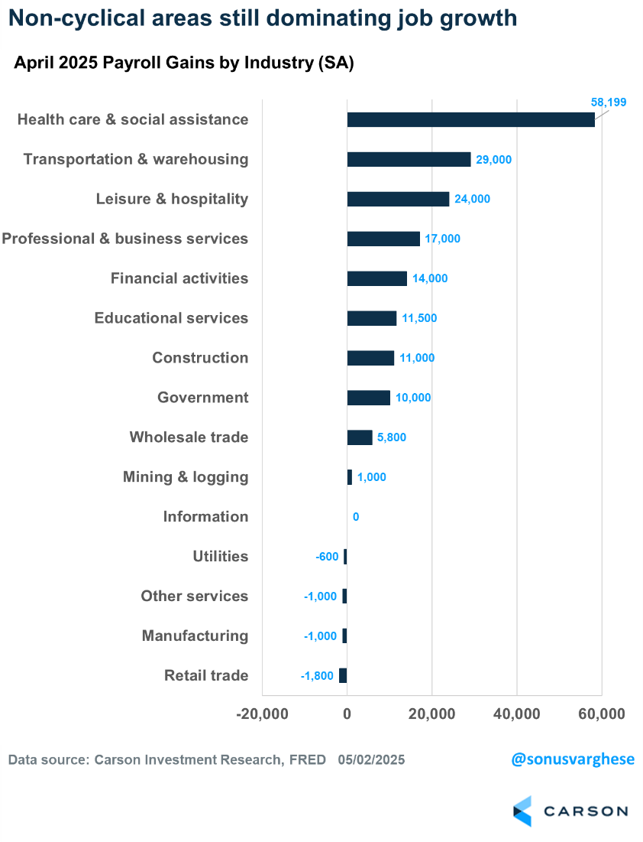
The cyclical areas of the economy, whether manufacturing or housing, are not being helped by elevated interest rates. In our Outlook 2025, one of the key risks we highlighted was high interest rates (in addition to the threat of tariffs). And now it looks like we may have to live with high interest rates for longer.
The Fed Is Likely To Stay on Pause
The Federal Reserve (“Fed”) is meeting on May 6-7, and this report completely shuts the door on any possibility of a rate cut at that meeting. Markets weren’t expecting a cut anyway, despite a big push from the White House. However, markets are pricing in a rate cut in June, and three more beyond that before the year is out. This seems overly optimistic given where the labor market is right now. Add to that the expected upward pressure on inflation from tariffs, which is probably not going to show up at least until the third quarter, and the Fed may very well be on pause until September.
I’ve noted before that there is uncertainty related to the tariff situation, since we have no idea what the end game is. But what it very likely will do in the near term is keep the Fed on hold because of inflation uncertainty.
Make no mistake, the status quo of the Fed staying on pause means policy is actually getting tighter and pushing a further slowdown in the economy. The Employment Cost Index for the first quarter (Q1) showed private sector wages and salaries are up 3.4% from last year, well below the Fed’s policy rate of 4.25-4.5%. Wage growth has been on a downtrend over the past year, and if the Fed pauses here that means policy is getting tighter. Historically, the fed funds rate (the short-term policy rate the Fed sets) rising well above the pace of wages has constricted the economy and ultimately these situations ended up in recessions.
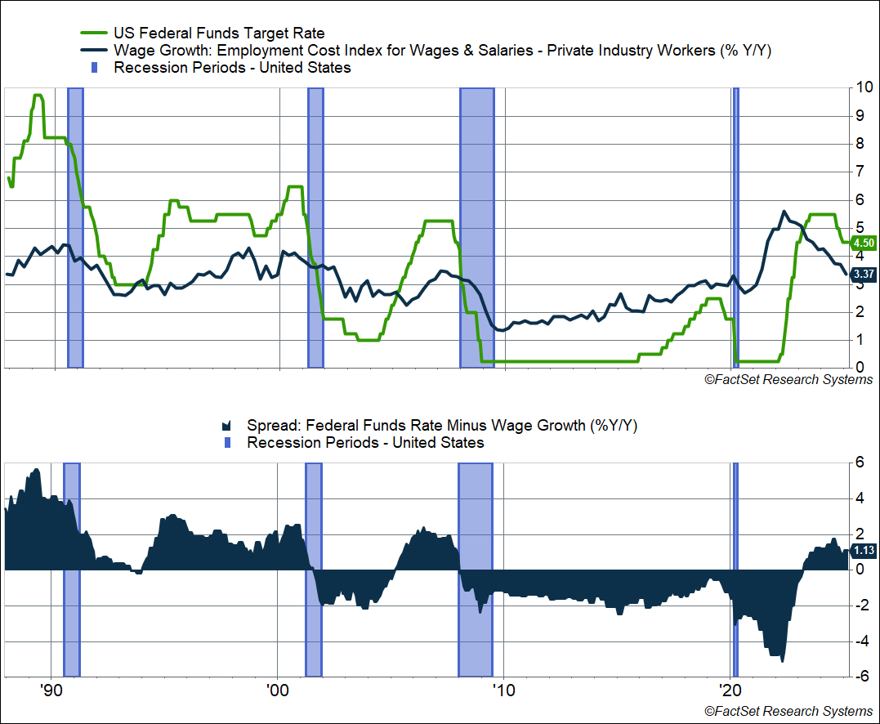
There’s a reason why Treasury Secretary Bessent wants lower interest rates (not to mention President Trump), arguing that it’ll benefit “Main Street.” Until a month ago, they didn’t seem too concerned with a slower economy, since interest rates would arguably fall in that scenario. The problem is that tariff policy is pushing the Fed in exactly the opposite direction. Also, with respect to a slower economy, be careful what you wish for because things can turn on a dime and stay that way for a long time. Which brings us to the Q1 GDP report.
A Messy, Muddy, Noisy GDP Report
Real GDP growth clocked in at a -0.3% annualized pace in Q1, slightly below expectations for a -0.2% reading. Keep in mind that this is just the first estimate, and this number is likely to go through significant revisions. Still, this was especially notable because it’s the first negative reading for real GDP growth in three years (since Q1 2022). Over the last two years (2023 – 2024), real GDP growth clocked in at an annualized pace of 2.9%. So this is a significant slowdown.
At the same time, this was an extremely messy GDP growth reading.
The chart below shows a breakdown of the components, how they contributed to the headline figure, and their respective quarterly growth rate (annualized). As you can see the big drag is from net exports, which pulled GDP lower by a whopping 4.8 percentage points. This was mostly because imports surged by almost 51% in Q1, as households and businesses began front-running tariffs.
However, I want to be careful here — it’s a little misleading to say imports drag from GDP. They shouldn’t be there in the first place, but the way GDP is calculated doesn’t initially account for that. GDP is domestic production (measured by sales), and something that is imported does not count toward domestic production but is hidden in sales, if that’s what you’re counting. For example, consumers bought a lot of footwear and clothing while businesses spent a lot on equipment (IT equipment spending surged by 22.5%) and a lot of it was clearly imported, so it’s counted in the consumption and investment data, but it shouldn’t be. So netting out imports is the “easiest” way to make sure imports don’t count toward domestic product.
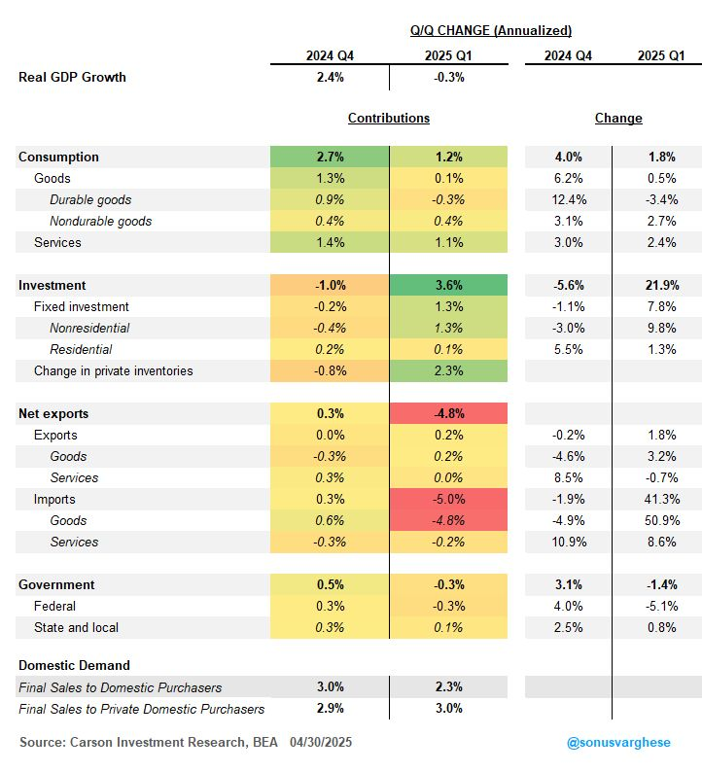
A big chunk of imports went towards inventory buildup, and as you can see above, change in private inventories was the single largest contributor to GDP growth, 2.3 percentage points (before netting out imports). It was the largest increase since 2021 Q4.
Of course, this is likely to shift in Q2. In fact, for GDP growth, it’s actually “change in private inventories” that matter. So even if inventories continue to rise in Q2 (for example, if companies rush to buy more goods before the end of the 90-day tariff pause), if inventories don’t rise as much as they did in Q1, it will drag from GDP growth.
So, there’s a reasonable chance that GDP growth in Q2 may also be negative. It’ll also depend on how much imports collapse, and consumers and businesses switch to US-made goods. If imports collapse, we could see the reverse of what happened in Q1, with net exports adding to GDP growth in a big way (unless exports also collapse).
The long and short of it is this: GDP readings over the next quarter or two are likely to be very volatile. And even revisions to Q1 GDP.
Usually, the best way to gauge underlying economic strength is to look at “real final sales to domestic purchasers” (final demand). This measure strips out the volatile net exports and inventories components of GDP, and just isolates household, business, and government spending. This is something I’ve highlighted over the last three years when net exports and inventories were especially volatile. Here’s the good news:
- Final demand rose 2.3% in Q1 versus 3.2% in 2023-2024 and 2.7% in 2018-2019.
- Final private demand (ex government) rose 3.0% in Q1 versus 3.1% in 2023-2024 and 2.6% in 2018-2019.
The private demand reading is especially strong and on the face of it, a big positive.
However, the problem is that it includes the big surge in IT equipment spending on the business side and increased spending on things like clothing and footwear on the household side — most of which were likely imported.
In other words, the Q1 readings of final demand are noisy, and it shouldn’t completely be taken at face value. At the same time, it does tell you that demand didn’t collapse in Q1 — economic activity slowed down, but we didn’t see anything close to a recession.

This newsletter was written and produced by CWM, LLC. Content in this material is for general information only and not intended to provide specific advice or recommendations for any individual. All performance referenced is historical and is no guarantee of future results. All indices are unmanaged and may not be invested into directly. The views stated in this letter are not necessarily the opinion of any other named entity and should not be construed directly or indirectly as an offer to buy or sell any securities mentioned herein. Due to volatility within the markets mentioned, opinions are subject to change without notice. Information is based on sources believed to be reliable; however, their accuracy or completeness cannot be guaranteed. Past performance does not guarantee future results.

S&P 500 – A capitalization-weighted index of 500 stocks designed to measure performance of the broad domestic economy through changes in the aggregate market value of 500 stocks representing all major industries.

The NASDAQ 100 Index is a stock index of the 100 largest companies by market capitalization traded on NASDAQ Stock Market. The NASDAQ 100 Index includes publicly-traded companies from most sectors in the global economy, the major exception being financial services.

A diversified portfolio does not assure a profit or protect against loss in a declining market.

Compliance Case # 7931225.1_050525_C

