Markets Perk Up but Macro Outlook Still Messy
- The S&P 500 bounced back nicley last week, even after a big dip on Monday.
- Last week saw multiple potentially bullish signals, suggesting better times could be coming.
- Some softening of aggressive trade policy talk sparked the buying, along with solid overall earnings, but markets are still in a heavily news- and tweet-driven environment.
- From a macroeconomic perspective, uncertainty continues to dominate.
- Unless we see substaning additional softening (which is possible), we could still be in for a long slog, but stocks could still do ok in that environment.
What a Week
Last week started with a huge 2.4% drop in the S&P 500, but it ended with a four-day win streak and stocks up 4% on the week. The rally started when President Trump opened the door to drastically lower tariffs on China, but it was also a big week for earnings. Although future guidance remains murky at best, nearly 75% of the companies that have reported so far have beaten earnings expectations, giving last week’s strength some backup from market fundamentals.
S&P 500 Up Big Three Days in a Row
It doesn’t stop there though, as the S&P 500 just gained more than 1.5% for three days in a row. We call this type of rare strength a buying thrust and it tends to happen early in bullish markets, as strong future returns are common after similar buying thrusts historically. In fact, stocks were higher a year later 10 out of 10 times.
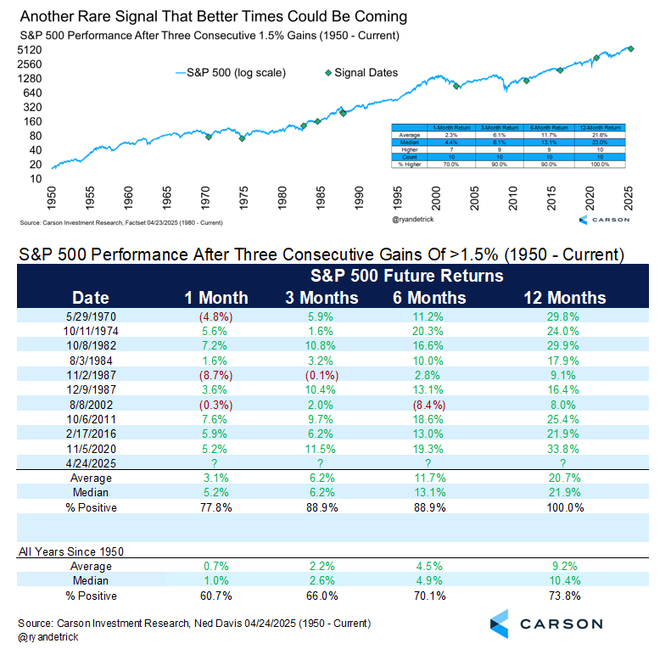
A Lot of Stocks Up the Past Three Days
More than 70% of the stocks on the NYSE were higher Tuesday – Thursday of last week, another rare and potentially bullish clue. After this signal stocks have also shown strong future performance historically and have been higher a year later 26 out of 27 times.
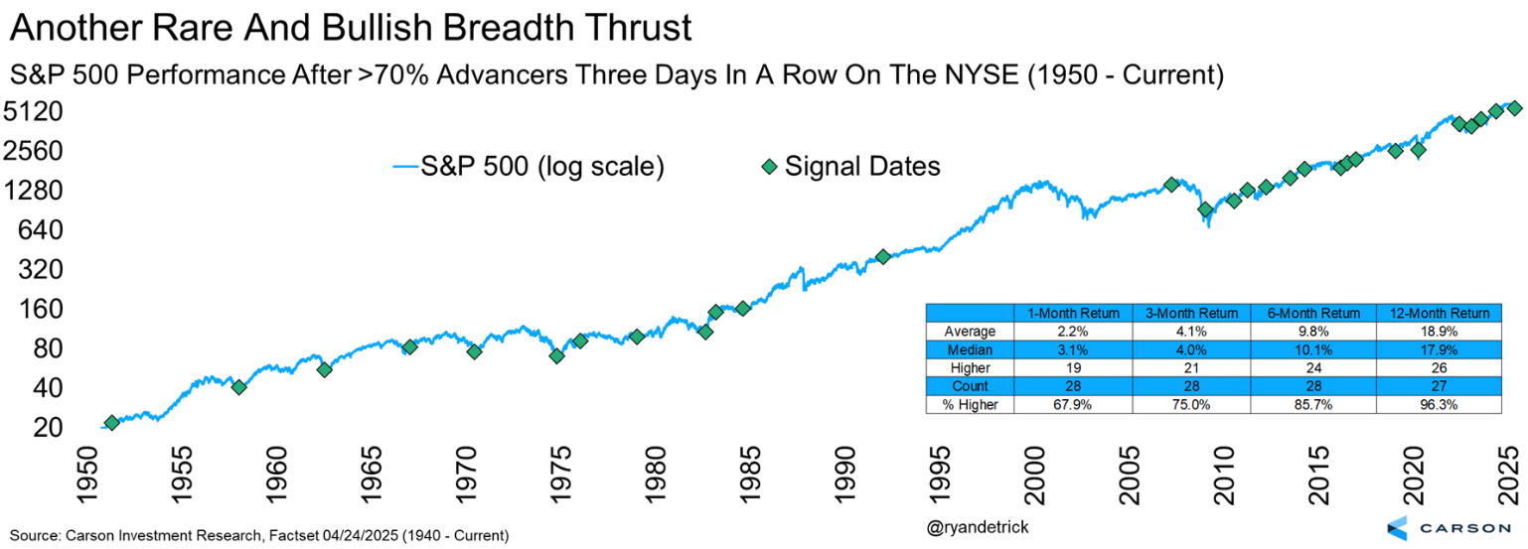

Two Weeks of Buying
It isn’t just the past three days though. We’ve been seeing extreme buying the past two weeks, again a rare and potentially bullish signal. We recently saw six out of 10 days with more than 70% advancers on the NYSE. This has a smaller sample size (only eight prior occurrences), but again historically has seen very strong future returns.
Dates like the lows in 1982, 2009, and 2020 show up this time, which always catches our attention. The next six months were never lower and up more than 14% on average; the next year higher every time and up more than 22% on average. Those numbers could have bulls smiling later in 2025.
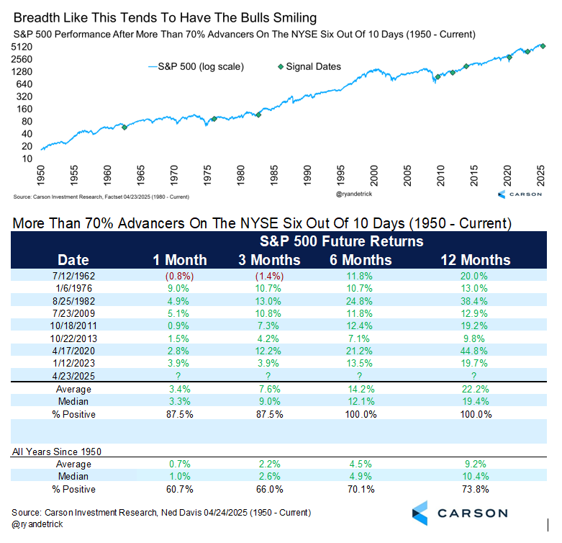
Two Huge Days
The S&P 500 soared 9.5% on April 9 and an incredible 94% of all stocks advanced that day. That was a clue something was happening, but we wanted to see another strong day nearby to confirm things. Well, that happened last Tuesday when there was another big up day with many stocks higher. On April 22 we saw more than 89% of the stocks (and total volume) advance. Having two such strong up days occur within nine days of each other is extremely rare, but another clue the bulls are trying to take back control.
Some of the other dates we saw two days this strong this close to each other? Early 1987, March 2009, August 2011 (after the US debt downgrade), and the COVID lows in March 2020. Again, small sample size, but we wouldn’t be ignoring this one. Another thing to note—all those prior times, policymakers stepped in to provide relief in a big way. There’s a chance we could see that again this time around if the Trump administration dials back tariffs significantly (although this is more righting a self-inflicted wrong than policy support), we get a meaningful fiscal stimulus bill, and the Fed can cut rates in the back half of the year. More on these possibilities below.
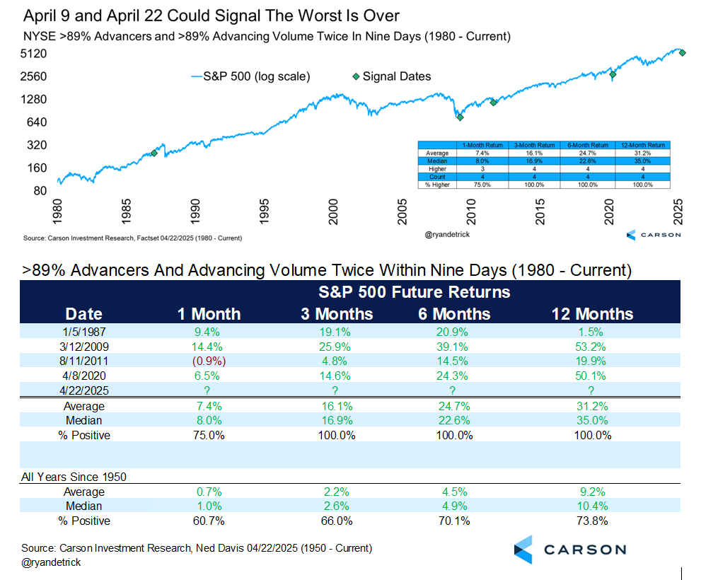
What Next? The Bull Case and the Bear Case
Uncertainty may be the new normal. Markets have been extremely volatile recently, with the S&P 500 experience nine 1%+ intraday moves over the first three days of this week. It’s not that we’ve never seen volatility before — that’s part and parcel of investing. The difference now is that markets are hanging on, and reacting to, every little positive and negative policy pronouncement from the Trump administration.
Keep in mind that these aren’t actual policy changes, just clarifications and thoughts about what policy could look like. Just on Wednesday, the S&P 500 rose as high as 3.4% from Tuesday’s close after President Trump walked back some of the China tariffs, saying he will not play hardball with China and the final tariffs will be well below 145%. Of course, by afternoon, the White House was saying that there would be no reduction in China tariffs, and that there will be a fair deal with China. (Note that the Chinese are yet to get in touch, and so this mostly looks like we’re negotiating with ourselves.) The S&P 500 lost 2% over the rest of the day, before more tariff policy clarifications and non-clarifications prompted a brief rally, the index closing about 1.8% higher on the day.
Simply put, it’s chaos, and it’s hard for businesses to plan around any of this.
- Do you keep hiring?
- Do you let people go to raise cashflow? But what if all this goes away and you have trouble hiring?
- Do you raise inventories? But what if demand craters across the economy and you're stuck with goods you can't sell?
- Do you raise prices and bet on "price over volume" (like in 2022-2023)?
- Do you do any capex investments? (This likely has an easy answer: no.)

As things become "impossible to predict," some companies are starting to use scenario analysis to give profit guidance. For example, United Airlines said their outlook is dependent on the macro environment and so they gave two guidance benchmarks, one for a stable environment and another for a recessionary environment.
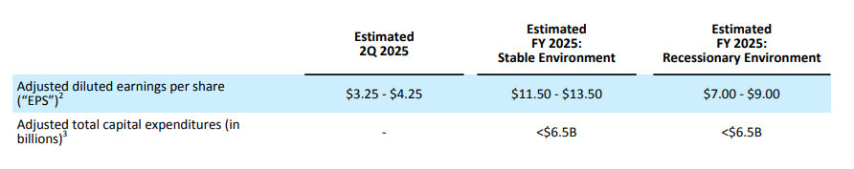
We thought it would be useful to do the same for markets, with a bull case and a bear case, and see where we land. To set a baseline we use the S&P 500's price level, but broken into12-month forward earnings per share (EPS) x the 12-month forward price-to-earnings ratio (P/E). The math is just Earnings * (Price / Earnings) = Price, since the Earnings parts “cancel.” It’s a way of getting a stock index price forecast by breaking it into two important pieces.
The goal is to come up with an estimate for the S&P 500 level at the end of the year. (It’s currently around 5,400.)
At the end of 2025, the forward 12-month EPS will actually be the 2026 EPS estimate, and so it makes sense to focus on that instead of 2025 EPS (the assumption is that markets are forward looking). Right now, the 2026 EPS level is at $302/share (about 2% below where it started the year, at $309/share).
The forward P/E ratio for the S&P 500 is currently between 18 and 19. It was 22.4 at the end of 2024, well above the 41-year average of 15.5.
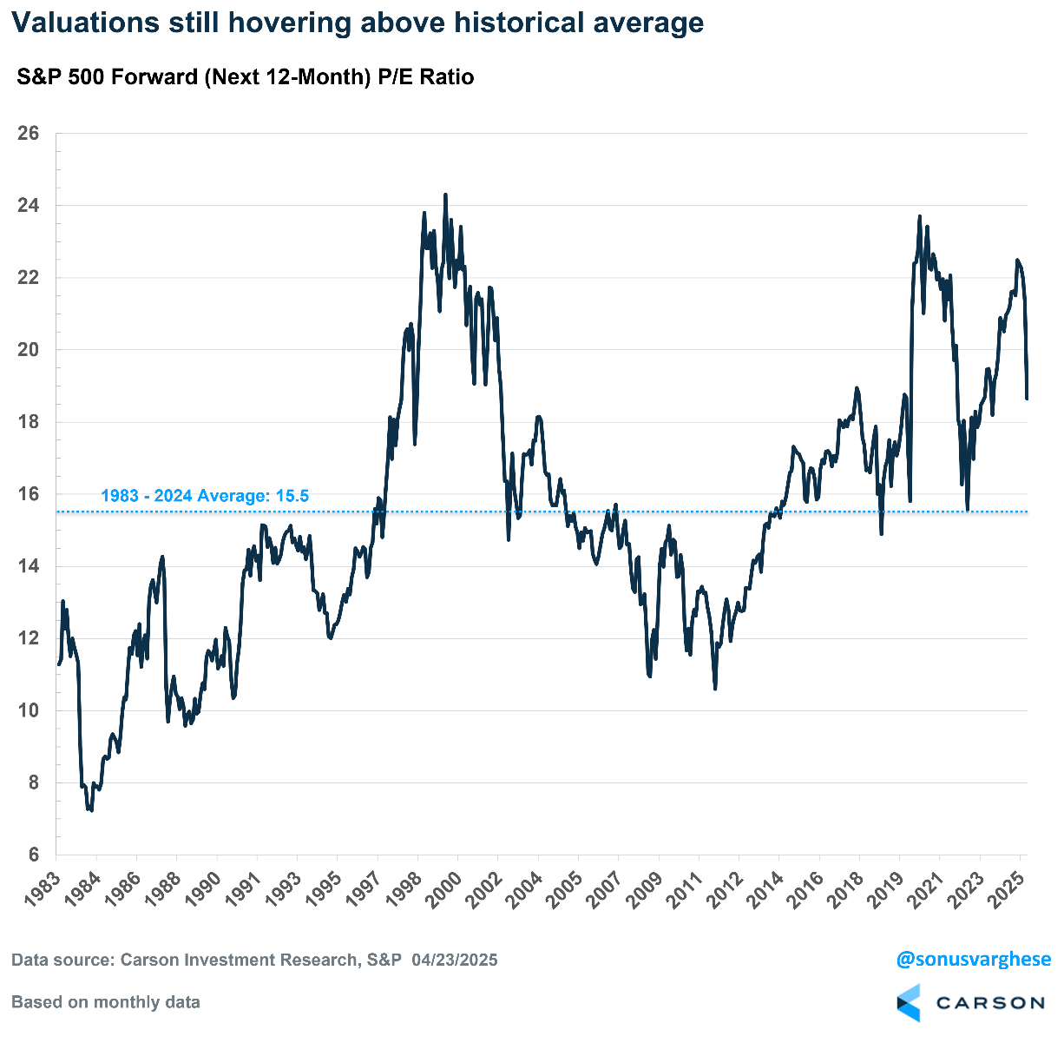

The Bull Case: Trump Caves, Completely
The bull case is that Trump removes almost all the tariffs. It's hard to imagine that the tariffs will go back to where they were, but perhaps we're left with about 10-15% additional new tariffs on average. It may even involve a phased approach (which was originally proposed in Congress), including something like 35% tariffs on Chinese goods that are not a threat to national security and about 100% for items deemed as strategic to US interests, but crucially, these would be phased in over five years. This would be very helpful for companies trying to navigate the tariffs (or that hope a future administration never imposes them). Perhaps the 25% steel and aluminum tariffs also remain, but we don't see other large sectoral tariffs, such as the 25% on autos, chips, electronics, and pharmaceuticals.
Ultimately, assuming we get clarity on all this, companies should be able to navigate the additional tariffs and maintain profit margins. Especially larger companies, who continue to benefit from what more or less looks like the existing global trade regime. There's no decoupling from China, no reshoring of manufacturing, no "External Revenue Service" replacing the IRS, no "Mar-a-Lago" accords (with US debt held by foreign companies restructured to much longer duration).
Perhaps we get a few deals, or a "one size fits all" kind of a deal, where other countries purchase more defense goods form the US, along with more agricultural products and LNG. However, the trade deficit doesn't really shrink in any meaningful way, and there aren't any deals on currency manipulation with countries like South Korea and Taiwan, let alone China. There's a question of what those countries get in return, but perhaps it’s simply assurance that the US is no longer looking to completely break the existing global trade regime.
In this scenario, inflation doesn't spike to worrying levels, with ongoing shelter disinflation offsetting idiosyncratic spikes in some commodity goods that are impacted by the tariffs. Long-term inflation expectations remain quite tame, and the Federal Reserve resumes cutting interest rates, perhaps as early as July if not June, staying on track to cut rates 2-3 times in 2025.
Congress also provides a cushion for the economy by raising deficits even further via tax cuts. Beyond renewing tax cuts that sunset at the end of 2025, they provide additional tax breaks for businesses and households (like no taxes on tips, social security, and raising the level for SALT deductions). Spending cuts are also minimal, with entitlements like Medicaid avoiding the axe. DOGE also remains a non-factor, which looks increasingly to be the case as they’ve already fallen well short of ambitions of cutting $2 trillion of spending (more like $5 billion to date). Elon Musk is stepping back soon as well, to focus more on his companies.
Of course, it doesn't mean things are perfect. The toothpaste is already out of the tube and there's an ongoing cost that gets harder to claw back the longer the current extraordinarily high level of tariffs stays in place. That’s either going to hit consumers via higher prices (and thereby lower real income growth), or businesses via smaller margins.
Still, the economy chugs along around 1-2% real GDP growth. There's no real boost from cyclical areas like housing and manufacturing, which continue to meander under the weight of elevated interest rates, which are likely to remain "meaningfully restrictive" even if the Fed cuts 2-3 times this year. Housing is going to struggle as long as mortgage rates stay above 6-6.5%. Investment will likely lag amid uncertainty — even if the trade war stops and tariffs go away, the threat remains.
For the market, the best case looks like 2026 EPS estimates remain where they are currently, around $302/share. But the added risk premium for US equities could result in a lower multiple, of say 20x optimistically.
That would bring the S&P 500 level to about 6,040 (= 302 x 20). That’s 12% higher than the current level of about 5,400 and results in a 3% price gain for the index over 2025. Add in dividends and the total return for the S&P 500 may be close to 5%. That wouldn't be bad considering everything happening now.
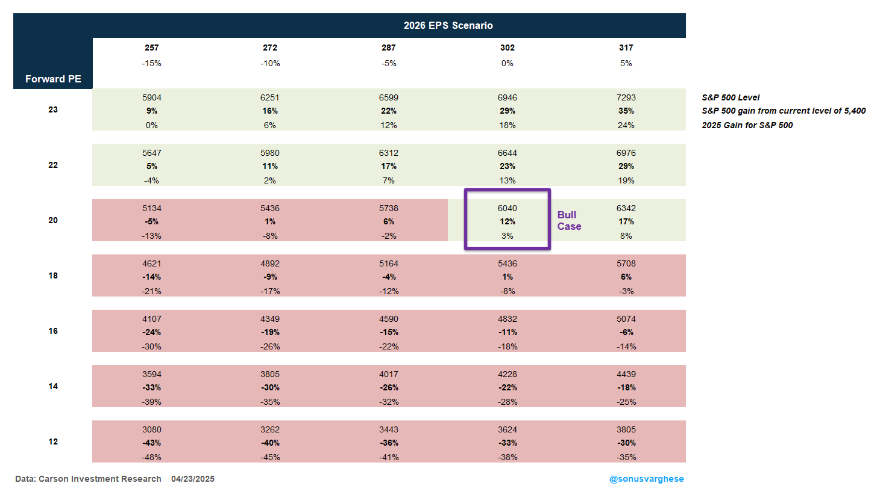
Note that a near 5% return for 2025 would be par for the course for the third year of a bull market, where average returns have been close to 2%.
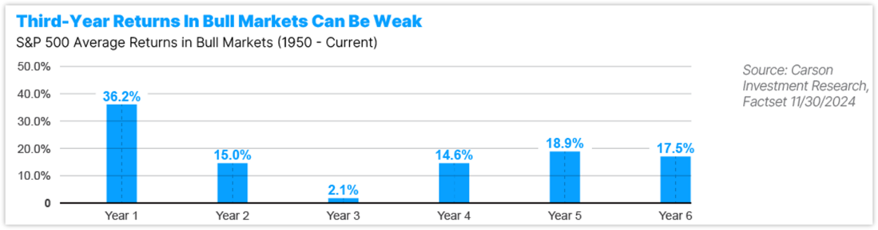
The Bear Case: Tariff-Cession
This is the base case for a lot of people now, and it's fairly straightforward: the US goes into a recession over the next 3-12 months.
The tariffs on China may be pulled back but we still see 50-65% tariffs on Chinese goods, which would be about three times worse than the worst case a lot of people were expecting before Liberation Day. (Note that tariffs on China even on Liberation Day were 54%.) Of course, this is not as bad as 150% tariffs on Chinese goods, which would likely stop a lot of trade altogether. At the same time, severe sectoral level tariffs remain, including on steel and aluminum, autos, pharmaceuticals, copper, chips, electronics, and even lumber.
Compounding the pain, the Fed sits back and pauses on rate cuts as idiosyncratic goods inflation puts core PCE on track to hit 3.5-4% by the end of the year (it's at 2.6% now). This is despite the unemployment rate starting to move past 4.5% (currently at 4.1%). But the Fed offers no relief as they focus on the inflation side of their mandate, as they did in 2022. They may eventually slash rates but it’ll likely be too late — though the turnaround may really start when rates hit bottom.
Plus, there's no relief from Congress either, as there isn't much room to increase deficit spending above current high levels of about 6% of GDP. The tax cuts are renewed but that simply maintains the status quo, with no additional boost — in contrast to what we saw in 2020 with CARES, or even via the Infrastructure Act, CHIPS Act, and Inflation Reduction Act in 2022-2023 (offsetting the impact of Fed rate hikes).
We start to see a drop in aggregate income, from a 4% annualized pace to about 2% or lower, as hiring freezes become commonplace and layoffs begin. As a result, employment gains drop, and hours worked also pulls back.
At the same time, it’s not like all of this happens in a vacuum, with the Trump administration sticking to their guns on tariffs.
Reaction and Conter-reaction Kicks In
As things started to get progressively worse, markets may start anticipating relief from the Trump administration, and/or the Fed. Maintaining the tariffs at massively high levels can lead to an adverse market reaction (in addition to an actual collapse in goods imports, leading to shortages and several small and medium sized companies going out of business). And as we saw over the last two weeks, the Trump administration is likely to try and dial back from extreme levels to avoid visible pain in markets (like in the bond market) or even on "Main Street" (as company CEOs warn of shortages and empty shelves).
Also, household and corporate balance sheets are in reasonable shape and not as leveraged as they were in 2007. So, we should be able to avoid a financial crisis, a la a 2008-style meltdown in markets and the economy. We could see 2026 EPS downgraded by about 10% (from $302/share to $272/share), and P/E ratios fall to about 16x (near the historical average). That would bring the S&P 500 level to about 4,349, which is 19% below where we are now and would represent a 26% decline for the index in 2025. Like I said, this is the bear case amid a lot of uncertainty, so it makes sense that we would end up in a bear market.
Note that I'm not trying to pinpoint the exact level of EPS and P/E multiple at the end of 2025. We could very well see this scenario play out by October or November, if not much earlier. This is just to lay out a framework for thinking about what could happen.
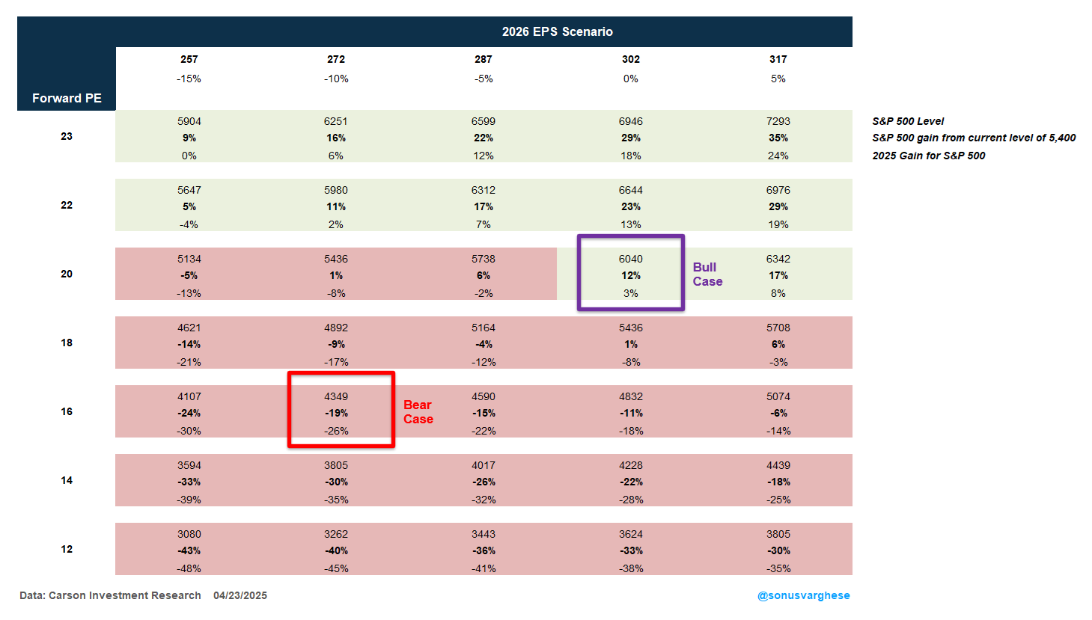
A Long Slog and Exod-US
It’s hard to put precise odds on the bull and bear case, since it’s entirely subjective and we really don’t know how committed the Trump Administration is to breaking the current global trade regime and forging a completely new one. Even if the goal is to reshore manufacturing, that’s going to involve increasing the share of manufacturing value-add in the economy, at the expense of services, but that is big reversal of what’s been happening in the economy for the last few decades. Keep in mind that this also involves changing how US multinationals generate profits, with global sales but also supply chains that crisscross the globe to keep costs low. Of course, companies are going to figure out how to navigate the situation, but it’s going to take some time. All this also assumes we have clarity on what “normal” looks like.
In reality, what we may get is a pinging back and forth between momentum toward the bull and bear case, especially as reflexivity kicks in. As things get better, the Trump administration feels even more emboldened in their mission to remake the global trading system. However, as they do this, adverse reactions in markets and companies across America lead to dialing tariffs down (or tariff rhetoric). For example, we may not see many deals being negotiated (and signed) before the 90-day pause is up, in which case we could see yet another 90-day pause. Plus, sectoral tariffs may be paused, or several companies may be given exemptions. In short, the dynamic we've seen over the past three weeks continues to play out over the next several months, and perhaps even beyond.
In the meantime, America's trading partners work around the US, either making deals with each other, and/or stimulating consumption within their own economies. Countries like China and Germany boosting consumption would arguably be good for the US, and especially US multinationals (who get to benefit from growth abroad). However, high uncertainty in the US leads to plunging investment. We may not get a recession under this scenario, but employment growth may remain lackluster, and we could see more inflation volatility over the next 2-3 years (especially with durable goods getting more expensive, amid idiosyncratic supply chain issues). This also means the Fed may keep rates elevated for much longer. That's going to dampen housing activity, let alone the manufacturing sector (a double blow since they'll also get hit by tariffs).
Short term uncertainty may also lead to longer term structural uncertainty. The reality is we don't have much experience with this, since the level of tariffs may remain higher than with Smoot-Hawley in the early 20th century. That is not to say we'll experience a Depression (far from it, we may not even get a recession). However, consumers and businesses may pull back from making large spending and investment decisions, eventually trying to adjust to a new "normal." Of course, there's also the possibility that any new normal reverts to some version of the old pre-Liberation Day normal if there's a new administration in 2028.
Ultimately, if uncertainty continues, the risk premium on US assets is likely to go up. That means lower multiples for equities and higher term premiums for bonds. This is also not to say the US dollar will collapse — there's too much of a network effect for that to happen anytime soon — but the standing of the US, particularly US assets, gradually diminishes, most notably their role as the go-to "risk-free" asset amid a crisis.
In a sense, this would be America voluntarily pulling back from the rest of the world, what you might call an “Exod-US” similar to Brexit, but in a much bigger way.
Implications for Investing
With respect to investing, I think we’re generally going to see more volatility than we experienced over the last decade, but that does not mean we’re pessimistic. There’s opportunity to potentially outperform during high volatility regimes. It just means portfolios may have to be more robustly diversified than they were in the past.
We still prefer equities over other asset classes, but we’d rather be much more diversified, across the globe. We also prefer large caps over mid- and small caps, which could struggle in a more volatile environment. That in and of itself is a big reversal from how we positioned portfolios over the last couple of years. Even within large caps, rather than just betting on the added risk being rewarded, we’d rather take advantage of factor premia like momentum, but barbelled with lower volatility stock exposure.
With respect to diversifying equities, we don’t think bonds should be the only game in town, especially if we see more inflation volatility and term premiums are higher. So, we’re underweight long duration bonds, and overweight alternative assets like managed futures, and even ultra-short duration bonds/cash-equivalents that are actively managed.
In short, across portfolios, when in doubt, diversify it out.

This newsletter was written and produced by CWM, LLC. Content in this material is for general information only and not intended to provide specific advice or recommendations for any individual. All performance referenced is historical and is no guarantee of future results. All indices are unmanaged and may not be invested into directly. The views stated in this letter are not necessarily the opinion of any other named entity and should not be construed directly or indirectly as an offer to buy or sell any securities mentioned herein. Due to volatility within the markets mentioned, opinions are subject to change without notice. Information is based on sources believed to be reliable; however, their accuracy or completeness cannot be guaranteed. Past performance does not guarantee future results.

S&P 500 – A capitalization-weighted index of 500 stocks designed to measure performance of the broad domestic economy through changes in the aggregate market value of 500 stocks representing all major industries.

The NASDAQ 100 Index is a stock index of the 100 largest companies by market capitalization traded on NASDAQ Stock Market. The NASDAQ 100 Index includes publicly-traded companies from most sectors in the global economy, the major exception being financial services.

A diversified portfolio does not assure a profit or protect against loss in a declining market.

The views stated in this letter are not necessarily the opinion of Cetera Advisor Networks LLC and should not be construed directly or indirectly as an offer to buy or sell any securities mentioned herein. Investors cannot invest directly in indexes. The performance of any index is not indicative of the performance of any investment and does not take into account the effects of inflation and the fees and expenses associated with investing.

Compliance Case # 7905356.1_042825_C

