A Closer Look at the Stock Market’s Reaction to Major Geopolitical Events

The Stock Market’s Reaction to Major Geopolitical Events Tends to Be Short-Lived
The escalating tension between Israel and Iran has many investors worried about what could happen next. Although we won’t pretend to know the answer, we do understand that while geopolitical events can cause near-term market volatility, they rarely cause major problems for markets longer term.
- Stocks had their worst week of the year and have now fallen three consecutive weeks for the first time since September 2023.
- Geopolitical worries are high, but historically the impact of global events on stocks has been short-lived, especially if the economy is strong.
- After a nearly 30% rally off the late-October lows, some market weakness shouldn’t be surprising and is actually quite healthy.
- While geopolitics is a near-term risk, three major themes for 2024 are worth watching:
  - Data continues to support an overall positive outlook for the economy.
  - We now expect higher interest rates (but not as high as current rates) for much longer.
  - No matter who is elected president or controls Congress, fiscal deficits aren’t going away.
We don’t want to minimize the events overseas, but we hear this question frequently, so we reviewed 40 major historical geopolitical events to determine the market impact. On average, we found that stocks were higher three months later. While some of these events caused recessions and likely hurt overall returns, in many cases stocks did just fine. This was likely because a stronger economy was able to absorb the impact, even if it was sometimes devastating from a human perspective.

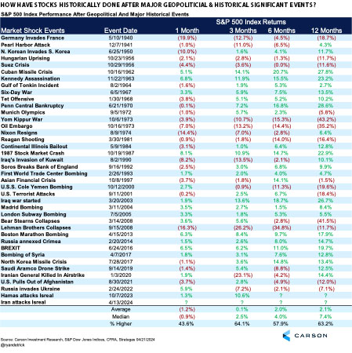
Investors cannot invest directly in indexes. The performance of any index is not indicative of the performance of any investment and does not take into account the effects of inflation and the fees and expenses associated with investing. Past performance does not guarantee future results.
Should the conflict between Iran and Israel continue to escalate, pulling in other countries, of course we would expect additional near-term volatility, especially given the sensitivity of inflation to oil prices. But, for now, it appears tensions have calmed in the region, and as long as the U.S. economy remains firm, which is likely, we expect the bull market to continue.
This Is Normal
The news headlines have been scary recently, but after the market run off the late-October lows, investors have been quite spoiled. From the Oct. 27 lows until the March 28 peak, the S&P 500 added 27.6%, marking one of the best five-month rallies in history. As we’ve noted previously, some weakness or choppy action after that kind of run is perfectly normal.
Most years tend to see more than three 5% corrections on average, and 2024 only just had its first. Even more interesting, many years have averaged a 10% correction but still managed to finish the year higher, with 2023 as the most recent example. Could the current 5.5% mild correction turn into a 10% correction? Anything is possible, but for now we do not expect markets to turn that far.
We are actually encouraged by the fear starting to build up in the market. A month ago, nearly everyone was a bull, so these bouts of volatility are necessary to flush out the weak hands. Flows are moving out of equities, sentiment polls are turning dour, and overall anecdotal sentiment is much different than it was a few months ago. All in all, a choppy period and potentially a little more weakness could be in the cards, but we believe a tactical low is near.
Lastly, reviewing previous election years that started strong, such as 2024, shows that choppy weakness could last until after Memorial Day, but a summer rally is also likely. So, don’t lose faith now. This is all part of the process, and we continue to expect a strong second half of the year.
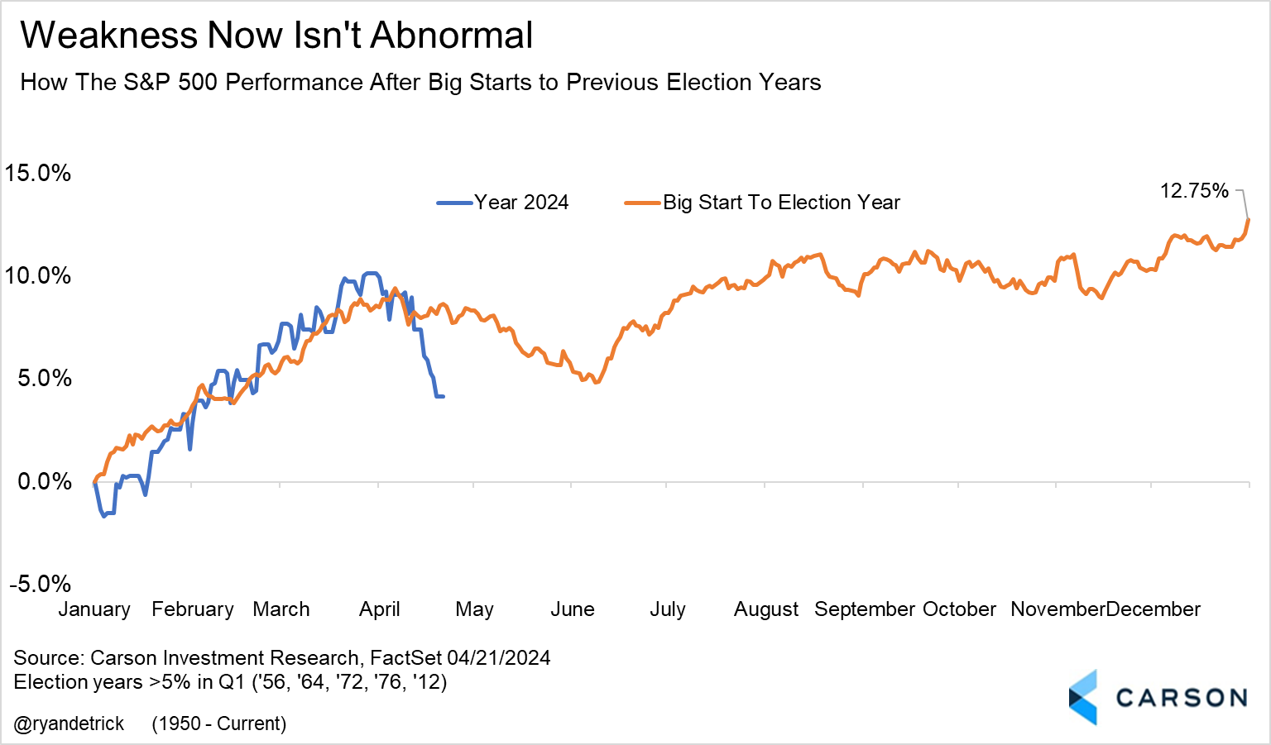
Investors cannot invest directly in indexes. The performance of any index is not indicative of the performance of any investment and does not take into account the effects of inflation and the fees and expenses associated with investing. Past performance does not guarantee future results.
Three Big Themes for 2024 and Beyond
One central theme in our 2024 Outlook is higher productivity growth. The key idea is that tight and mature labor markets enhance worker productivity and incentivize businesses to organize work more efficiently and invest in technological resources. That doesn’t happen when labor is cheap. Better productivity growth can lead to strong wage growth without significant inflationary pressure. That allows the Federal Reserve to ease rates — not by a lot, but just enough to boost business investment and drive further productivity gains.
The current problem is rate-cut expectations have been pushed further out, thanks to firmer inflation data in the first quarter. That led to rising bond yields and market volatility in April. The shift in pricing has been remarkable, moving from an expectation of 6-7 rate cuts at the beginning of the year to fewer than two now.
However, some investors are missing the forest for the trees amidst this sharp shift in sentiment. We think it’s useful to look at the big picture.
Economic Growth Remains Solid, As Does the Outlook
While inflation data for Q1 was hot, albeit for idiosyncratic reasons, we also received the following:
- Strong employment data, with payroll growth accelerating from last year and layoffs low.
- Strong consumer spending data, including March retail sales.
- Strong industrial production data and a pickup in manufacturing survey sentiment.
Perhaps the best way to capture the various data points is via the Atlanta Fed’s GDP Now estimate for first-quarter GDP growth, which is 2.9% and hides underlying strength. Inventories and exports are typically the most volatile parts of GDP, so excluding these indicates the pace of underlying demand in the economy (inflation-adjusted). That is above 3.5% now! For perspective, the 2010-2019 average pace was 2.4%.
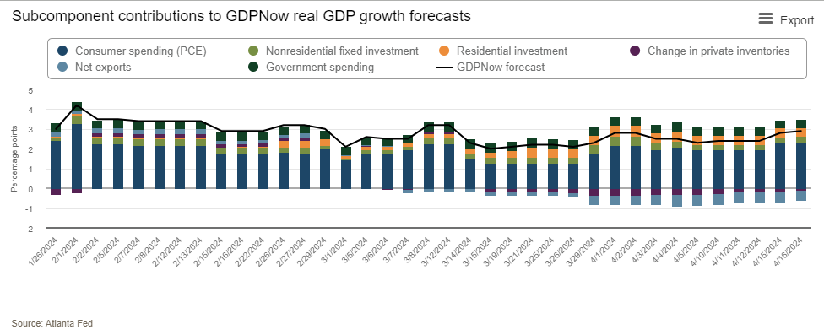
Past performance does not guarantee future results.
Perhaps just as importantly, the employment data shows that “hours worked” was more or less flat in the first quarter. That means productivity, which is output over hours worked, is likely to run above trend for the fourth quarter in a row. It’s good to see the productivity narrative is intact, mostly thanks to a strong labor market. That bodes well for future growth.
Higher Interest Rates for Much Longer
Usually as short-term interest-rate expectations rise, investors become worried that the Fed is too tight, driving economic growth lower or into a recession. Long-term yields typically fall in anticipation, as inflation expectations fall. However, long-term rates have risen recently, and even more so than short-term rates.
At first approximation, long-term rates are simply an estimate of future short-term Fed policy rates. Higher long-term rates means investors now expect higher policy rates in the future. In fact, expected policy rates for 2029 are now higher than 4%, well above where they were at the end of 2023. That implies investors expect stronger economic growth in the future, with robust labor markets and high productivity. At the same time, an economy running near capacity means potentially more inflationary pressure, which is why investors expect policy rates to stay on the higher side.
Interestingly, the Fed expects to lower rates all the way down to 2.5-2.75% over the long run. That’s because Fed members expect the economy to revert to the low-productivity, low-growth status of the last two decades. We disagree. We expect stronger productivity growth over the next several years, leading to a stronger economy relative to the last decade and higher interest rates as a result.
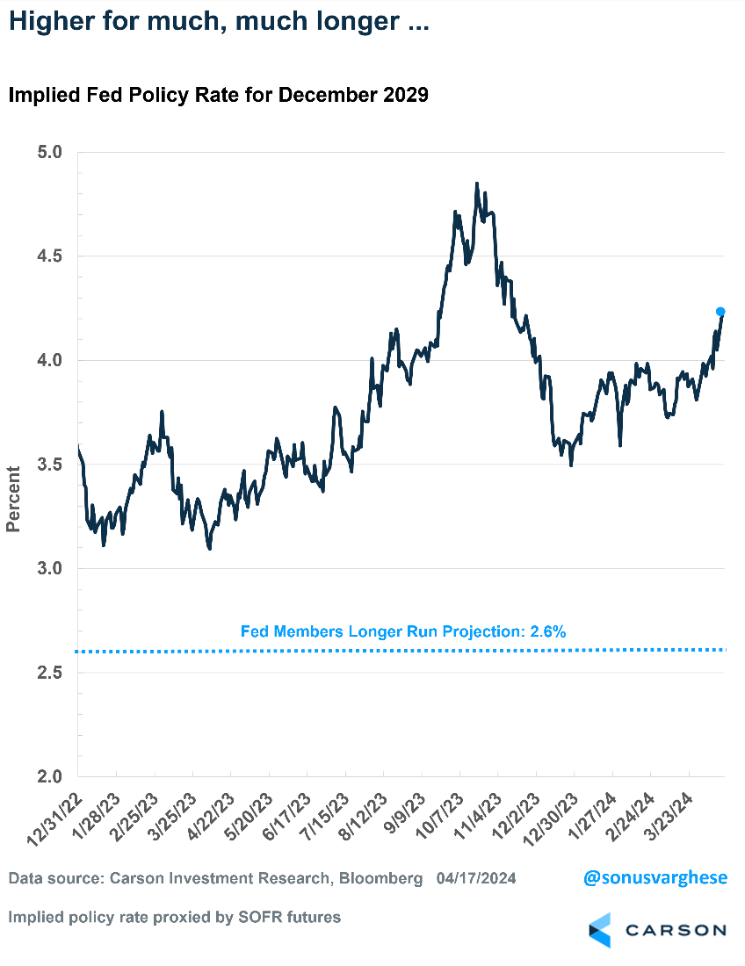
Fiscal Deficits Are Not Going Away
This is an election year, and come the fall, the election-related noise is going to increase by several decibels. It’s best not to involve politics in investing. Historically, it has paid off to ignore who sits in the White House. But that does not imply that elections and policies don’t matter. Irrespective of who’s president, or who controls Congress, higher fiscal deficits are likely to persist over the next several years. This is partly because of higher interest costs for the government, but policy will also play a role no matter which party is in the White House.
With respect to President Joe Biden and former President Donald Trump, we have a reasonably good idea of the policies they will implement if either wins a second term, and both courses are likely to drive the deficit higher over the next few years. The big one is tax policy. The 2017 Tax Cuts and Jobs Act (under President Trump) had a slew of individual tax cuts that are all slated to sunset at the end of 2025. Renewing them all, as Trump has said he will do, means the deficit remains high (and he’s indicated even more tax cuts are possible). Some revenue will come in if Trump raises tariffs, but that won’t be nearly enough to offset tax cuts.
On the other hand, Biden has said he will not renew all the individual tax cuts, so cuts for the highest tax brackets would go away. He has also raised the possibility of raising corporate taxes. Of course, he will need a Democratic sweep of the House and Senate for this to happen, and that is looking very unlikely. The table below shows scenarios for control of Congress under Biden or Trump and the likely impact on the fiscal deficit.
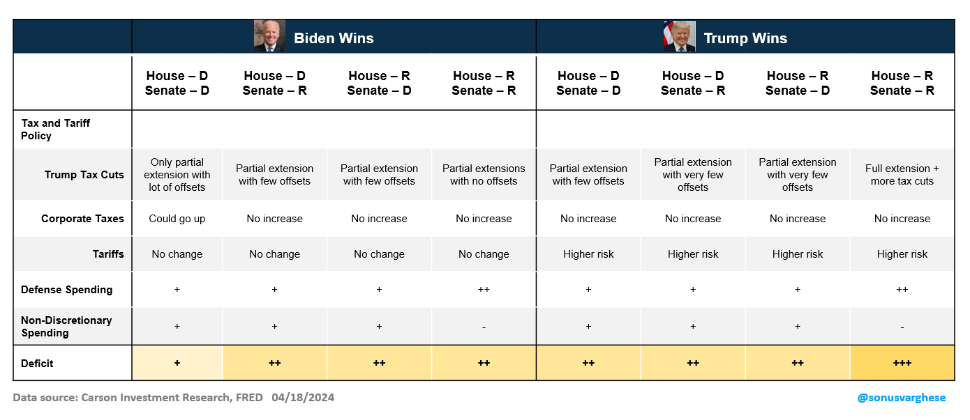
Of course, the question is how do deficits matter to markets?
Market Implications
A common refrain is the stock market is not the economy (and vice versa), sometimes phrased as “S&P is not GDP.” That is true, but profits matter to markets. Over the long term, market returns are mostly driven by profit growth, and profits come from the economy. It’s the net result of saving and consumption by four sectors of the economy: households, businesses, governments, and the rest of the world via trade. In fact, there’s a national accounting identity that precisely relates profits to the various components of GDP called the Levy-Kalecki profit equation:
Corporate Profits After Tax = Corporate Investment + Dividends – Household Savings – Government Savings + Current Account Surplus
This equation captures the various sources of profits on a macro-aggregate level:
- Investment: More businesses investing in equipment, structures, etc., increases profits. The idea is that one business’s investment is another business’s revenue and profits.
- Dividends: Income received by shareholders tends to get spent, unless households increase their savings. So, it goes back to businesses as revenue.
- Household savings: If households spend more, that translates to more revenue and profits for businesses. Conversely, increasing household savings reduces profits.
- Government savings: Rising government savings reduces corporate profits, and vice versa. In other words, deficits add to profits, all else equal.
- Current account surplus: A rising current account surplus means the rest of the world is buying more U.S.-made goods and services than Americans buy from other countries, and that increases business revenues and profits. Whereas a current account deficit, which is typically what the U.S. holds, means Americans buy more from abroad, which is a drag on profits.
By definition, this accounting identity has to be true. It doesn’t indicate which companies are growing profits, or how profits are distributed across industries, or even the sustainability of profit growth. But it shows what can happen to drive profits up or down. For example, if the government is reducing its deficit, corporate profits will rise only if the private sector is increasing consumption such that it offsets increased government saving. If not, corporate profits will fall.
The chart below shows an attribution of corporate profit growth over several sub-periods since 2010. Note that this is not equivalent to S&P 500 profits, as it comes from macroeconomic data and includes all businesses in the U.S., public and private.
- 2010 – 2015: Business investment and dividends drove profit growth, overcoming the drag from reduced government spending.
- 2016 – 2019: Profit growth surged thanks to rising fiscal deficits after the 2017 tax cuts, even as household savings increased.
- 2020 Q1 – 2021 Q2: Profit growth was driven by massive fiscal deficits, which overcame the drag from rising household savings, lack of business investment, and rising trade deficits as Americans purchased more goods from abroad.
- 2021 Q3 – 2022 Q4: Recovering household consumption as consumers spent their excess savings and business investment drove profit growth, overcoming the drag from falling fiscal deficits.
- 2023 Q1 – 2023 Q4: Profit growth was once again boosted by rising fiscal deficits, especially as interest costs rose, more than offsetting rising household savings.
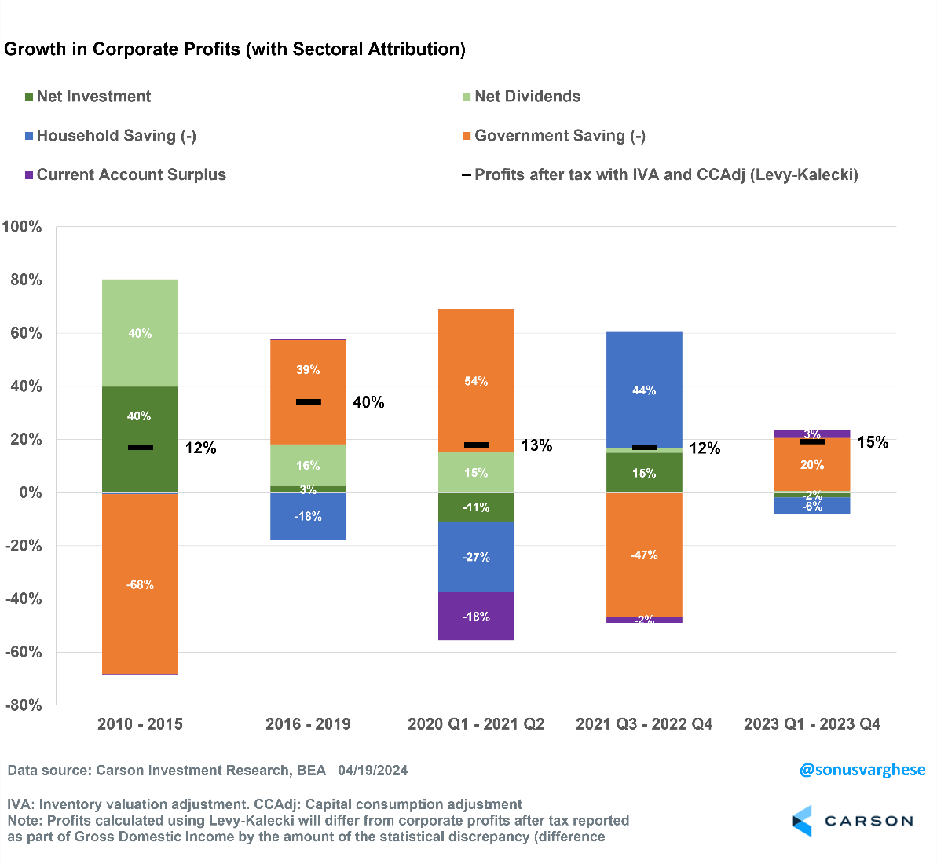
Portfolio Positioning
These three themes: economic growth driven by stronger productivity, higher interest rates amid a strong economy, and fiscal deficits, are all related to profit growth. As discussed above, business investment that boosts productivity can drive profits higher. The outlook for fiscal deficits suggests they are going to increase. Higher interest costs for the government will only add to this surge. Fiscal deficits can boost profits as long as they are not completely offset by higher household savings rates and lack of business investment.
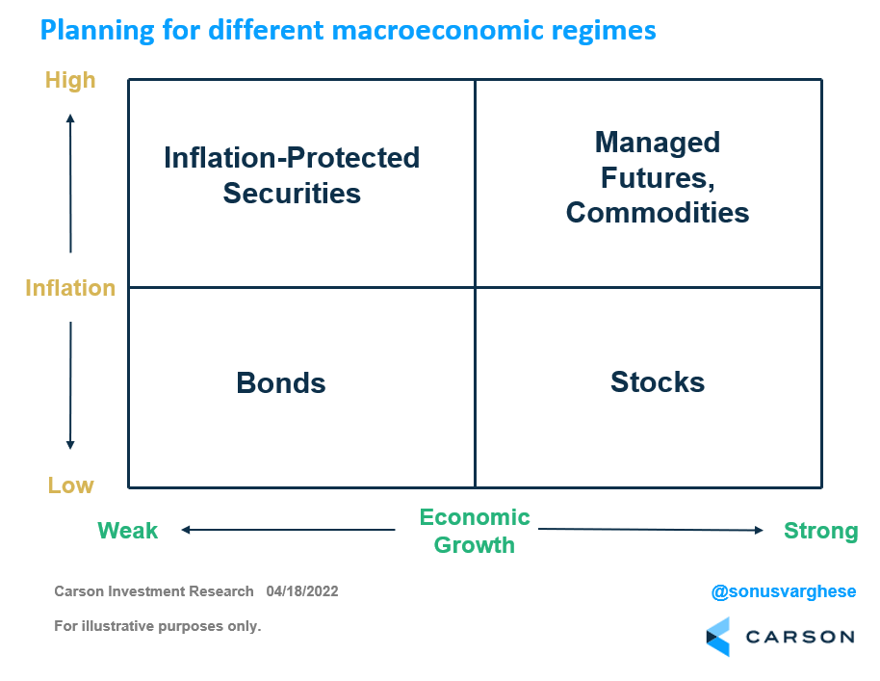
The chart above shows how we view allocating among asset classes depending on the macroeconomic regime. Right now, we believe the positive outlook for profit growth amid a strong economy makes the case for overweighting equities and underweighting bonds — amid a high economic growth environment. At the same time, a high-capacity economy that is likely to see inflationary pressures from time to time makes the case for diversifying away from bonds and into asset classes such as managed futures. Managed futures is a trend-following strategy that can take long or short positions in commodities, interest rates, equities, and currencies and provide valuable diversification to stocks and bonds. Periods of rising inflation, and rising rate expectations, can put pressure on both stocks and bonds, increasing the importance of diversification outside these two traditional asset classes.

This newsletter was written and produced by CWM, LLC. Content in this material is for general information only and not intended to provide specific advice or recommendations for any individual. All performance referenced is historical and is no guarantee of future results. All indices are unmanaged and may not be invested into directly. The views stated in this letter are not necessarily the opinion of any other named entity and should not be construed directly or indirectly as an offer to buy or sell any securities mentioned herein. Due to volatility within the markets mentioned, opinions are subject to change without notice. Information is based on sources believed to be reliable; however, their accuracy or completeness cannot be guaranteed. Past performance does not guarantee future results.

S&P 500 – A capitalization-weighted index of 500 stocks designed to measure performance of the broad domestic economy through changes in the aggregate market value of 500 stocks representing all major industries.

The NASDAQ 100 Index is a stock index of the 100 largest companies by market capitalization traded on NASDAQ Stock Market. The NASDAQ 100 Index includes publicly-traded companies from most sectors in the global economy, the major exception being financial services.

A diversified portfolio does not assure a profit or protect against loss in a declining market.

Compliance Case # 02210749_042224_C

