Markets React to Inflation

Even in Healthy Markets, Stocks Go Up and Down
After more than a 30% total return on the S&P 500 over the last 12 calendar months, a five-month win streak, and a 27% rally in the first 100 trading days off the late-October lows, the market may finally be having a well-deserved break. We want to stress that this isn’t something to fear. It’s all part of the process, even in healthy bull markets.
- Stocks fell last week on inflation and Middle East worries.
- After the historic run, some type of consolidation is perfectly normal.
- CPI inflation came in hotter than expected, shifting rate-cut expectations.
- We don’t believe inflation is a concern but agree it has likely pushed back rate cuts.
In fact, now is a good time to remind investors that having to endure volatility is the toll we pay to invest. Or, to quote Ben Franklin, “There are no gains without some pains.” Last year, stocks gained more than 20% but experienced a 10% correction into late October, which worried many investors but was actually a fairly normal stock market development, historically.
Below is a useful table from our friends at Ned Davis Research on market volatility. It shows that the average year has historically more than seven 3% dips, more than three 5% mild corrections, and one 10% correction. That puts this year into perspective, considering stocks have pulled back less than 3%, and serves as a reminder that more volatility could be in store.
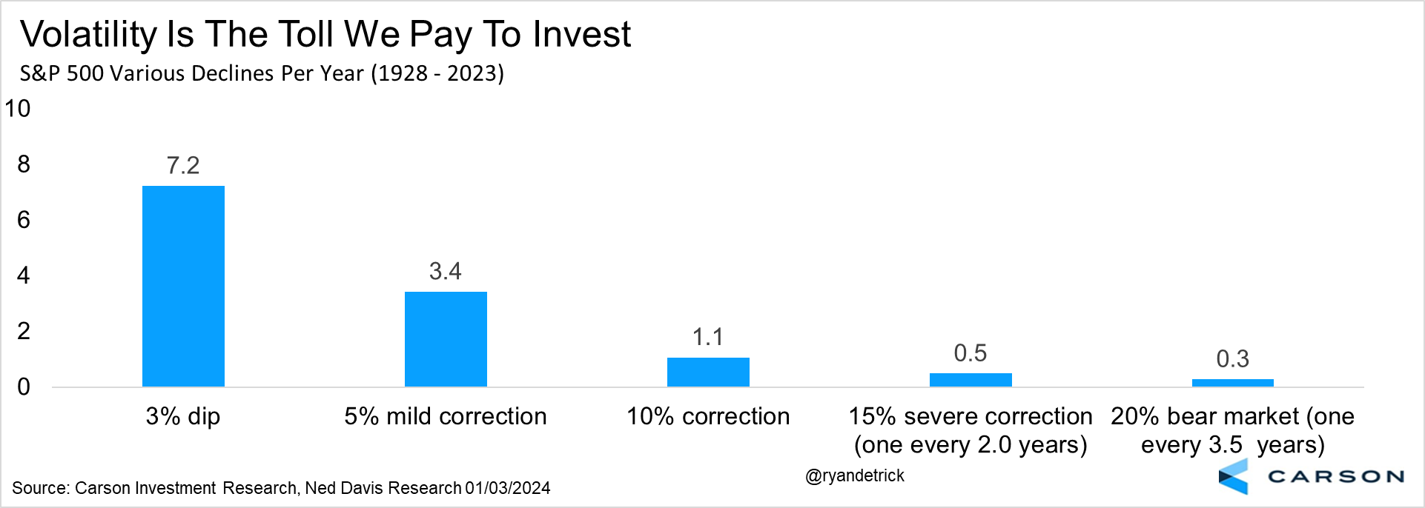
Here’s another perspective. The average year for the S&P 500 since 1980 has seen a peak-to-trough correction of 14.2%. More than three months into 2024, stocks have pulled back 2.5%, which would tie it with 1995 for the smallest pullback ever if things stay this way. We believe we are in a bull market and stocks will be higher at the end of the year. But it’s unlikely to be an easy ride.
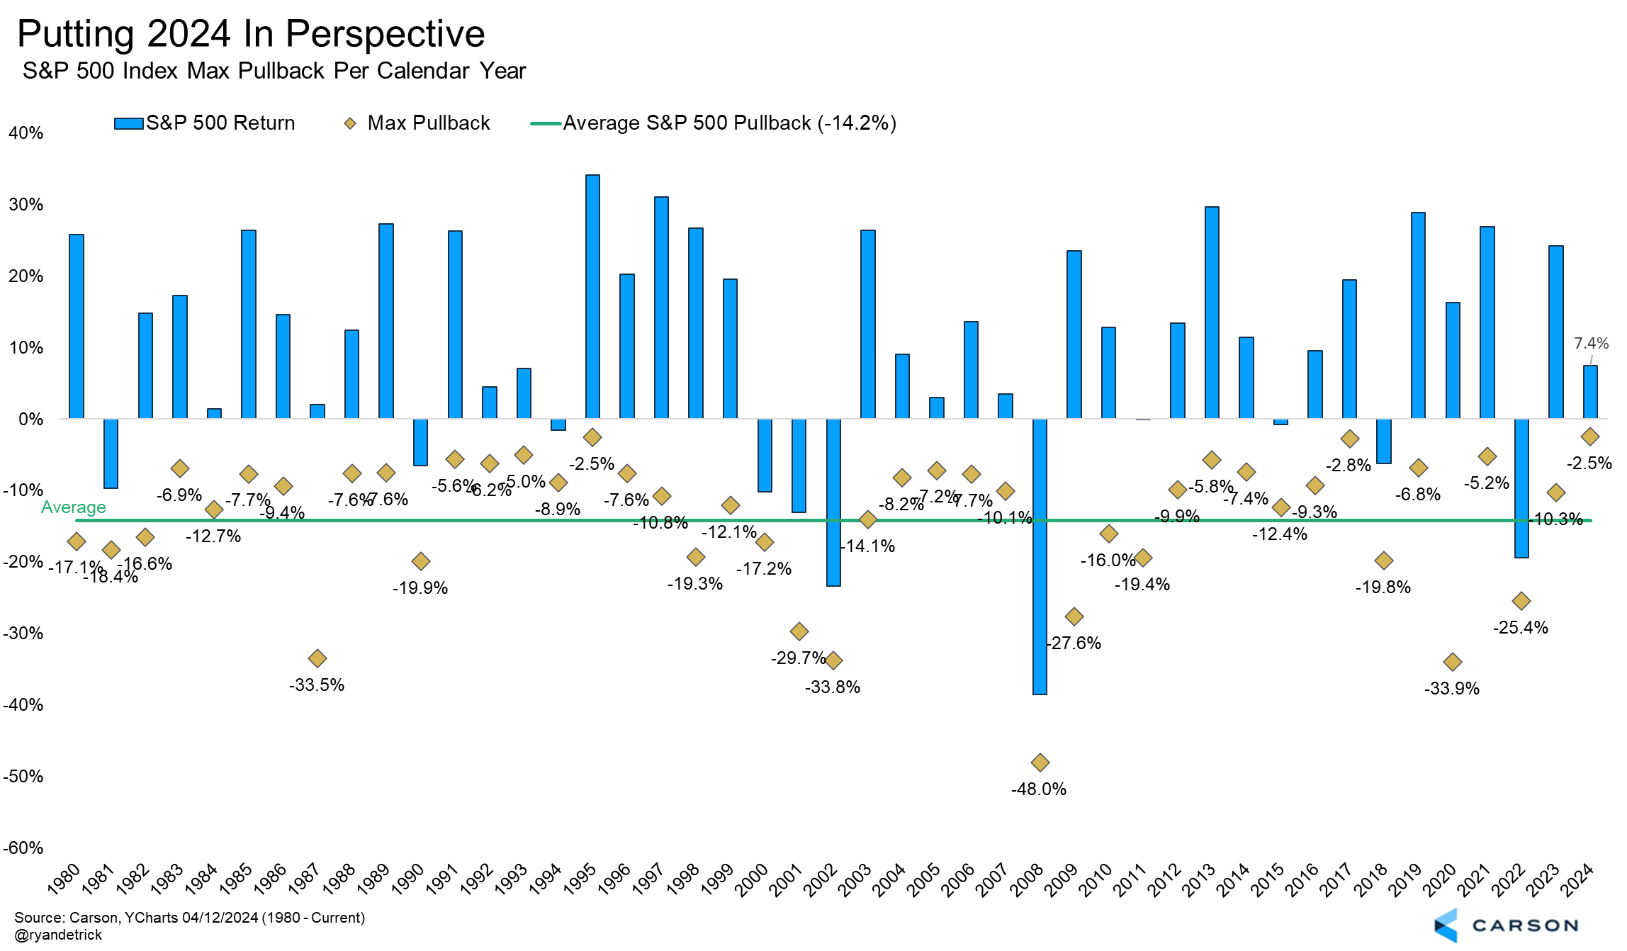

Inflation Ran Hot in Q1 but Path Likely Still Lower
Is it time to start worrying about inflation again? We believe the short answer is likely no. Make no mistake, inflation ran hot in the first quarter, especially relative to the fourth quarter of 2023. The March Consumer Price Index (CPI) report was an unwelcome surprise. Both headline and core inflation (excluding food and energy) came in above expectations. Headline inflation is up 3.5% from last year, and as the solid line in the chart below shows, inflation progress has stalled since June 2023.
But the breakdown also suggests shelter inflation is behind the stall. Inflation within every other major category, including food prices, vehicle prices, and even household furnishings, apparel, airfares, and hotels prices, has eased relative to last June. Gas prices have risen this year, but we’re a long way away from the energy price surge of mid-2022.
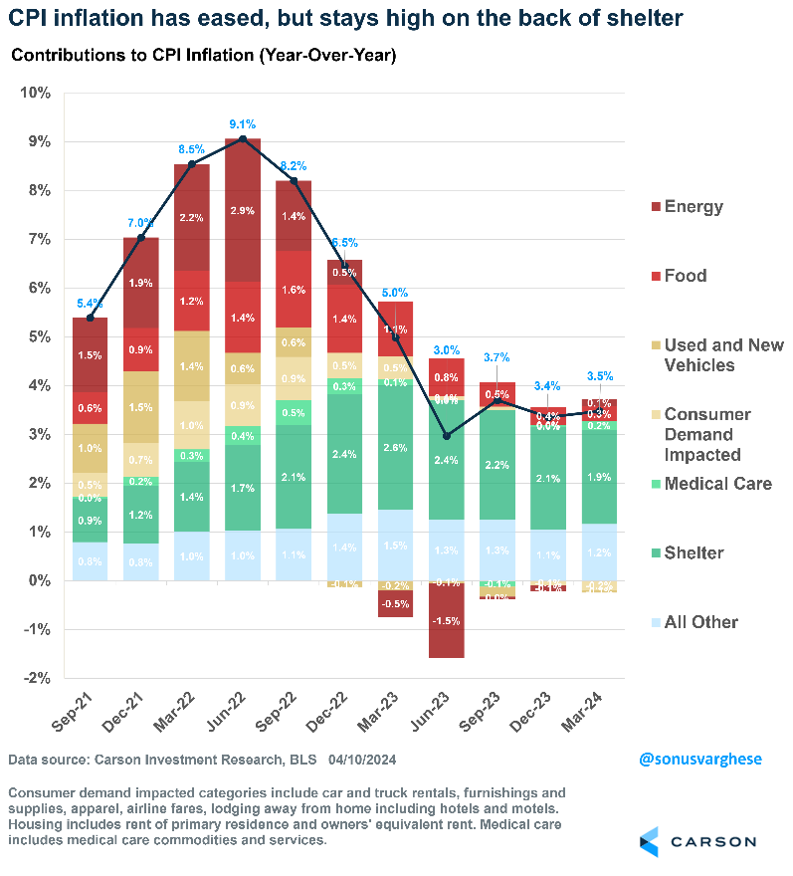

I’ve written about shelter inflation several times over the past year and a half, and so I’ll skip the details. Suffice it to say, official shelter inflation has a significant lag to rents in the private data. Shelter inflation matters a lot for CPI, as it makes up 35% of the basket. Rents of primary residences account for 8% of shelter inflation, while “owners’ equivalent rent” (OER) accounts for 27%. OER is the “implied rent” homeowners pay, and it’s based on market rents as opposed to home prices.
What’s strange is that the U.S. is the only major country that includes a concept like OER in its CPI basket. Other major countries, including in Europe and Canada, include rental inflation but not OER. The Bureau of Labor Statistics calculates an equivalent measure for the U.S. called the “harmonized index of consumer prices” (HICP), which is similar to CPI excluding OER. I find this a useful gauge of inflation because it includes regular rental inflation but excludes the problematic OER. It’s also helpful for comparing U.S. inflation to inflation in other countries on an apples-to-apples basis. U.S. HICP is up 2.4% since last year, and core HICP (excluding food and energy) is up just 1.9%. In March, core HICP rose 0.2%, equivalent to an annualized pace of 2.3%. This indicates underlying inflation is not worrisome.
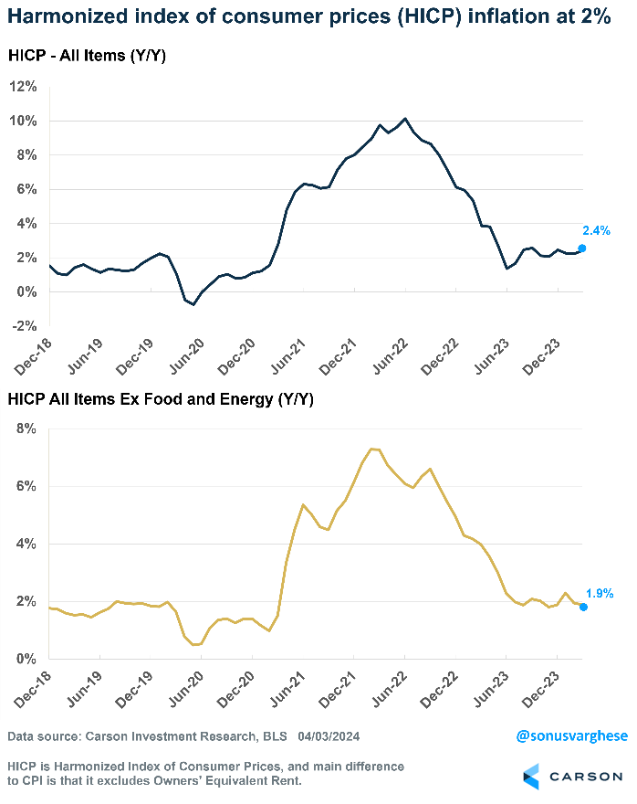

Unfortunately, CPI inflation is widely followed in the U.S. Shelter inflation, including March data, is easing, but it’s happening slowly. Apartment List’s national rental index has been in a year-over-year decline for 10 straight months. Official shelter inflation may not get as low, but more easing is likely in the months ahead.
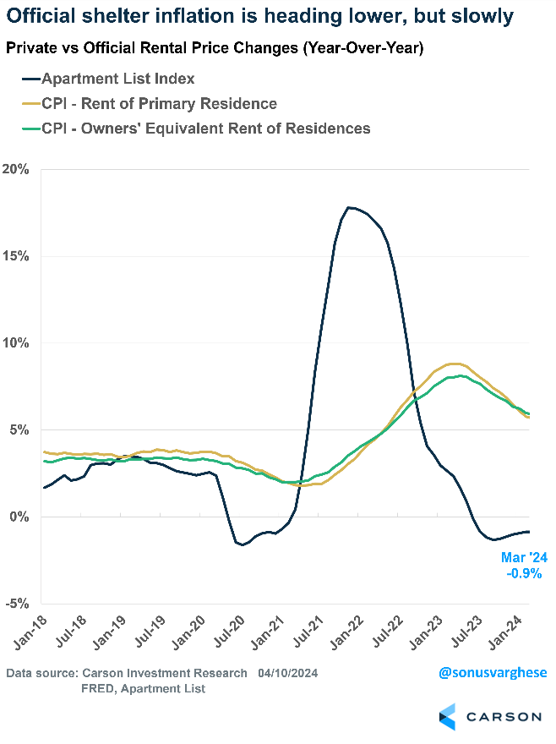

Shelter was not the only upward force on inflation in March. Core inflation (excluding food and energy) rose 0.36%, of which shelter contributed 0.19%. Another 0.09% came from motor vehicle insurance, which makes up less than 4% of the core CPI basket. Together, shelter and motor vehicle insurance contributed 78% of the core CPI increase in March. Motor vehicle insurance rose 2.6% in March and is up 23% since last year. A big reason is cars and trucks are pricier now, and so insurance is getting more expensive. Repair costs are also rising. For example, a bumper used to be a cheap replacement part, but now its advanced electronic sensors make it expensive.
The Strong Economy Not Causing Inflation to Accelerate
Outside of shelter and motor vehicle insurance, most categories are seeing disinflation or an outright fall in prices. That’s despite strong household consumption. Most major categories are improving, whether it’s food prices, commodities outside food and energy, such as vehicles, household furnishings, and appliances, or services, such as hotels, airfares, personal care services, theater and concert admissions, and car and truck rentals.
One category we like to follow to help monitor overall inflation is “full-service meals and snacks.” It has tracked core inflation closely even though it’s not included within the core inflation basket. We find it useful because full-service restaurant meals combine several elements that go into inflation, including:
- Commodity prices – food and energy
- Wages – for restaurant workers
- Rents – for the restaurant premises
Inflation for restaurant meals has eased significantly over the last few months. It was up just 3.3% from last year, which is in line with where it was in 2019. At its peak in August 2022, inflation for restaurant meals was as high as 9%. The current level suggests underlying inflation is quite benign.
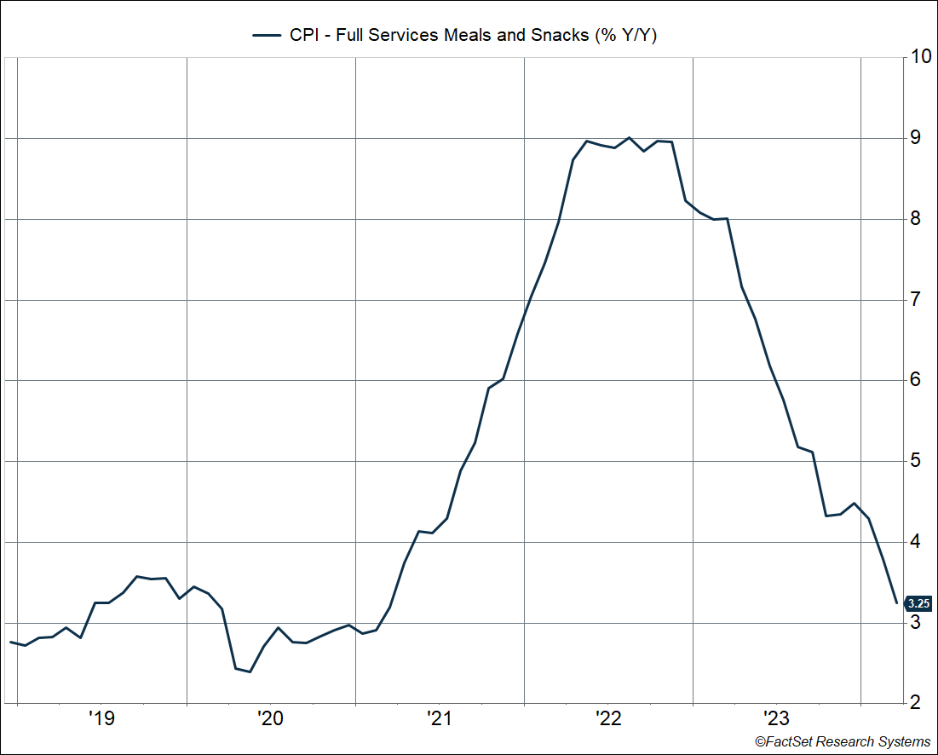

Listen to Consumers
Federal Reserve Chair Jerome Powell has said that one cause of spiraling inflation is rising inflation expectations, which is what happened in the 1970s. If consumers expect higher inflation, they tend to demand higher wages, and that puts more pressure on prices for goods and services. We can rest easy, because consumer expectations of inflation — both over the next one year and five years — have come in below 3% for three months straight (using the University of Michigan consumer survey). That’s not far above pre-pandemic levels, when expectations were running around 2.5-2.8%.
Consumer inflation expectations are not particularly accurate in forecasting future inflation. (It’s hard even for the Fed.) But we find it a useful way to gauge current inflation, because consumers usually project current inflation out into the future. And right now, consumers are saying inflation is running only slightly above where it was in 2019.
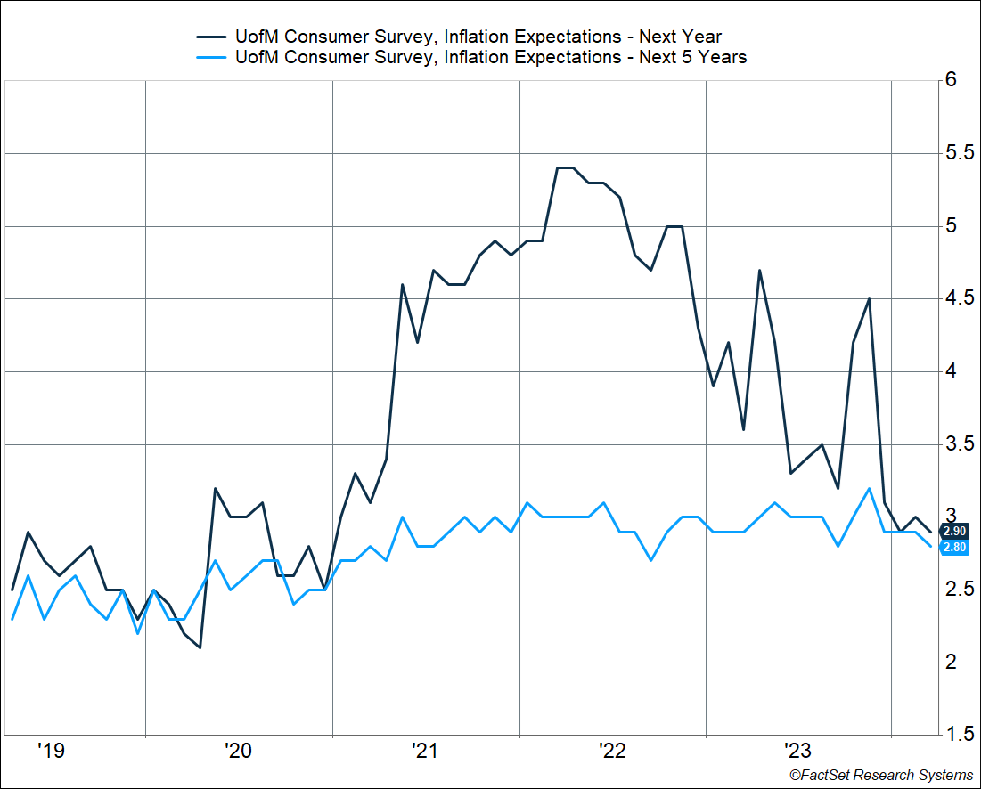

Rate Cuts Get Pushed Out
The firm inflation data in the first quarter likely pushes out the timing of the first interest-rate cut by the Fed, perhaps to July at the earliest, if not September. There’s even less urgency to cut because the labor market continues to run strong. At the same time, there’s a lot more inflation data to come between now and June, let alone July. The underlying data points to core inflation achieving the Fed’s end-of-year estimate of 2.6% — and based on the Fed’s own projection, that’s good enough for cuts.
As Powell noted in his press conference in March, Fed members didn’t sound victory bells when inflation eased in the second half of 2023, and they’re not going to panic based on the Q1 data. The disinflation trend is likely on track, albeit with a few bumps along the way.

This newsletter was written and produced by CWM, LLC. Content in this material is for general information only and not intended to provide specific advice or recommendations for any individual. All performance referenced is historical and is no guarantee of future results. All indices are unmanaged and may not be invested into directly. The views stated in this letter are not necessarily the opinion of any other named entity and should not be construed directly or indirectly as an offer to buy or sell any securities mentioned herein. Due to volatility within the markets mentioned, opinions are subject to change without notice. Information is based on sources believed to be reliable; however, their accuracy or completeness cannot be guaranteed. Past performance does not guarantee future results.

S&P 500 – A capitalization-weighted index of 500 stocks designed to measure performance of the broad domestic economy through changes in the aggregate market value of 500 stocks representing all major industries.

The NASDAQ 100 Index is a stock index of the 100 largest companies by market capitalization traded on NASDAQ Stock Market. The NASDAQ 100 Index includes publicly-traded companies from most sectors in the global economy, the major exception being financial services.

A diversified portfolio does not assure a profit or protect against loss in a declining market.

Compliance Case # 02200967_041524_C

